Customer Case Study: Enhancing Software Selection with Qlerify



Introduction

CRM Software Advies is a consulting firm specializing in helping companies with successfully selecting and implementing new CRM platforms. It is headed by Ruud Verduin, a management consultant with 25 years of experience. It is Ruud’s ambition to transform the traditional software selection process and make it more effective, shorter in time, and more cost-effective. This case study delves into Ruud's challenges, solutions, and thoughts on improving the software selection process.

Background
After selling his previous company, Ruud started a new consultancy company that is 100% focused on software selection for customer relationship management software (CRM). In this company, called CRM Software Advies – Dutch for CRM software advice - he aims to put into practice a range of new approaches for improving the selection and implementation process of CRM applications.

Challenges
Ruud identified a range of significant challenges in the existing practices used in the software selection process, including:
- The selection process takes too long as it contains a lot of non-value adding activities and slack
- The potential for driving real business transformation is not used to its fullest
- The decision-making process is unstructured and leads to emotion being a main driver in the selection process
- The approach and contract between the client and the vendor turns out to be more in favor of the vendor than of the client and the final costs turn out to be much higher than originally calculated



”Qlerify turned out to be exactly what I was looking for: extremely user-friendly, easily understandable by people participating in workshops, cost-effective and with a unique structure that dynamically links system requirements to business process workflows”

Ruud Verduin, Managing Partner

Solution
In his search to improve this process, Ruud discovered Event Storming. This is a great technique to actively involve stakeholders in developing a vision and process models of the desired way of working. But it has one drawback: Event Storming leans heavily on brown-paper workshops and lots of colorful sticky notes. They are great for the people involved, but not so intuitively understood by people who were not present during the workshops.

So Ruud started looking for a tool that could be used to document the colorful vision and process models. He compared a range of tools, varying from complicated BPM tools to visual collaboration tools such as Miro and Mural, but did not find a tool that felt right. Then he discovered Qlerify, and it turned out to be exactly what he was looking for: extremely user-friendly, easily understandable by people participating in workshops, cost-effective and with a unique structure that dynamically links system requirements to business process workflows. And on top of that, it aligned extremely well with the principles of Event Storming which emphasizes focusing on outcomes (events) rather than activities.

CRM Software Advies have successfully utilized Qlerify in both online workshops and offline scenarios in several customer projects. The tool not only resonated with the professional needs of CRM Software Advies’ consultants but also presented a user-friendly interface suitable for both end users and decision makers of their clients.

Results
Adopting Qlerify led to significant improvements in CRM Software Advies’ consulting process:
- Enhanced efficiency: Quicker definition of future state processes, thus cutting project delivery time.
- Improved focus: Qlerify, when paired with the methodology Event Storming, centers on crucial business events, ensuring optimal use of time.
- Professional output: The diagrams created in Qlerify maintain a high standard, suitable for presentations to various stakeholders and managers.
- Flexibility: Qlerify can be used both by consultants and internal team members of an organization and can be applied in various settings, from online workshops to offline personal use.

Furthermore, it turned out to be a great way to communicate with software vendors about the desired future state.

Value
CRM Software Advies perceives Qlerify as superior to other BPM tools, citing its visual appeal, ease of use, unique linking between process steps and system requirements and cost-effectiveness as standout features. What Ruud values most is that it is a great way of communication with all parties involved, including end users, senior management and other stakeholders.

Conclusion
Ruud's journey with Qlerify highlights the tool's significance in modernizing and streamlining the software selection process. Qlerify is the go-to platform in creating a future state vision for any IT system, by defining business processes and system requirements in a format that is understandable to various stakeholders, and easily documented for management review. Using Qlerify helped CRM Software Advies to substantially reduce lead time in the software selection process.

About CRM Software Advies
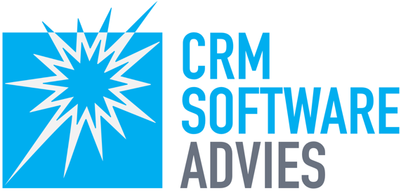
CRM Software Advies helps directors, managers and project managers with issues involving customer focus and realizing customer value. We do this in the form of advice, sounding boards and inspiring presentations. Visit https://crmsoftwareadvies.nl for more information.

