How Webking Used Qlerify to Streamline Customer Collaboration

Webking simplifies people’s lives with the help of modern technology and innovative solutions

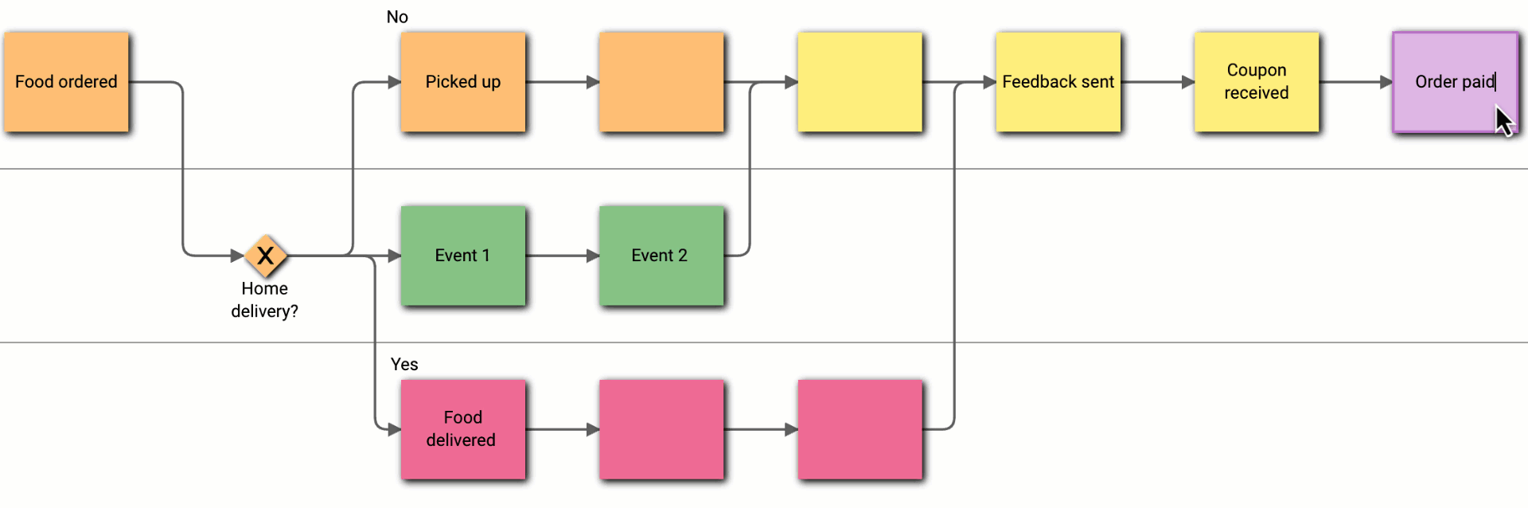

Challenges
Customer collaboration can be challenging in software development projects. Analyzing and documenting customer needs is tricky and can result in specifications that do not fully reflect the true needs of the customer. For Webking, the customer collaboration process is very important and the existing process was complex and time consuming with their existing tools, such as Microsoft Visio or Sparx EA.
- These tools could not be used for real-time visualization and alignment during customer meetings.
- Documentation had to be created after the meetings and then several new meetings had to be scheduled with the customers to go through the documentation, validate the contents and make changes for the things that had not previously been captured.
- Documents were created with various tools in different formats and stored in several locations.



”We have used Qlerify in several projects. As a software architect, I found Qlerify easy and powerful to visualize the business process for my clients."

Robert Jansz, Founder of Webking

Solution
Customer collaboration can be improved by using powerful and user-friendly visualization tools since most people think it is easier to understand and engage with visual models compared to traditional requirement specifications. A web based modelling and collaboration tool is easy to access for everyone using a standard web browser and there is no longer a need for complicated desktop applications to do the initial application modelling work. This makes it easy to invite customers and collaborate using a simple web browser.

With the Qlerify app, collaboration with customers has become much easier and faster and is done in a more uniform way. Content is stored in one location that is easily accessible by developers and customers.

Webking has used the Qlerify app in six different projects for a customer in the sustainability sector. Every time the customer has a new project, the project starts with creating a system blueprint in the Qlerify app. By using the Qlerify app, the initial analysis phase has become much more streamlined and fits well with Webking’s agile development process. The Qlerify app has also improved transparency and made it easier to reach consensus with the customer.

The visual output from the Qlerify app is used by the developers to estimate the work effort. Estimates can now be delivered faster to the customer and the estimates have become more accurate. This is very important for Webking since they usually share the financial risk of the project with the customer.

The Developers at Webking are involved early in the projects and quickly get a good understanding thanks to the visual flows in the Qlerify app. These flows along with linked user stories and UI sketches has reduced misunderstandings and rework.

In several cases the Qlerify app has been used by the developers to propose automation improvements. They started by describing the ”as is” situation. Then they analyzed the current situation and quickly designed a desired ”to be” flow and showed it to the customer along with work estimates. The customer was then able to quickly review and approve the changes.

In other cases, Webking has helped customers to map and document processes that have not been properly documented before. Mapping processes or user journeys and maintaining them can be done very fast with the Qlerify app, thanks to the intelligent diagramming editor. By using swimlanes, Webking helped the customers to visualize areas of responsibility within the company and increase the overall understanding for the business processes.

Results
Concrete results from the switch to Qlerify as described by Robert Jansz, founder of Webking:

- Reduced license costs for Visio and Sparx EA.
- Shortened lead time from first meeting to a complete visual illustration of the customer's process/flow. In several cases, we have saved many hours in effective time and days in calendar time, as the time between meetings and reconciliations usually drags on.
- A uniform way of working on all projects, avoiding complex and incompatible issues arising from multiple tools.

Conclusion
The ease and speed of the Qlerify app enables Webking to perform real-time visualization of customer needs with immediate validation of the needs during meetings with customers. This saves a lot of time when creating software application blueprints and reduces misunderstandings, rework and delays. The amount of required work after customer meetings has been dramatically reduced since most of the documentation is created and approved during the meetings.

About Webking
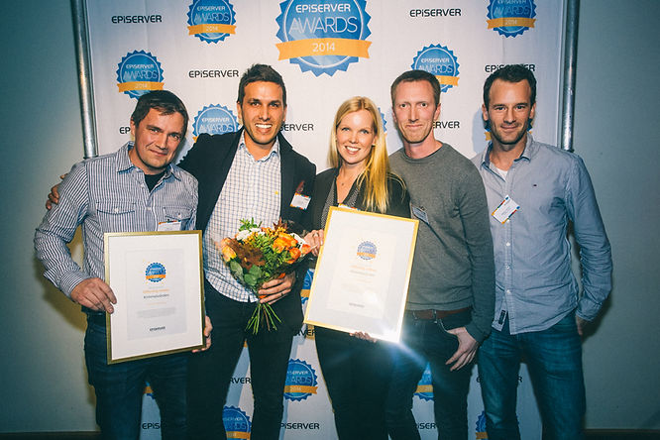
Webking simplifies people’s lives with the help of modern technology and innovative solutions. With drive, joy and ambition, we create digital solutions that make our customers more competitive and more profitable.

