

User Manual for Flotilla IOT Client Application

Login

For logging into Flotilla IOT, enter the official URL of Flotilla IOT into the address bar.
Login page:
- Enter username
- Enter password
- Click on 'LOGIN button to login to Flotilla IoT successfully.
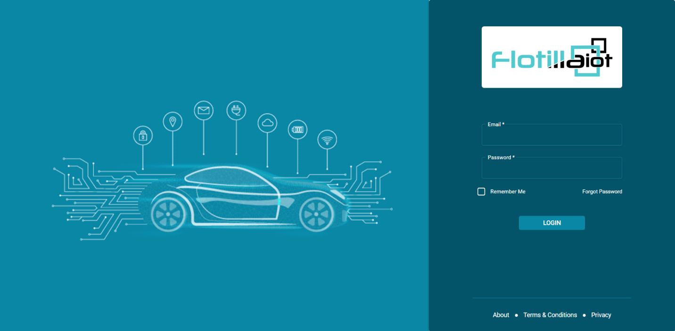

Remember Me

Flotilla IoT provides a "Remember Me" option on the login page. It means that, after a user has logged in once from a device, he/she can login from the same device without entering 'Email' and 'Password' again. This access will only be possible if the user does not logout.
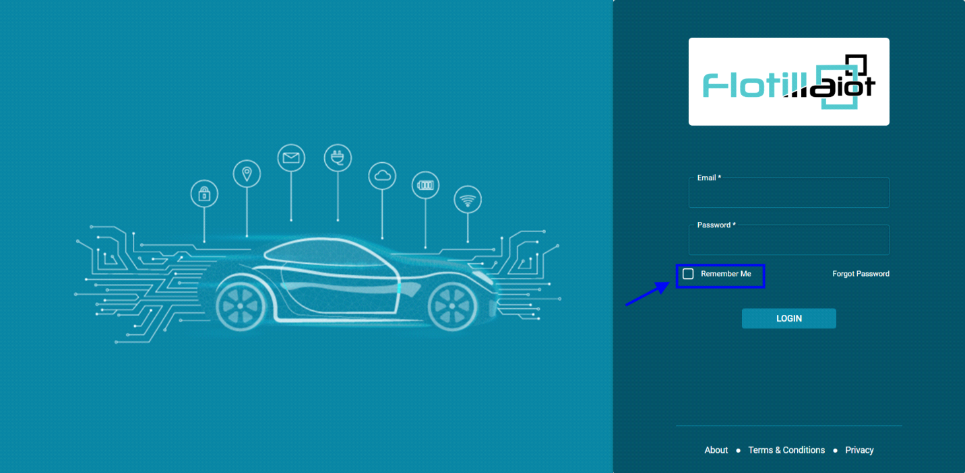

Forgot Password

- Flotilla IOT provides a "Forgot Password" option on the login page.
- If the user forgets the password, he/she can click on 'Forgot Password' button on login page.
- The user is asked to enter an email address where link is sent to reset password.
- After entering email address, press 'SUBMIT' button.
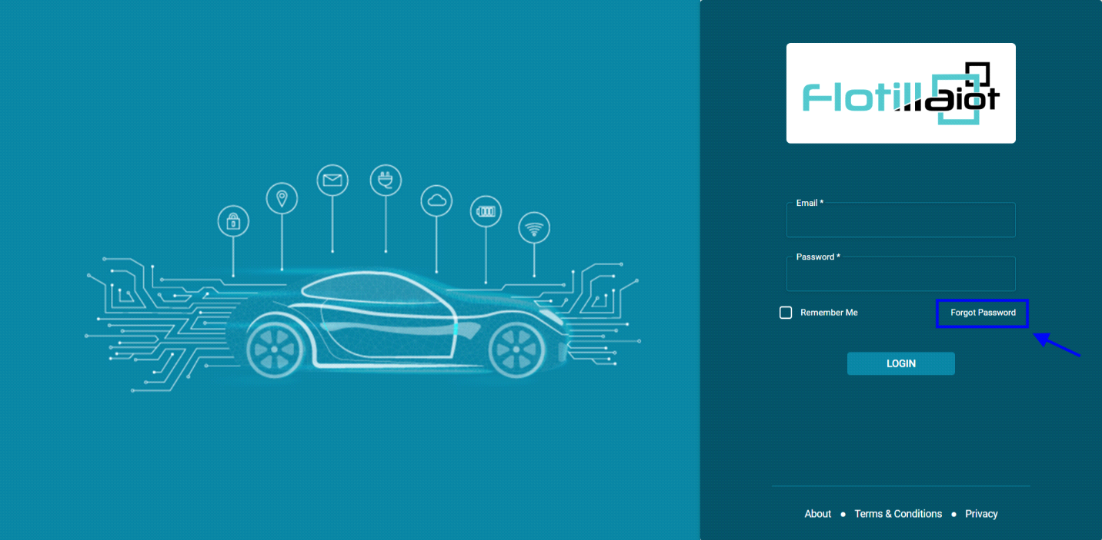

Password Change

- User can change the account password from 'User Settings' option.
- Click on the 'User Settings' in the top right corner of the screen.

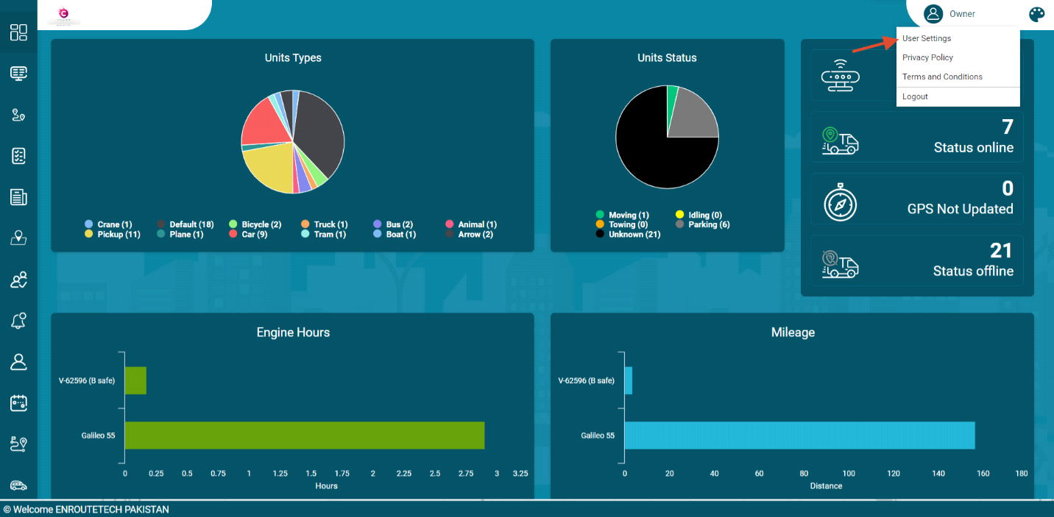
- Click on 'CHANGE PASSWORD' option.
- Enter Current password, new password and repeat new password.
- By clicking on 'CHANGE PASSWORD' button, new password will be updated and user can login into the system with the new password.
- Click on 'RESET' button to set password again.

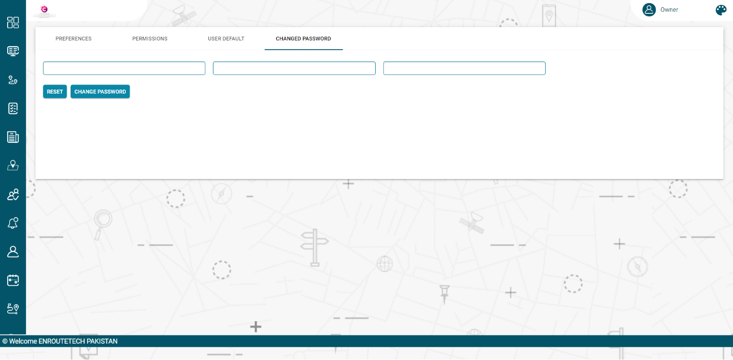

User Settings

- The 'User Settings' option in Flotilla IOT allows users to configure certain system parameters.
- To view user settings, go to the username in the top right corner panel and click 'User Settings'. The User Settings option containing the following options, depending on the system configuration:
- Preferences
- Permissions
- User default
- Changed Password
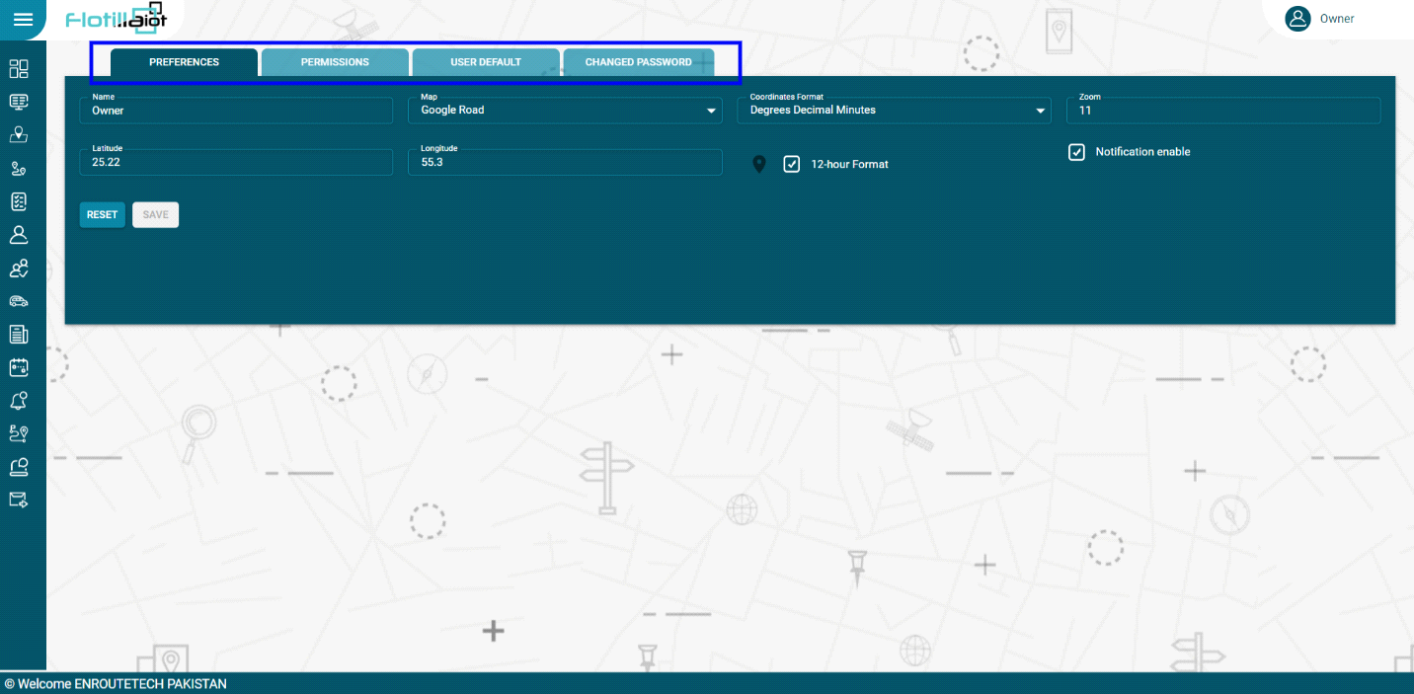

Preferences

- In this option, users can set functionality aspects of the software.
- Set the 'Name' of user.
- Set the 'Map' from the dropdown
- Set the 'Coordinates Format' from the dropdown options.
- Set the 'Latitude', 'Longitude' and 'Zoom' options.
- Click on the location icon to add or set the location (optional)
- Click on the check box of 12-hour Format (If the user wants to set the time format)
- Users can set notifications for various events and activities by checking the ‘Notification Enable’ box.
- ‘RESET’ button can be clicked for resetting all parameters.

Permissions

In this option, the users can view or change the followings parameters:
- Expiration date of the user account
- Unit Limit
- User Limit
- User can generate a public login link token to conveniently login in future by using this link.
- ‘RESET’ button can be clicked to reset all the parameters.

User default
In this option, the user can set the following details:
- Time Zone
- Language
- Measurement unit
- Custom tags can be generated for vehicle and staff to add a new field in them.
- ‘RESET’ button is available for resetting the all parameters.

Changed Password
For changing password, user has to follow these steps:
- Add New password
- Repeat new password
- Add Current password
- Click on ‘CHANGE PASSWORD’ button
- ‘RESET’ option is available for reset the all parameters
Password will change successfully. Now user can login into the Flotilla IOT with the new password.

Logout

- For logging out from the Flotilla IOT system, click on the user name in the right corner of the display and then click on the logout option.
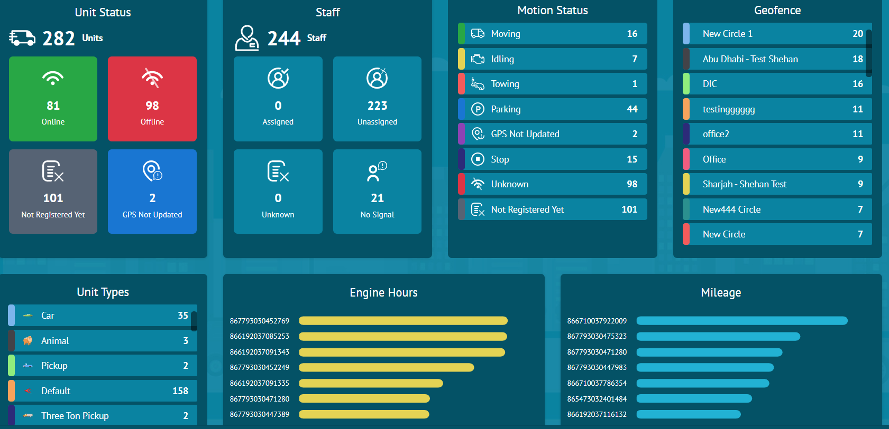

Flotilla IOT Web Application

The main menu of the Flotilla IOT on the left contains different modules. These modules contain different elements and subcategories depending on the applied settings. All the modules along with their functionalities are given below:

Dashboard

Flotilla IOT provides the comprehensive dashboard that contains summary about the units from the units list. From the dashboard, user can view the details about unit status, unit types, staff, geofences, motion status, engine hours, and mileage. This information is updated as new real-time data is received from the units.

Unit Status

- This option contains the latest status of the units divided into four categories including ‘Online’, ‘Offline’, ‘Not registered yet’ and ‘GPS Not Updated’.
- User can view the names and number of units falling in a particular category.
Staff
- This option shows the distribution of drivers in four categories Assigned, Un Assigned, Unknown, No Signal.
- The number of drivers falling in a specific category is shown.
- By clicking on any driver, all its detail can be viewed including ID, name, the assigned vehicle ID, and assigned vehicle name.
Motion Status:
- The motion status of vehicles including Moving, Idling, Towing, Parking, Stop etc. can be viewed.
- The number of vehicles in a certain status is displayed with the status name.
Geofence:
- All the created geofences are displayed in this section.
- The number of vehicles in a specific geofence is displayed next to its name.
Units Types

- This option contains the different types of units (vehicles) which are shown with their names and logos on the dashboard.
- The total number of units belonging to a certain type are displayed in front of the name.

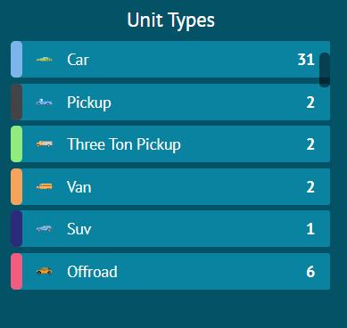

Engine Hours

- This option contains the engine hours which is the time between the ignition ON and ignition OFF.
- It shows the engine hours of top 10 units which are shown in the descending order on dashboard.
- By hovering on graph user can also view the engine hour value of every individual unit with its unit.
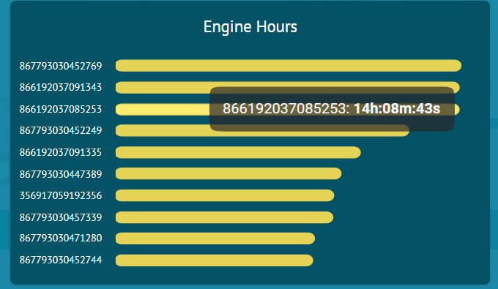

Mileage
- This option contains the mileage of top 10 units which are shown in the descending order on dashboard.
- By hovering on graph user can also view the mileage value of every individual unit with its unit.

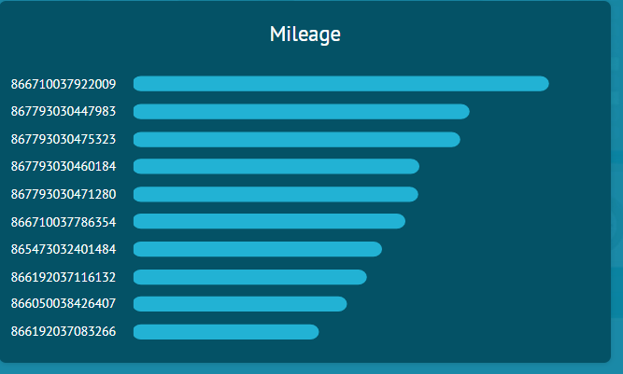

Monitoring

In the monitoring module, users can view the all the details about units and their functionalities including movement of units on the map, notification of units, status changes etc.
- By clicking on the settings icon, the options to display in the horizontal bar can be set by checking them.
- User can search places on the map with maximum zooming feature to view the unit’s movement discreetly.
- Users can select/change any type of map by clicking on the map icon in the horizontal bar.

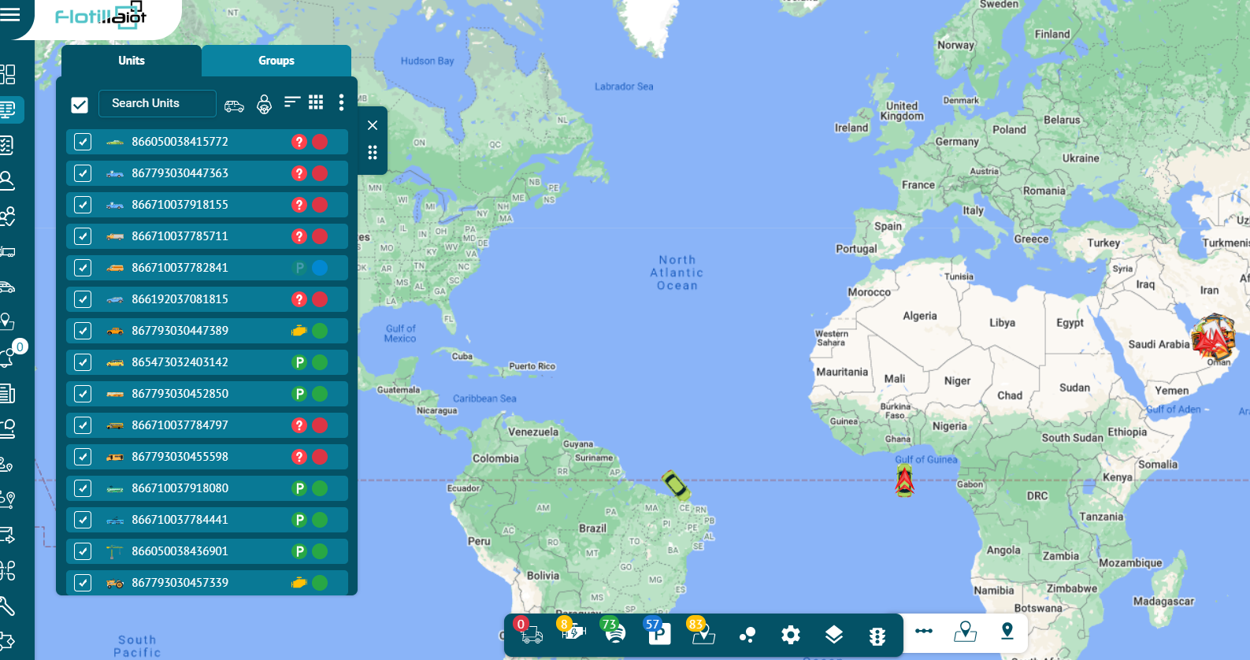

Units

User can view the units list individually and in groups. In the units list, user can manage the list of units by adding and deleting them.
- The sorting of the units can be done name wise and device status wise.
- The status of the vehicle in the list is shown by small icons next to its name.
- To find the required unit in the list, use the search field above units list.
- The color of the circle near the unit’s name indicates the current status of the unit.
- Green circle indicates: Unit is online
- Red circle indicates: Unit is offline
- Blue circle indicates: GPS is not updated.
- Grey circle indicates: Unit is Not registered yet.
- To follow a unit on the map, click on its name in the units list. As a result, the map centers and zooms in on the selected unit.
- User can also select all units at once by selecting the check box “Select All” in the top left corner of the units list.
- To cancel the selection of all units, uncheck the “Select All” check box.
- By clicking on the ‘Vehicle Filter’ and ‘Staff Filter’, you can search the units based on vehicle and staff filters.
- In the horizontal bar, the changing status of the units can be viewed in real time.
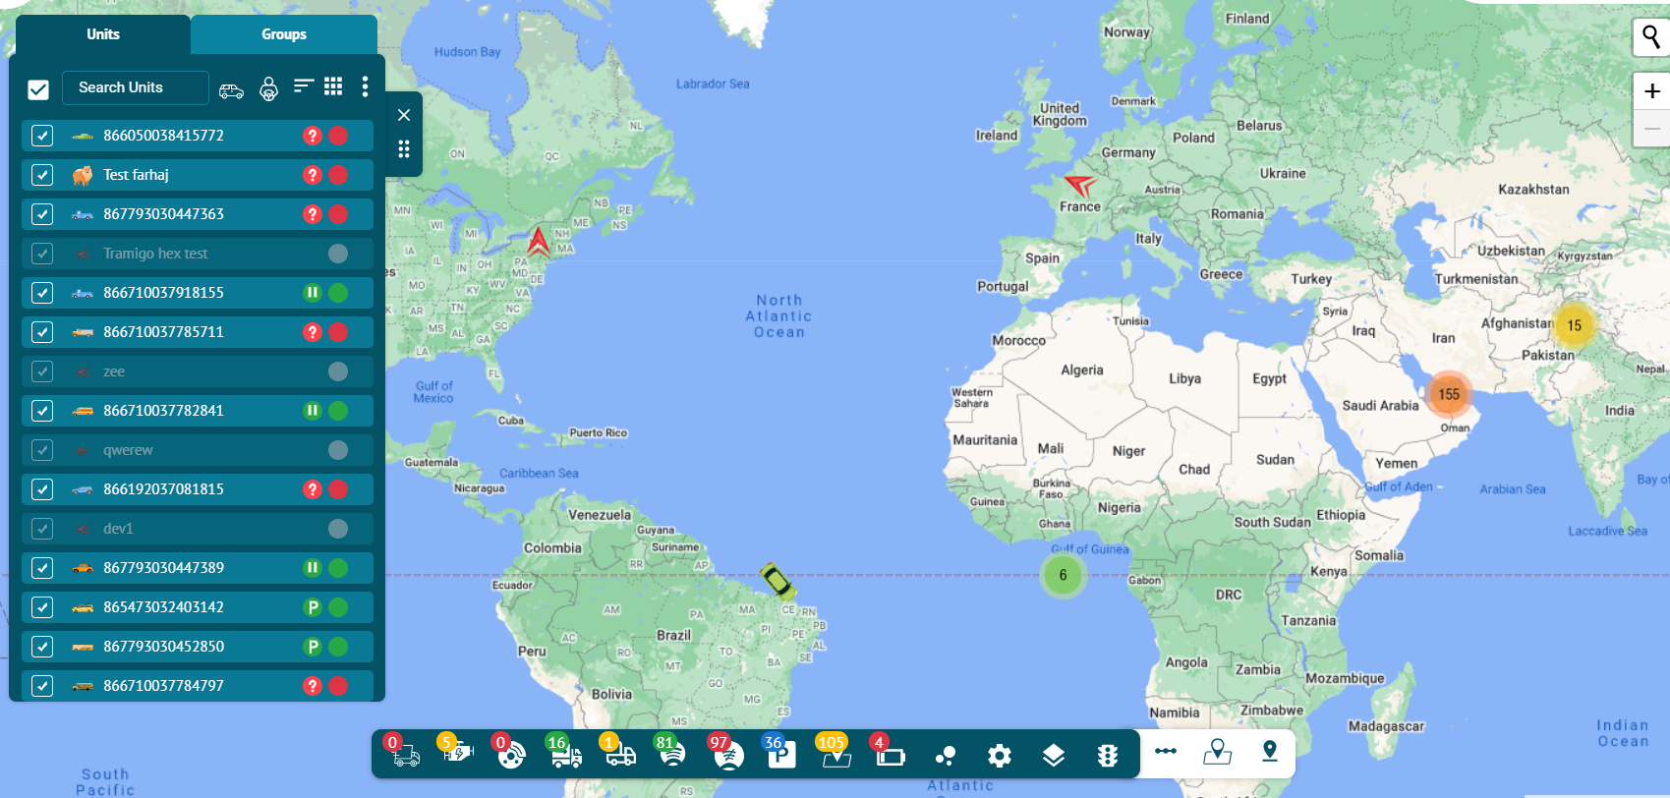
- User can view the details of units by clicking on “View details” button. All details of unit appeared with unit status, movement status etc.
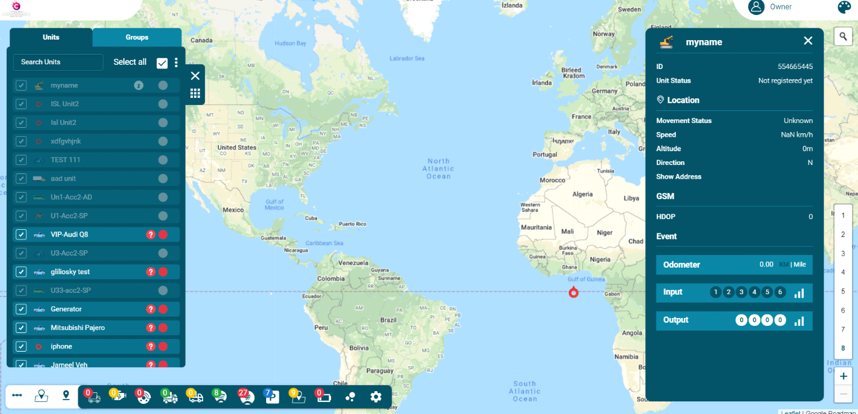
User can also set the units movement status and monitor status changes moving, idling, towing etc.

Groups

- By clicking on groups user can view the groups list on monitoring screen.
- User can create groups and assign units into groups and name these groups. Group management can be done in the units tab.
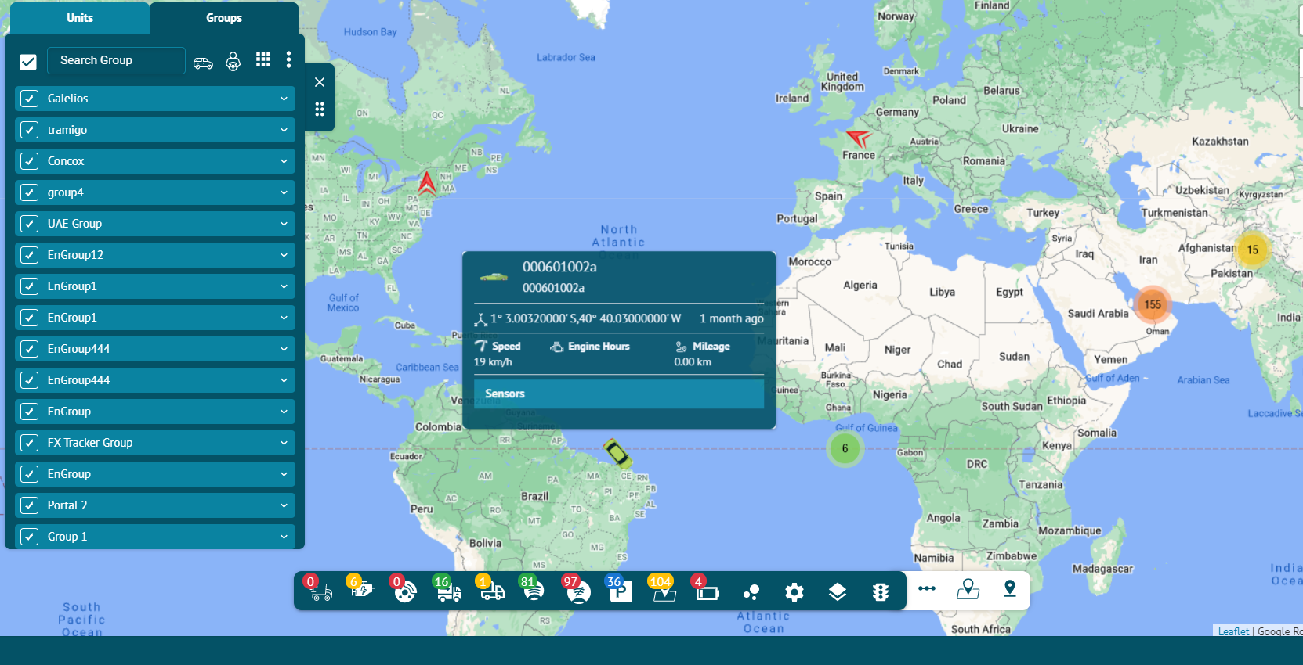

Status Bar:

Measure distance and area calculator
- The area and distance can be measured by clicking on the calculation option in the horizontal bar.
- By clicking on measure distance and calculator area icon on map, user can set location from one point to another point to measure the distance or calculate the area.

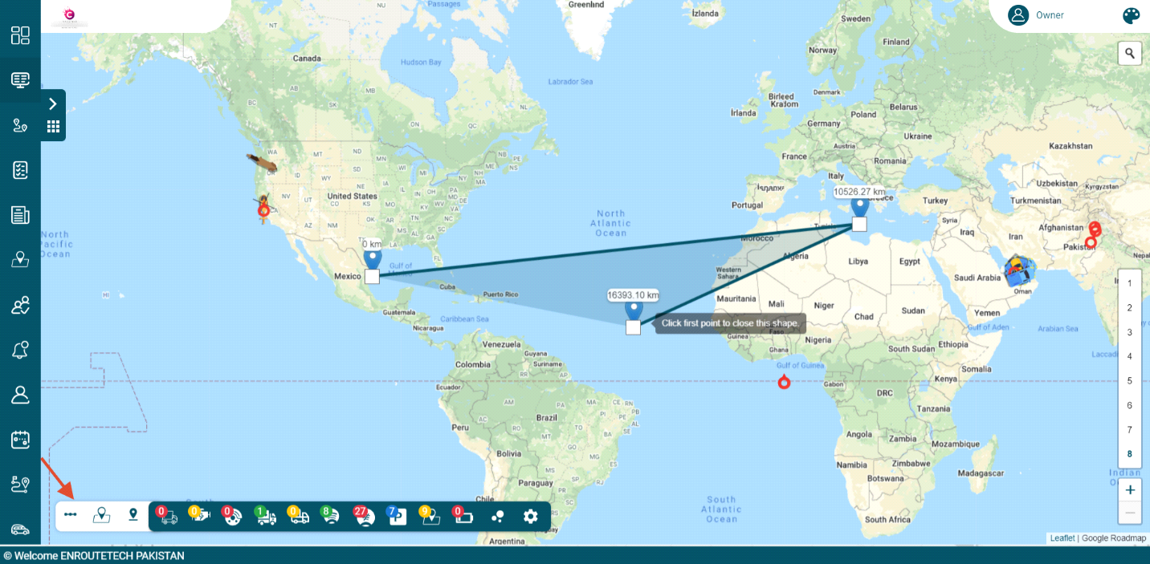

Geofences

Geofence is an area on the map that is important for route planning and tracking purposes. User can choose a name, description and color for a geofence.
- New geofences of any size and shape (circle, polygon and polyline) can be created by clicking on the ‘Geofence’ option.
- By clicking on geofences icon on the map, user can create, edit and delete geofences.
- The number of vehicles in the geofences are displayed with the ‘Inside Geofence’ icon in the horizontal bar.

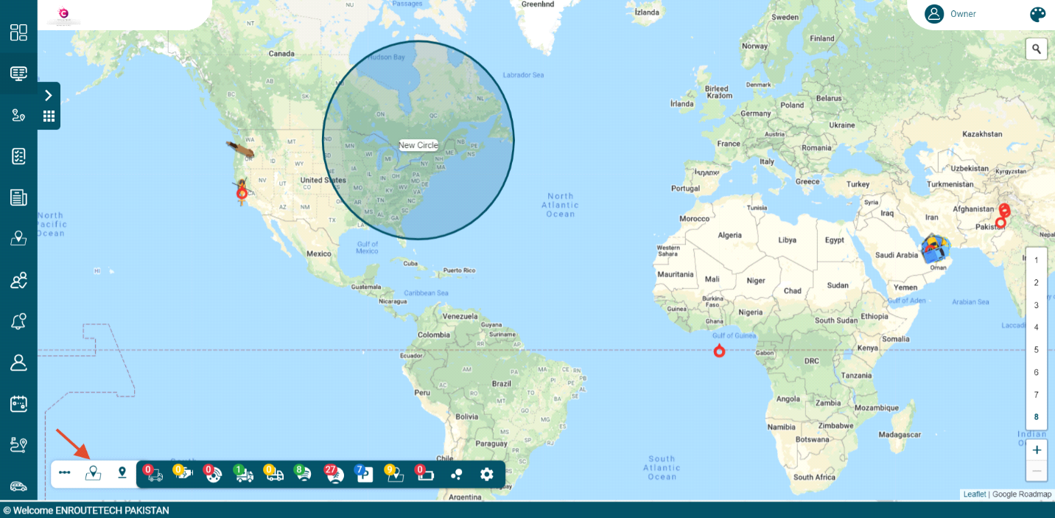

POI (Points of interest)
- By clicking on the ‘POI’ icon, a point of interest can be created showing the exact location coordinates.
- User can create the places by right clicking on the map as reference points and can give them names and description.

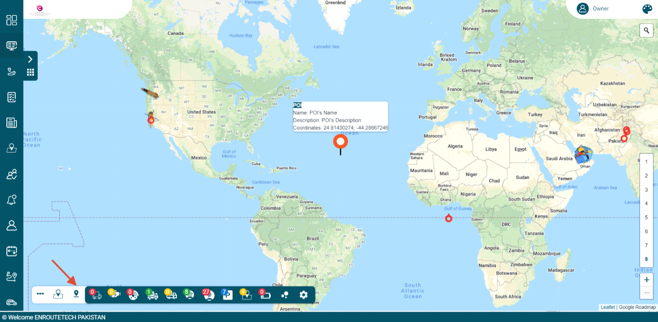

Cluster Markers
- By checking the ‘Cluster Markers’ box, the number of vehicles can be viewed on the map.

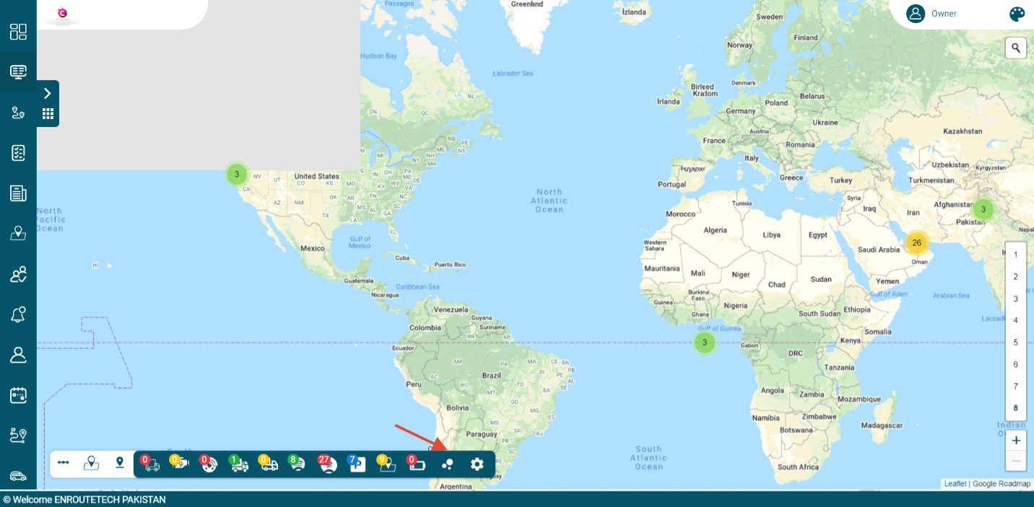

Toggle Traffic
By clicking on this option, you can view the traffic situation on different roads with the help of three indicators.
- Green lines show that there is no traffic.
- Orange line show that there is moderate traffic.
- Red line shows that there is heavy traffic.
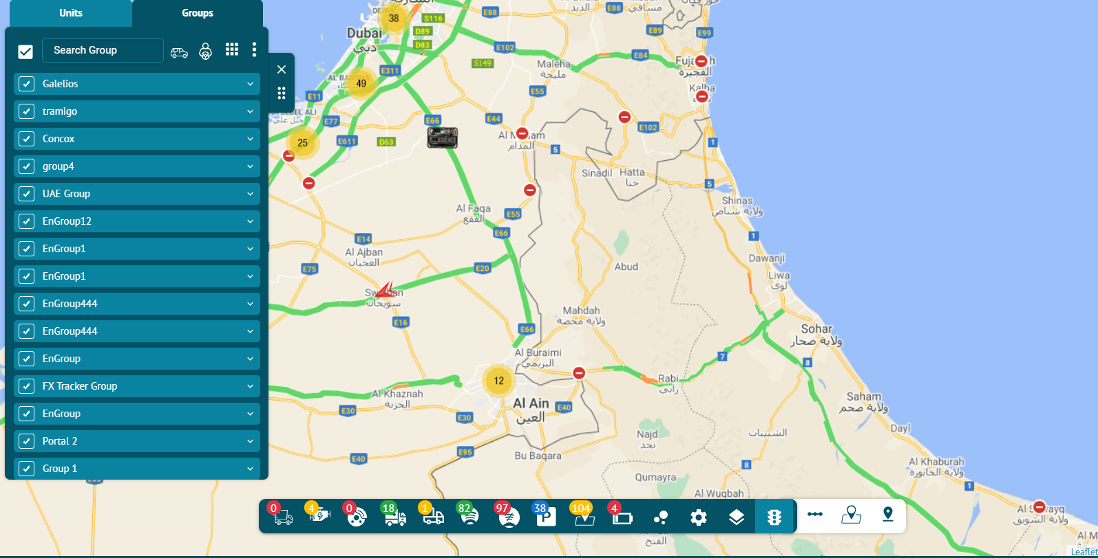
Map Selection:
By clicking on this option, you can select the type of map you want to display on the Flotilla IoT system.

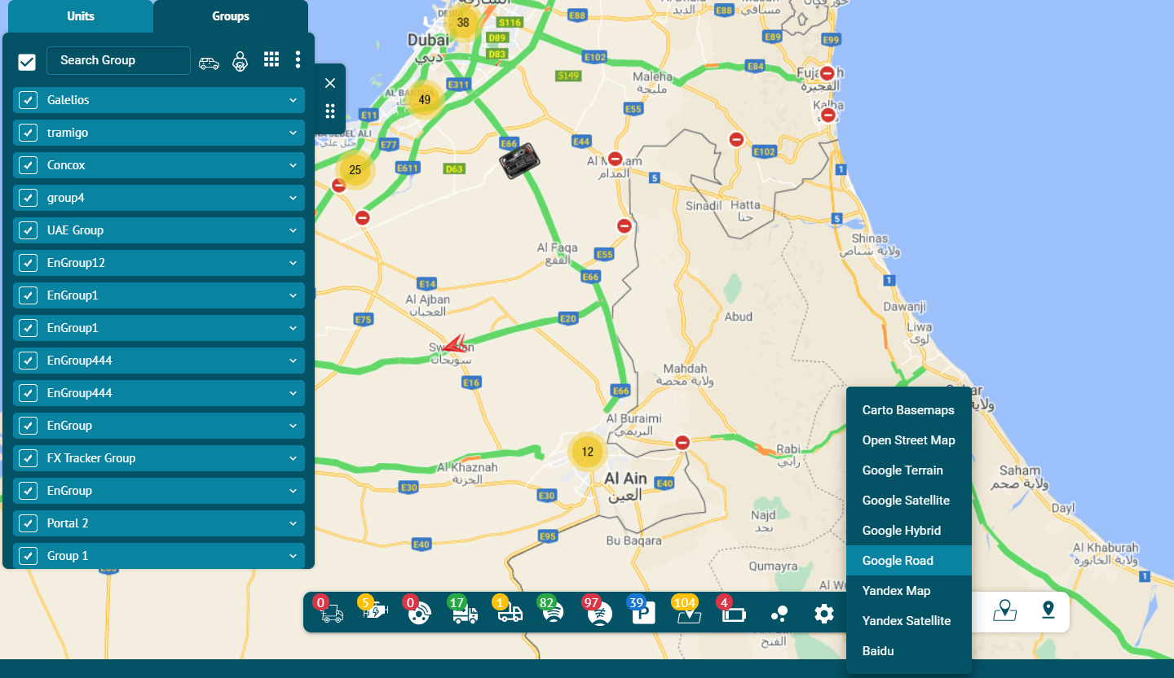

Units

In Flotilla IOT system, units are the most important entity. A unit can be characterized as any type of be moving or stationary object that can be monitored. They are assigned a unique identification code in the system to monitor it efficiently. Two modes of display are available in units i-e. "Units" and "Groups".
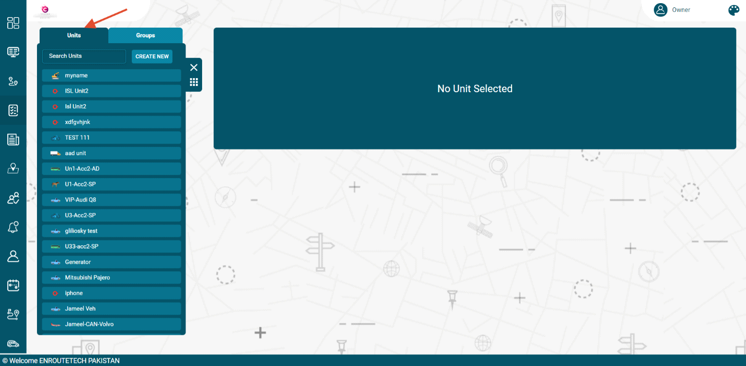

Create Unit

To create a unit:
- Open the Units component by clicking the Units tab name in the main menu.
- Click on ‘CREATE NEW’ button.
Enter the required information of the unit
- Name
Enter the specific name of the unit. By this name, the unit is shown on the map, in the unit list and some other component.
- Identifier
Enter the unique identification code (ID) for the unit required to identify it by the system.
- Device Model:
Select the model of the device from the dropdown list.
Enter some extra information related to the unit:
- Phone number
Enter the phone number of the unit. The phone number should be in the international format.
- Group
Enter the group from which the unit belongs.
- Contact
Enter the contact number of the unit. The contact number should be in the international format.
Enter the attributes of the unit:
- Unit password
Enter the specific password of the unit. Set the specific password of the unit.
- Time Zone
Select the time Zone of the unit i.e. Asia/Dubai etc.
- Speed
Enter the speed limit of the unit in km/h.
- Device no data duration:
Set the data duration delay till it is expected.
- Click on the Save button.
The Unit will be created successfully and displayed in the units list.
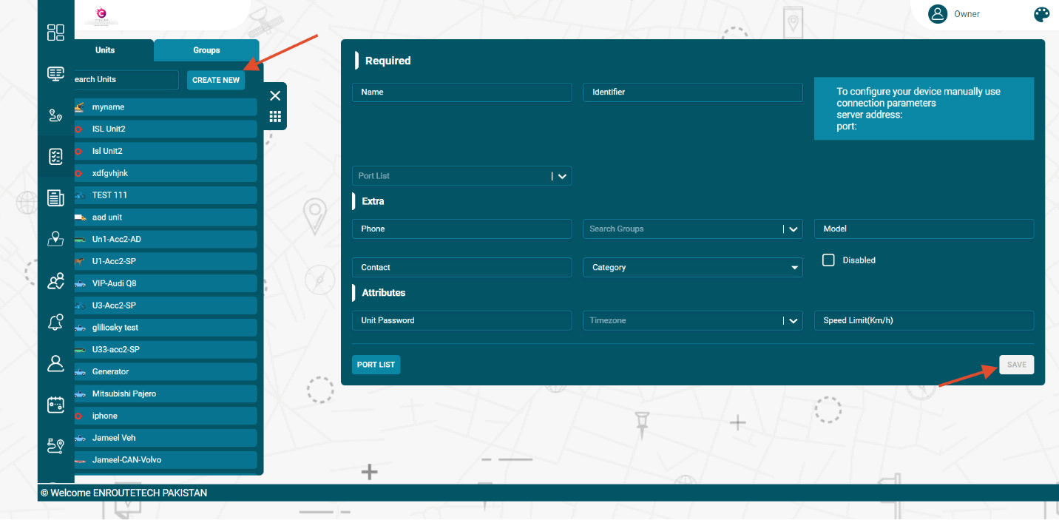

Delete Unit

To delete a unit, follow these steps:
- Go to the unit name and click on Delete icon next to unit name in the units list
The Unit will be deleted successfully and will not be displayed in the units list.
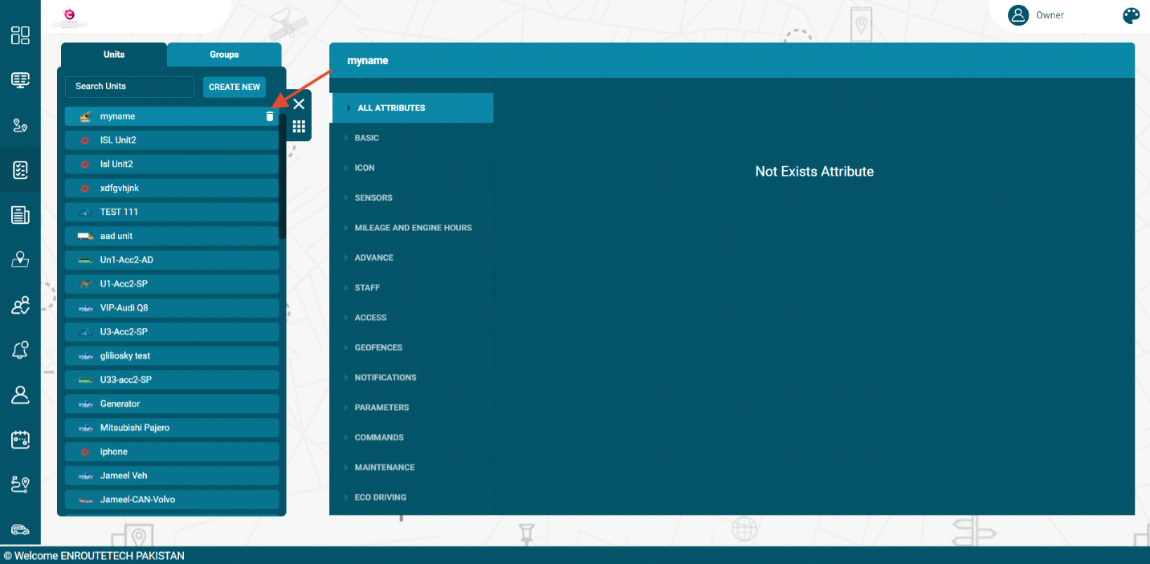

Search Unit

- To find the required unit in the units list, use the search field above units list.
- Enter the required unit name in search field and the matching results will display in the list.
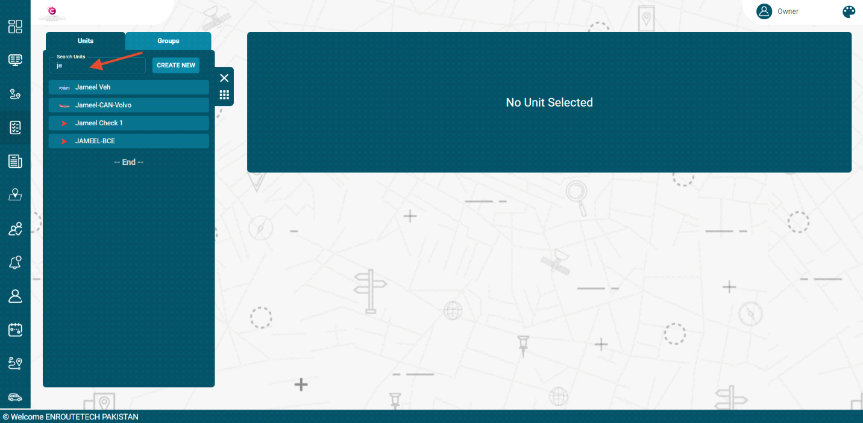
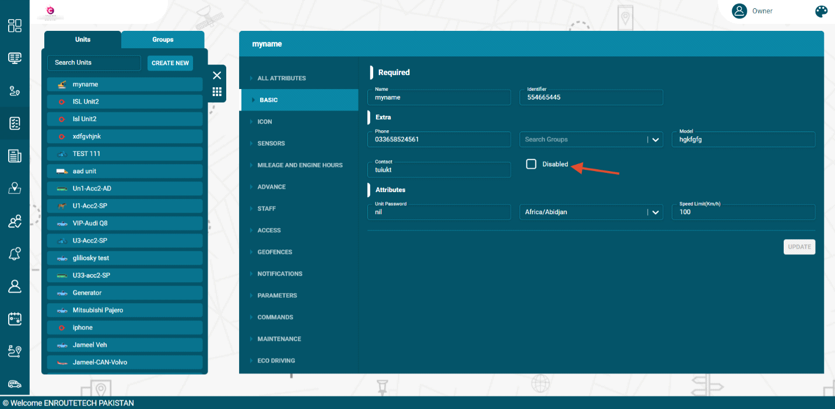

Update unit

To update a unit:
- Click on the unit in the units list
- Select the Basic tab
- Update the unit information that user wants to change like name, ID, unit password etc.
- Click on the update button to save the changes.
The unit information will be updated successfully.
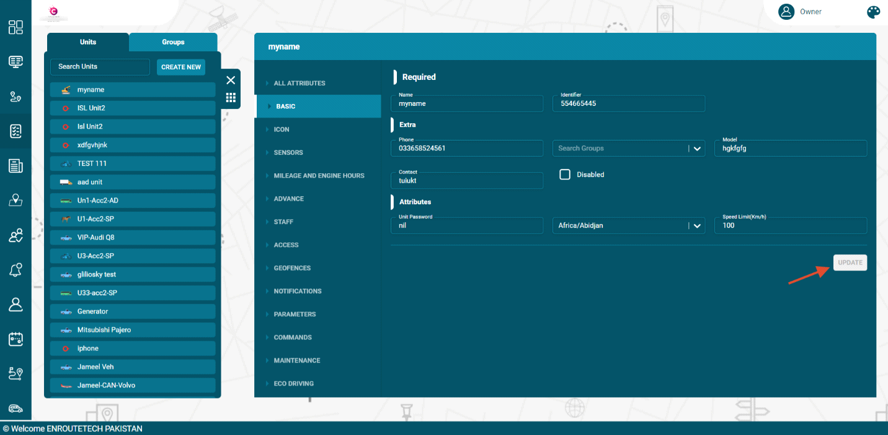

Units Options

Flotilla IOT provided several options of the units to offer customization. These options can be displayed by clicking on a unit’s name from the list. . The number of options can vary depending on provided access rights.
Following are the unit options available in the Flotilla IOT system
- ALL ATTRIBUTES
- BASIC
- ICON
- SENSORS
- MILEAGE AND ENGINE HOURS
- ADVANCE
- ACCESS
- NOTIFICATIONS
- ELOGIC
- COMMANDS
- MAINTENANCE
- ECO DRIVING
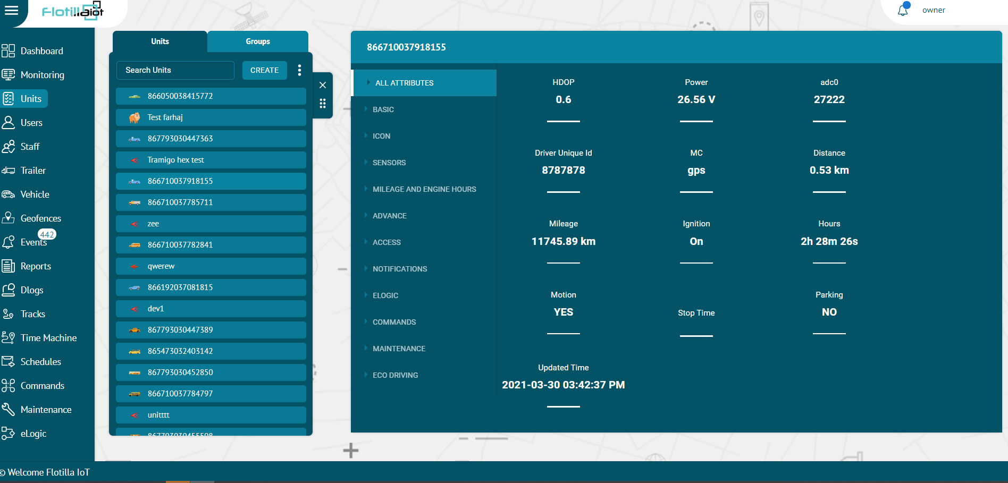

All Attributes:
In this option, all the data attributes of the selected device can be seen.

Basic
In the Basic option, users can update or set the information about the units.
Following are the information types that can be set or updated:
Required:
- Name
Set the specific name of the unit. By this name, the unit is shown on the map, in the unit list and some other component.
- Device Model:
Select the model of the tracking device connected to the unit.
- Identifier
Set the unique identification code (ID) for the unit required to identify it by the system.
Extra:
- Phone number
Set the phone number of the unit. The phone number should be in the international format.
- Model
Set the model number of the unit.
- Contact
Set the contact number of the unit. The contact number should be in the international format.
Attributes
- Unit password
Set the specific password of the unit. Set the specific password of the unit.
- Time Zone
Set the time Zone of the unit i.e. Asia/Dubai etc.

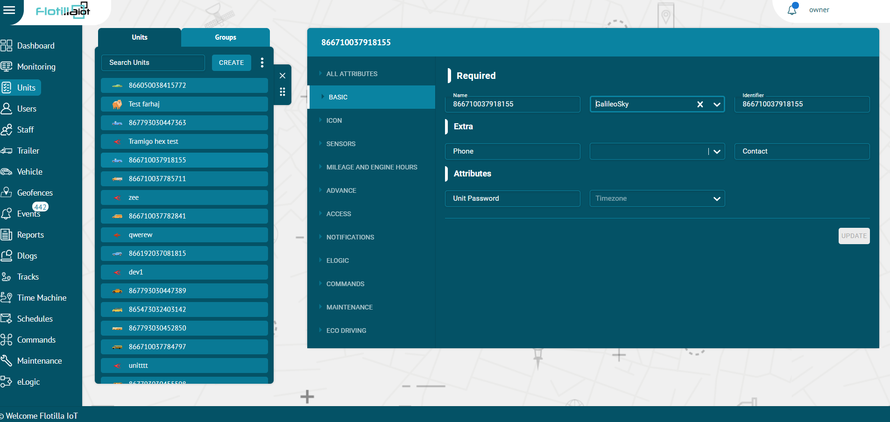

Icon

In the Icon tab of the Unit options, users can select any icon to display unit in the system. There are standard icons of different types provided by Flotilla IoT that can be used to represent units.
- To choose or change an icon for a unit, click on the ICON tab.
- Select the specific icon for a unit
- Click on Update button to set the icon of a unit.
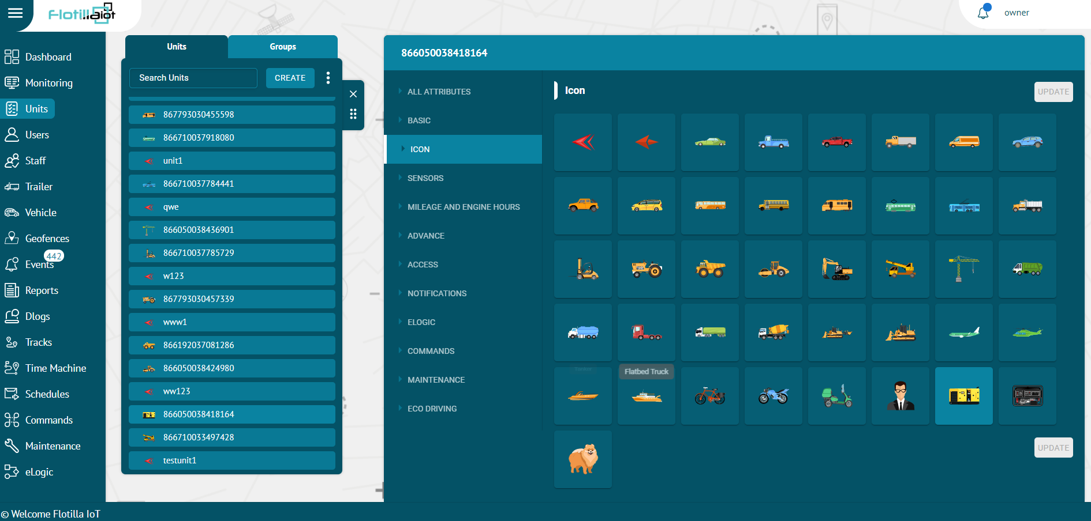

Sensors

The Sensors tab in the Unit options, displays a list of all the sensors created for this unit. Flotilla IOT provides three different options to add sensors: discrete, measurement and other sensors. The sensors can be viewed, edited and deleted by clicking on the SENSORS tab. Users need to have access right to create, edit, and delete sensors, otherwise, they can only view existing sensors. By clicking on the SENSORS tab, user can view the information about all three sensors created for the selected unit.

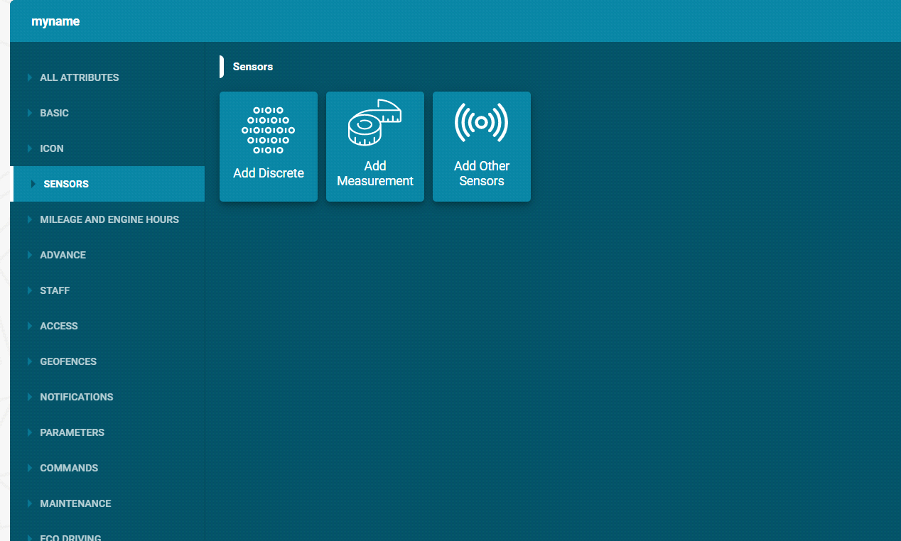

Create Sensor
Flotilla IOT provides three different options to add sensors:
- Add discrete
- Add measurement
- Add other sensors
To Add Discrete:
It is a digital sensor that gives the input in the form of true false. It is normally used to check the trueness of a condition. For example, if you add ignition sensor then you will get the result in ON/OFF.
- Click on the Add Discrete button
- Enter the description of the sensor with which you want to display it.
- Select the sensors type from the dropdown list
- Select the Input of data type like odometer, distance, mileage from the list.
- Select a Threshold value after which you want sensor to start collecting data.
- Check the ‘Save last data received’ checkbox to save last received data.
- Click on SAVE button to save changes.
- Click on Cancel button to dismiss changes.
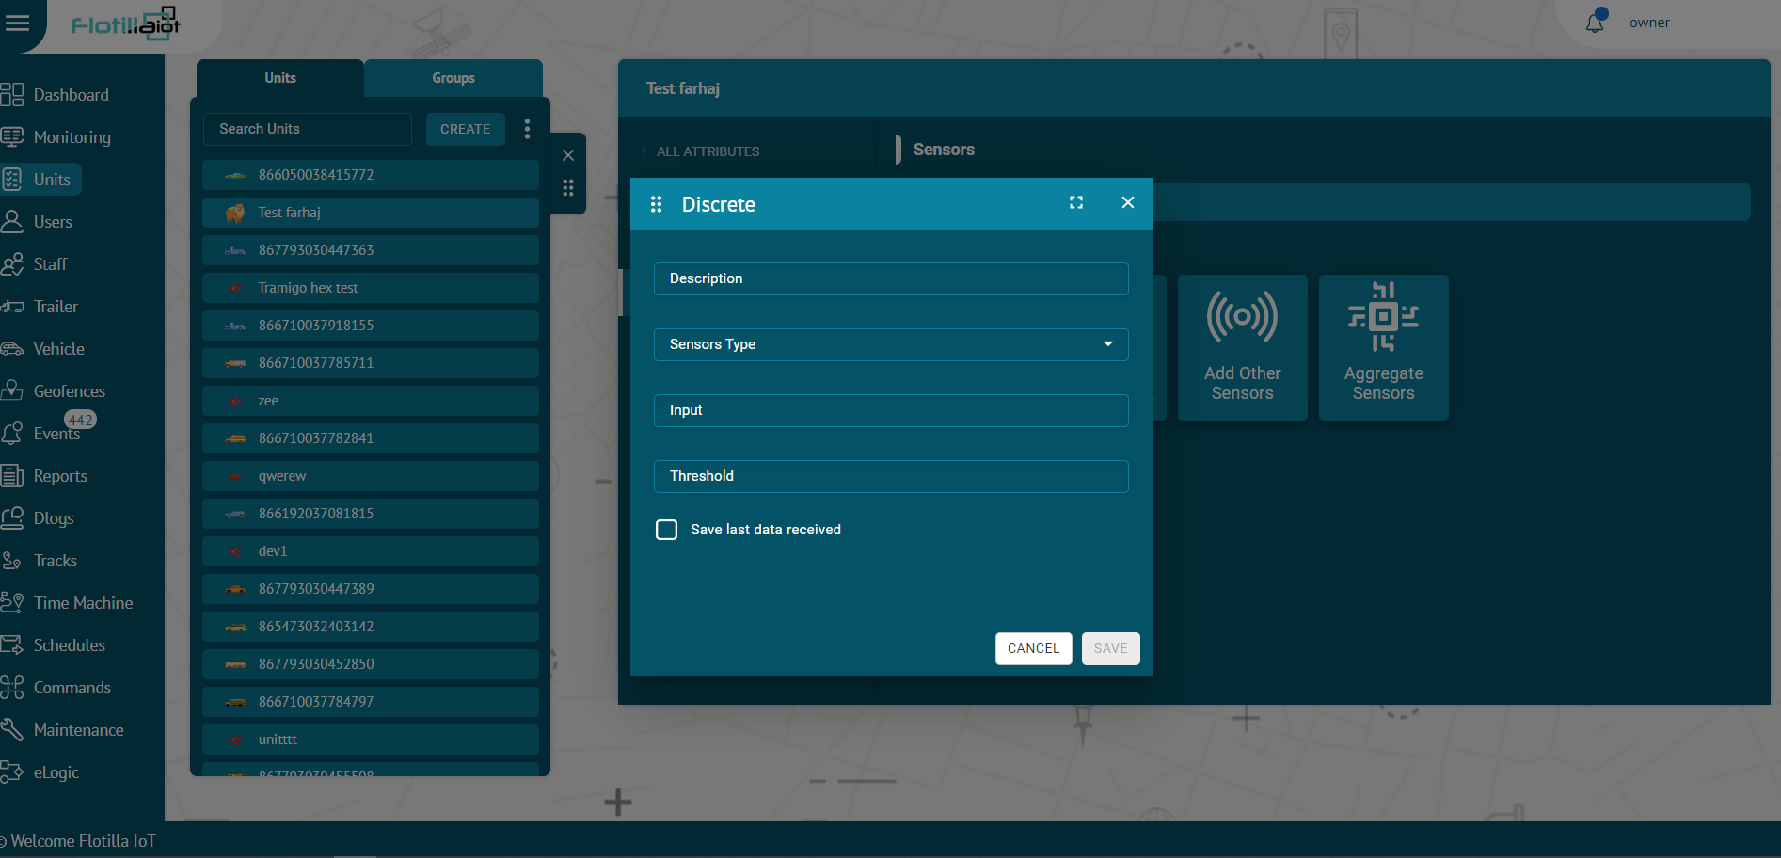
To Add Measurement:
The measurement sensor is used for performing calibration on different inputs fetched from the device. At times, the device does not send data in the form that has to be displayed on the software. By applying calibration, you can display the inputs from the device in the required form. For example, if the device is sending data in the form of voltage, we can convert it into temperature, fuel consumption or any other such parameter.
- Click on the Add measurement button
- Enter the required information like Sensor label, Input, Sensor type.
- Select the sensors type from the dropdown list
- Select the measurement unit and accuracy
- Enter Sensor value and Quantity
- By clicking on ‘Add More’ option, multiple sensor value’ and ‘quantity’ can be set.
- By clicking on the bin icon next to ‘Quantity’, the entries can be deleted.
- Enter the Ignore Values (Optional) which is the range of data that has to be fetched. Any value below the lower limit and above the upper limit will be ignored.
- Add value in the Multiplier option that multiplies the data value with the enter number.
- Check the ‘Save last data received’ checkbox to save last received data.
- Click on Save button to update changes.
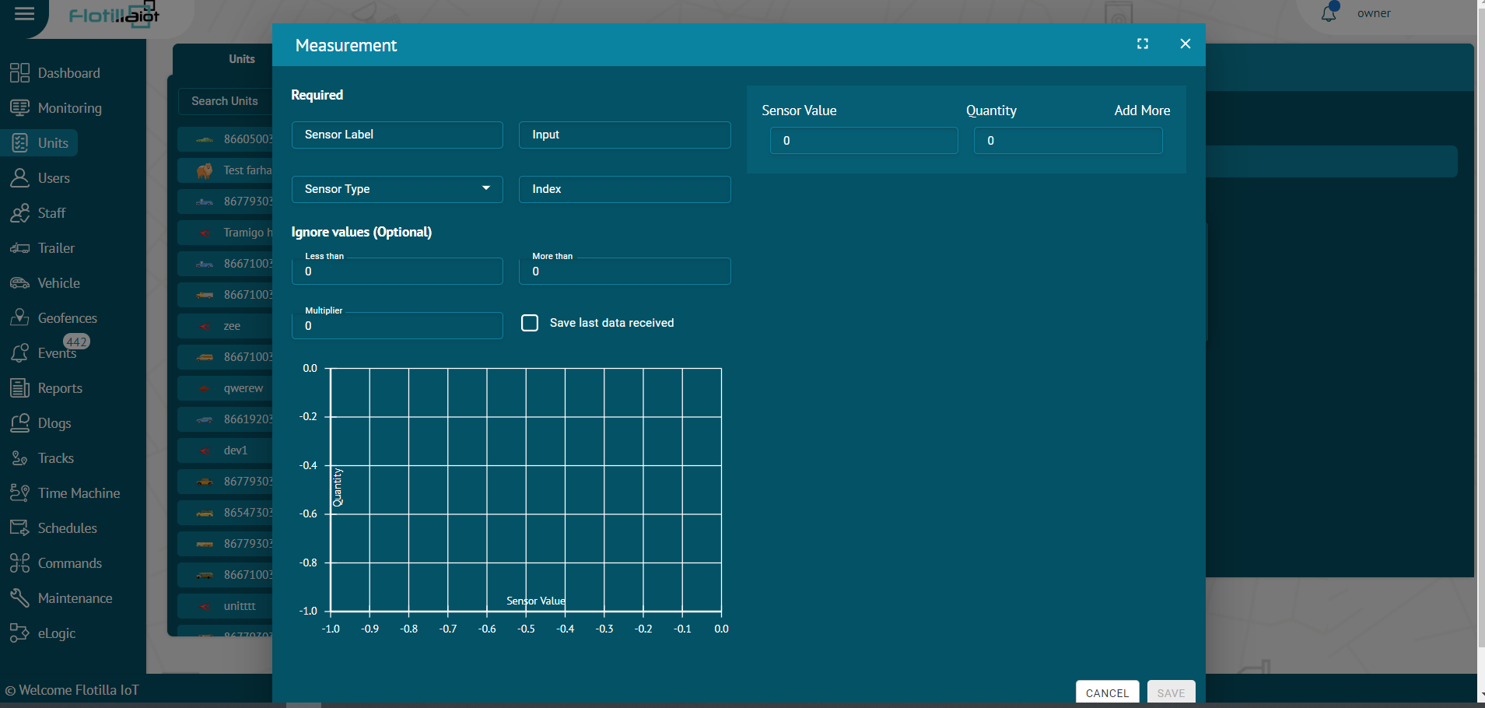
Add Other Sensors:
It includes the verification sensors for driver, passenger and trailers. When a unique ID is punched, it verifies that the authorized driver, passenger or trailer is attached to the unit.

- Click on the Add Other Sensors button
- Enter the description of the sensor
- Select the sensors type from the dropdown list
- Enter the Input
- Check the ‘Save last data received’ checkbox to save last received data.
- Click on Save button to update changes.
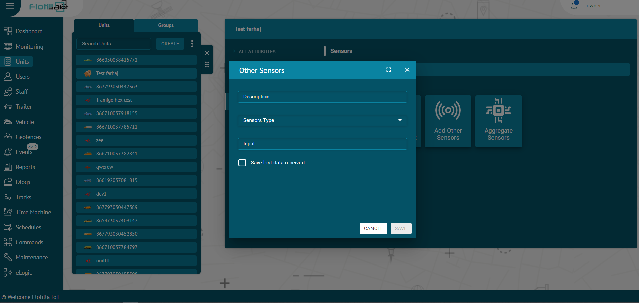
Aggregate Sensors:
It is used to calculate aggregate values from the input data. When the device is sending data on certain parameters, you can calculate the value of missing parameter. For example, if device is sending data speed and time then you can calculate distance from it by applying the formula distance = speed*time. You can add the inputs on which the speed and time data is being received and apply multiplication (*) operation on it to get distance value.
- Description:
Enter the name with which you want to identify the sensor.

- Sensor Type:
There is option of many default sensors along with custom sensor types. The default sensor types are given below:
- Driver ID
- Passenger ID
- Trailer UUID
- Ignition
- Panic Button
- External Power
- Engine Status
- Car Alarm
- Doors
- Fuel
- Temperature
- RPM
- Board Power
- Mileage
- Speed
- Counter
- Avg. Fuel Consumption
- Inst. Fuel Consumption
- Flow Meter

- Attributes:
Click on this option and all the data attributes of the selected unit will be displayed. Select the attribute on which you want to apply operation on both the sides.
- Operator:
Select the arithmetic operation from the list which has to be applied on the attributes.

- Return Type:
Select the return type in which you want to display the result. There are three available options.
- String
- Number
- Boolean

- Save last data received:
By clicking this option, the software will consider the last value otherwise not. It is usually used when the new data value from the device is delayed so the last saved data will be considered.
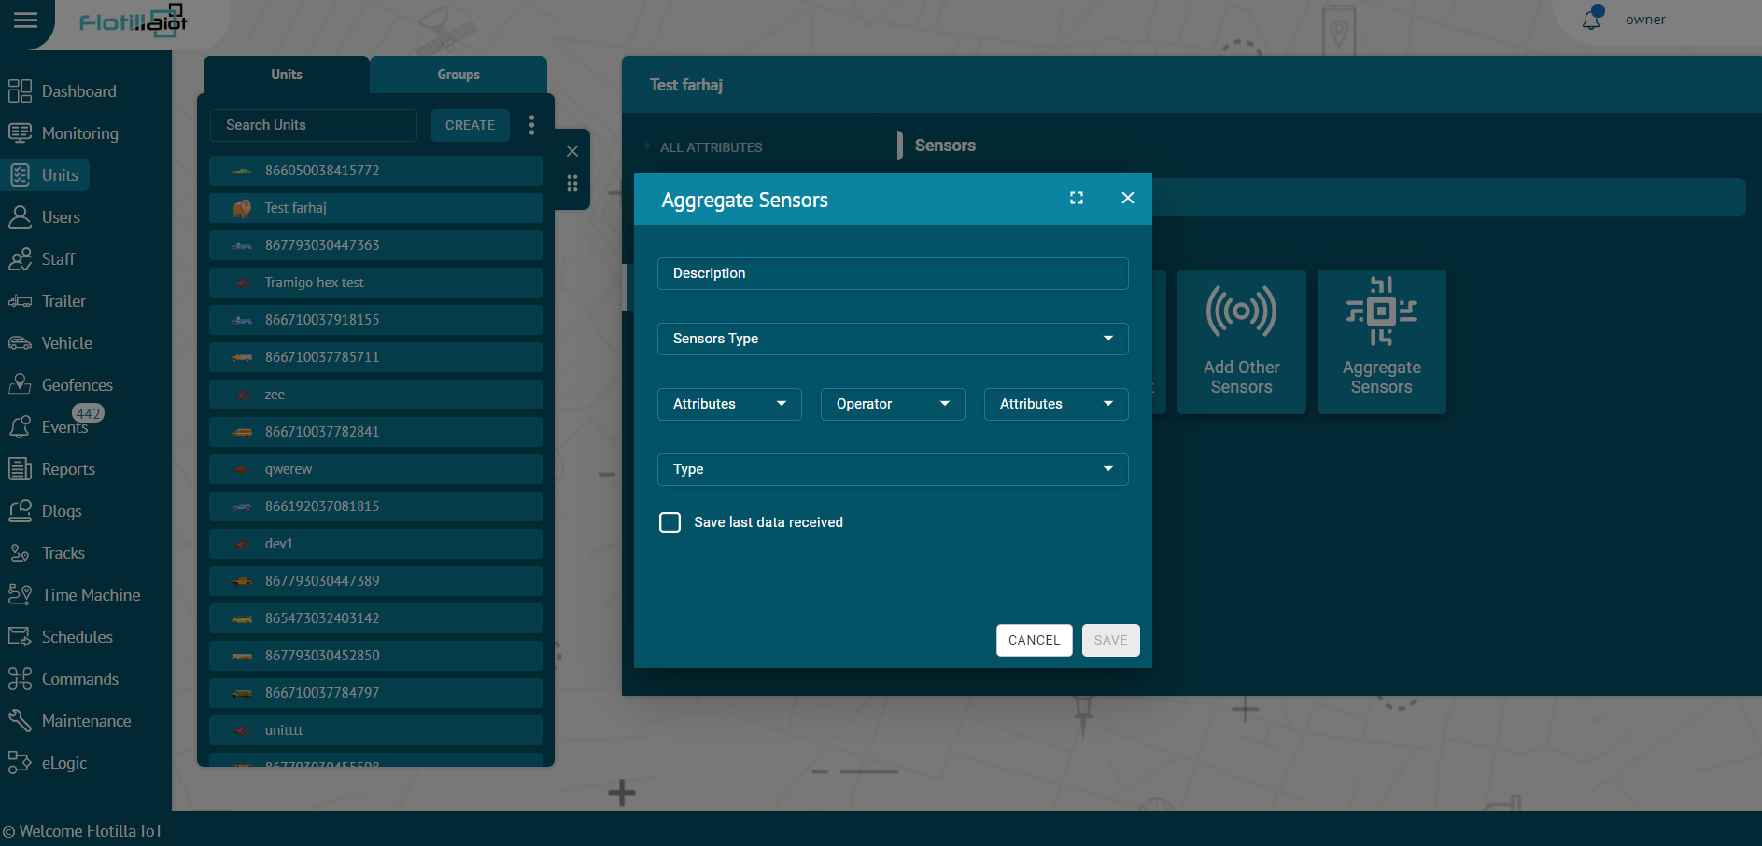

Delete Sensor
To delete a sensor:
- Select the sensor from the sensors list and click on Delete icon next to its name.
The sensor will be deleted successfully and will not be displayed in the sensors list.
Update Sensor
To update a sensor:
- Select the sensor from the sensors list and click on Edit icon next to sensor name.
- Change the information that you want to update and then click on UPDATE button.
The sensor information will be updated successfully.

Mileage and Engine Hours

Mileage counter is used to calculate the distance. Mileage counter is widely used in the Flotilla IOT in online monitoring, as well as in reports.
The mileage counter can be set with the following calculating methods:
- GPS: Mileage is calculated by GPS coordinates (possible for any unit).
- Device Odometer: Mileage is calculated according to the relative odometer sensor which counts the distance traveled since the last message.
- Alternative sensor: Mileage is calculated by alternative sensor and given input.
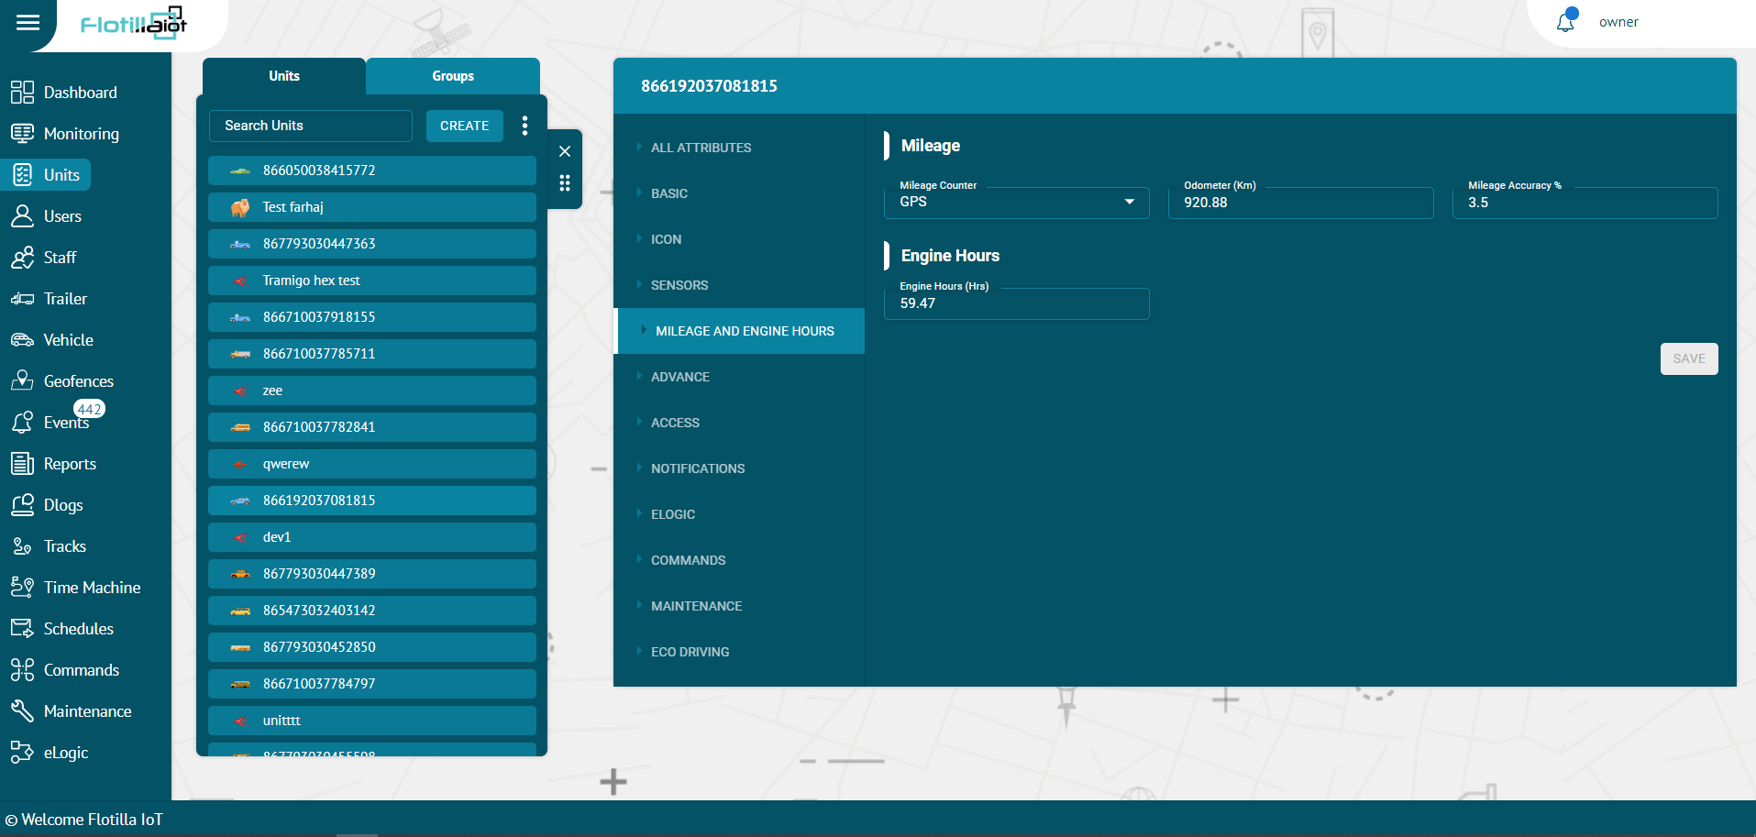

Engine Hours

The engine hours counter is used to calculate the engine hours (hrs.). The engine hours counter is widely used in online monitoring, tracks as well as in reports.
- The engine hours counter can be set by entering fractional value in the engine hours field (engine hours are measured in hours).
- User can enter a fractional value for the engine hours counter (It is displayed with accuracy to two decimal places i.e. 3526.19)
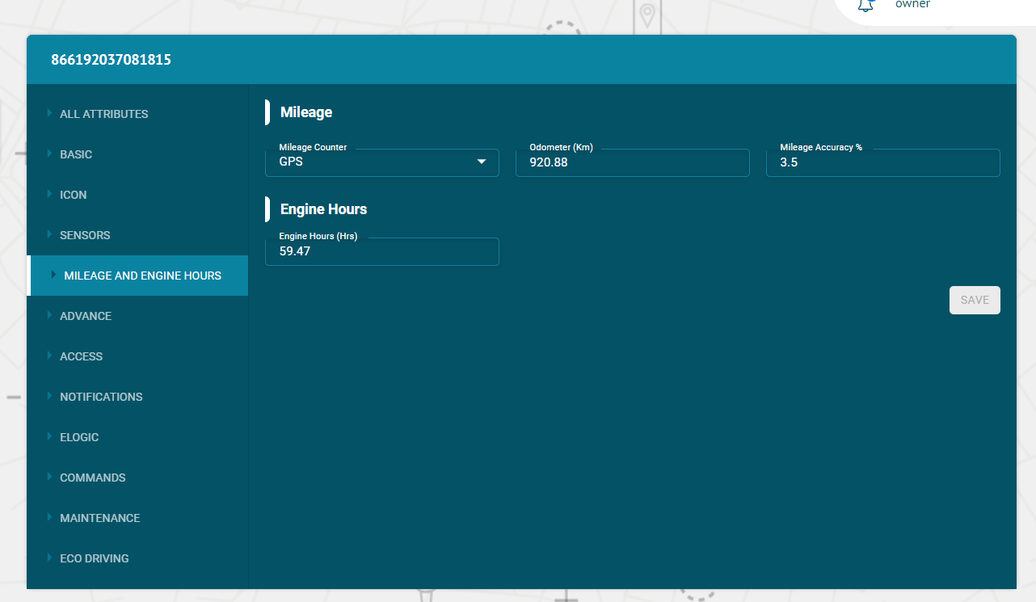

Advance

In the Advance tab of the unit’s options, the trip detector is configured in the Units. Trip detector is used to detect movement intervals like trips and idling (stops).
- Movement Detection
Flotilla IOT provided two main methods to detect movement:
GPS speed: It can be applied to any device type and configuration.
Engine ignition sensor: It is used for the units that have ignition sensor.
Detection of Movement States
Minimal No Data Duration (Seconds): It is the minimum no data duration for ending a trip. For example, if the minimal no data duration is set 10 minutes, the trip would end if the device does not send any data for more than 10 minutes.
Minimal Parking/ Idling Duration (Seconds): Set the minimal parking duration (seconds) which is the time for which unit must be motionless to consider the parking and idling condition. For example, consider the case where minimal parking/idling duration is set for 5 minutes. It means that when the car is stopped for more than 5 minutes and its engine is ON, it is in idling state. Similarly, if the car is stopped for more than 5 minutes and its engine is OFF, it is in parking state.
Minimal Trip Duration (Seconds): Set the minimal trip duration in seconds which is the minimum time limit of travelling after which the trip is detected. User can set the minimum trip duration (Seconds) at low values for detecting short-lived movements as trips. On the contrary, you can set minimum trip duration (Seconds) at a high value for detecting considerable time span as trips.
Minimal Trip Distance (Meter): It indicates the minimum distance after which trip is detected. It is advisable no to set distance too small as any slight movement of the unit would be considered as a trip.
Speed Threshold (km/h): Set the speed threshold in km/h of a unit which is the lower speed limit after which the movement is detected as a trip.
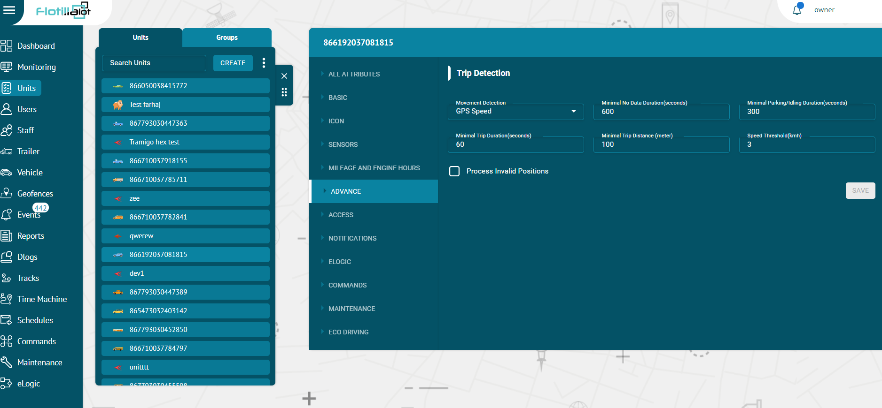

Access

In the Access tab of the Unit options, users can manage the access rights of different users towards the unit. The users with the right tick in the check boxes are those who already have some access to this unit. The users with the empty check boxes are those who doesn't have access to this unit.

- To give unit’s access to the users, click on the Access tab.
- Check the checkbox before the name of the users to give them access to users.
- To give access to all the users at once, press the ‘Assign all’ option before the name option.
- Press OK button to assign access of unit to all users.
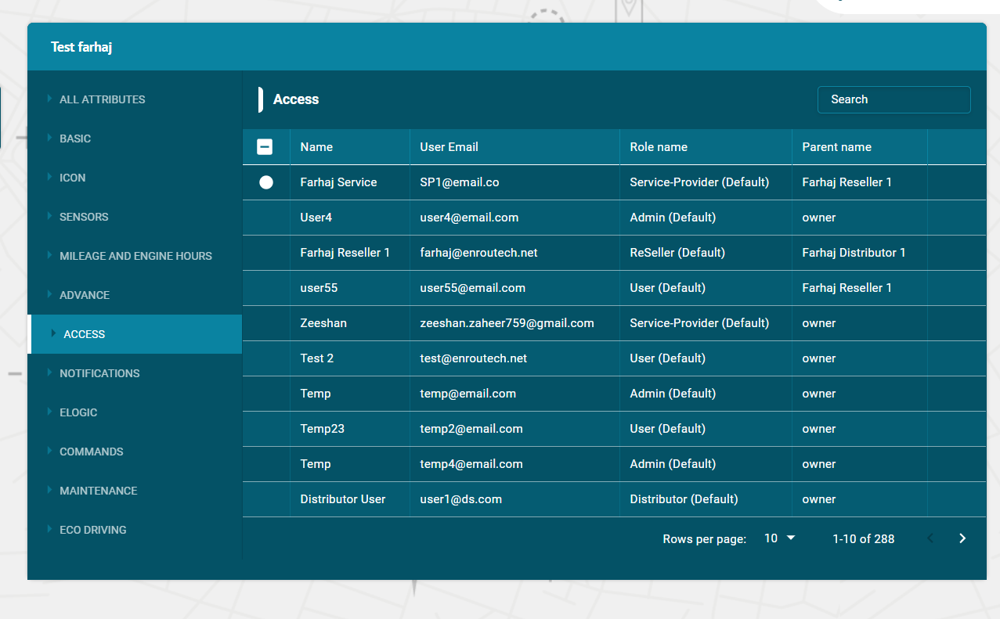

Notifications

In the notifications tab, users can create, edit, delete or view notifications and can assign notifications to the units.
In the flotilla IOT, user can be notified about any unit activity or change. It can be sensors values, change of location, speeding and others. A notification can be delivered by mail or web (display online in a popup window), mobile notifications and SMS. User need to have access right to create, edit, assign and delete notifications, otherwise, user can only view existing notifications.
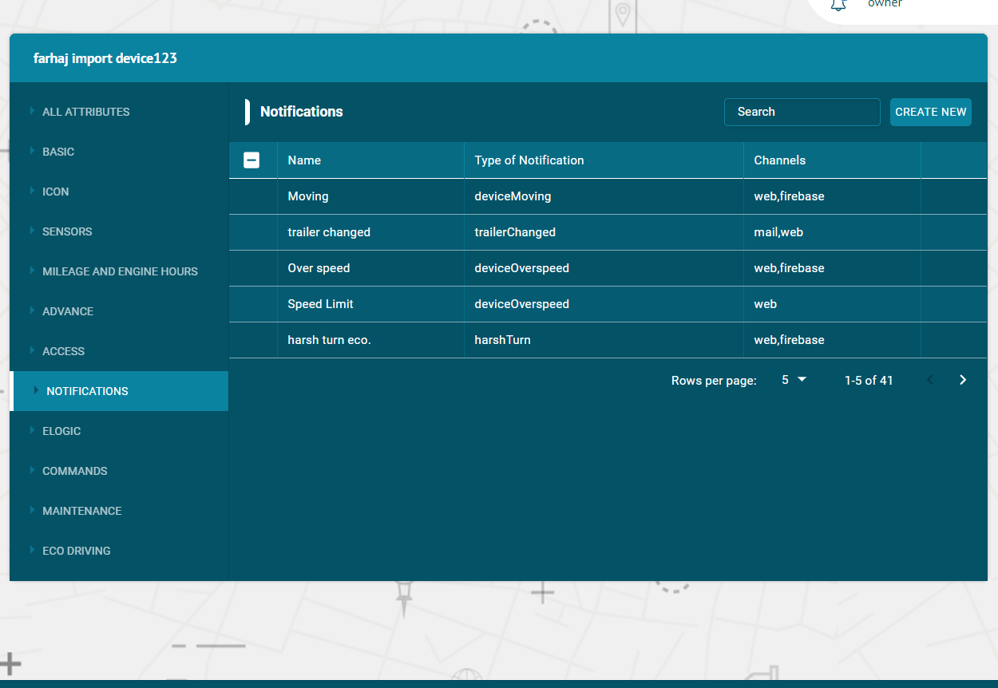

Create Notification
Notification can be created for individual units and groups.
To create a notification:
- Click on the Create new button
Functional Type:
- Select the functional type of notification from dropdown list including Movement, Maintenance Reminder, Digital, Analog etc.
- Select the Unit, Group or Staff to assign notification. In case of maintenance reminder, you cannot select the unit from this option. You can create a maintenance notification and assign it to a unit from the ‘MAINTENANCE’ module.
- Select All Units check box (optional: If user select this check box then created notification is automatically assigned to all units)
- Click on the ‘NEXT’ button.
Notificators:

- Select ‘NOTIFICATORS’ for setting notification medium from email, web popup, and mobile notifications.
- Click on Next button.
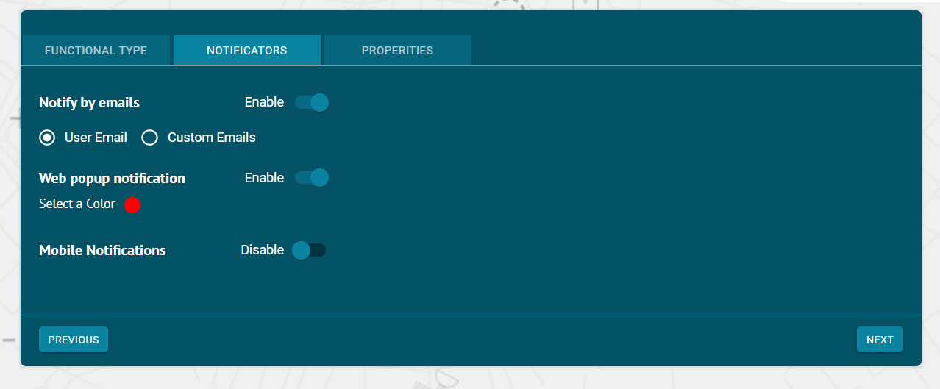
Properties:
Basic:
- Name:
Enter the name of the notification in this option.
- Description:
Enter any description that you want to add for the notification.
- Alarm State/sec:
Enter the alarm state (in seconds) which is the duration for which you want to trigger the notification.
- Interval/min:
Enter the time interval (in minutes) which is the time duration between subsequent notifications.

Time Control:
You can apply time control on the notification according to your requirement.
Weekly:
Select the days on which you want to receive notification.
Custom:
- Select the time span, dates and months at which you want to receive the notification.
- You can also select multiple time slots by clicking on the ‘ADD ANOTHER SLOT’ button.
- You can check the days on which you want to receive the notification.
- Check the month in which you want to receive the notification.

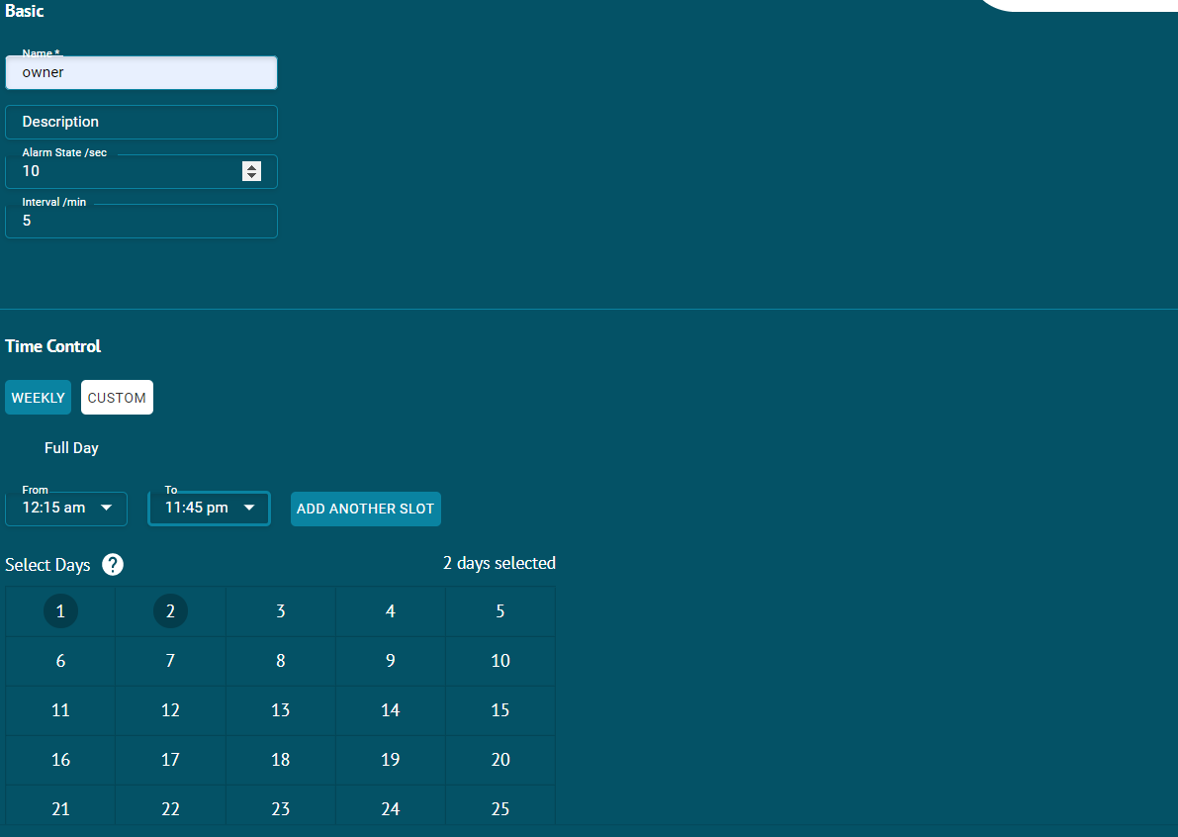
Assign Notifications
- To assign notifications to the units — Click on the unit and then Notifications tab.
- Click on the check boxes of the Notifications to assign this unit.
- The notifications with the right tick in the check boxes are those who already have some access to this unit.
- The notifications with the empty check boxes are those who doesn't have access to this unit.

Search Notification
- To find the required notification in the notifications list, use the search field above notifications list.
- Enter the required notification name in search field, the result will display.

Delete Notification
To delete a notification:
- Select the notification on the notifications list and click on Delete icon next to notification name in the notifications list
- The notification will be deleted successfully and will not be displayed in the notifications list.

Update Notification
To update a notification:
- Select the notification on the notifications list and click on Edit icon next to notification name in the notifications list
- Update the notification information that user wants to update and then click on update button.
The notification information will be updated successfully.

ELOGIC

In the ELOGIC tab, users can create, edit, delete or view parameters and can assign ELOGIC to the units.
In the flotilla IOT, ELOGICS can be of any names. Some names are predefined in the device configuration. ELOGIC are the required sensor property. Sensors fetch the data on the basis of ELOGIC set during device configuration. ELOGIC can also be used to create sensors.
Users need to have access right to create, edit, assign and delete ELOGIC. Otherwise, user can only view existing ELOGICS.
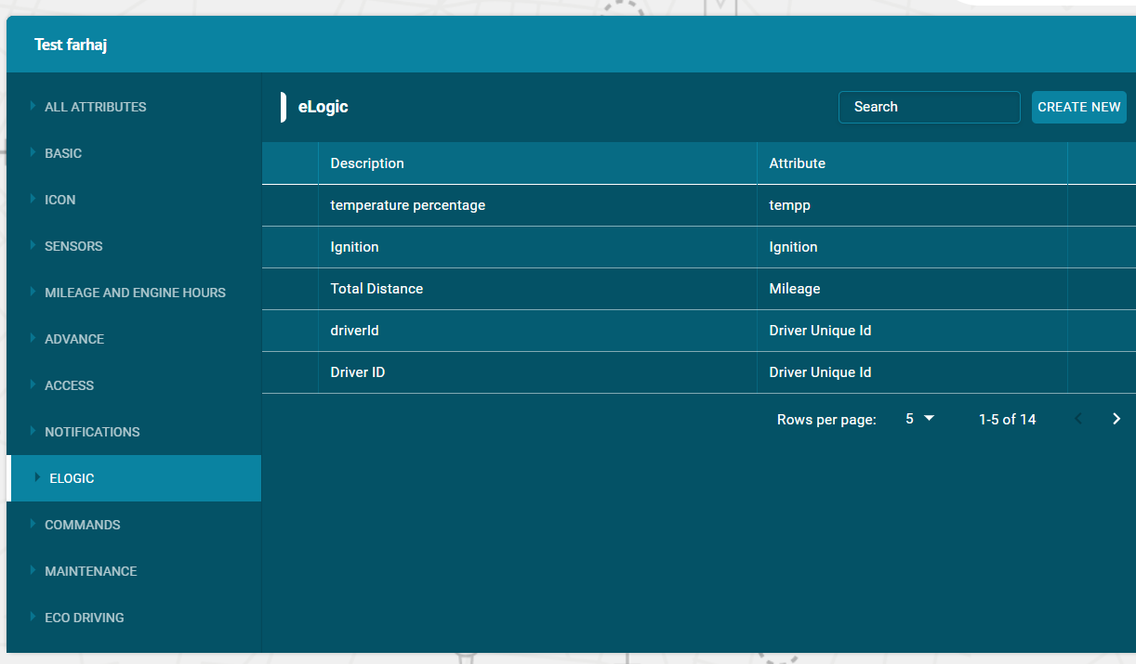

Create ELOGIC
To create a ELOGIC
- Click on the Create new button
- Enter description of the ELOGIC
- Enter attributes of the ELOGIC
- Enter the ELOGIC /input value
- Enter Type (String, Number, Boolean)
- Click on Add button.

Assign ELOGIC
- To assign ELOGIC to the units — Click on the unit and then ELOGIC tab.
- Click on the check boxes of the ELOGICS to assign this unit.
- The ELOGIC with the right tick in the check boxes are those who already have some access to this unit.
- The ELOGICS with the empty check boxes are those who do not have access to this unit.

Search ELOGIC
- To find the required ELOGIC, use the search field above list. Enter the required ELOGIC’s name in search field, the result will display.

Delete ELOGIC
To delete a ELOGIC:
- Select the ELOGIC in the list and click on Delete icon next ELOGIC’s name.
- The ELOGIC will be deleted successfully and will not be displayed in the list.

Update ELOGIC
To update a parameter:
- Select the ELOGIC in the list and click on Edit icon next to ELOGIC’s name in the list
- Update the customized information that user wants to update
- Click on update button.
- The ELOGIC information will be updated successfully.

Commands

In the Commands tab of the Unit options, users can create, edit, delete and configure commands to be sent to the units.
To send a command to the unit, user need to have access right to create, edit, assign and delete commands. Otherwise, user can only view existing commands.
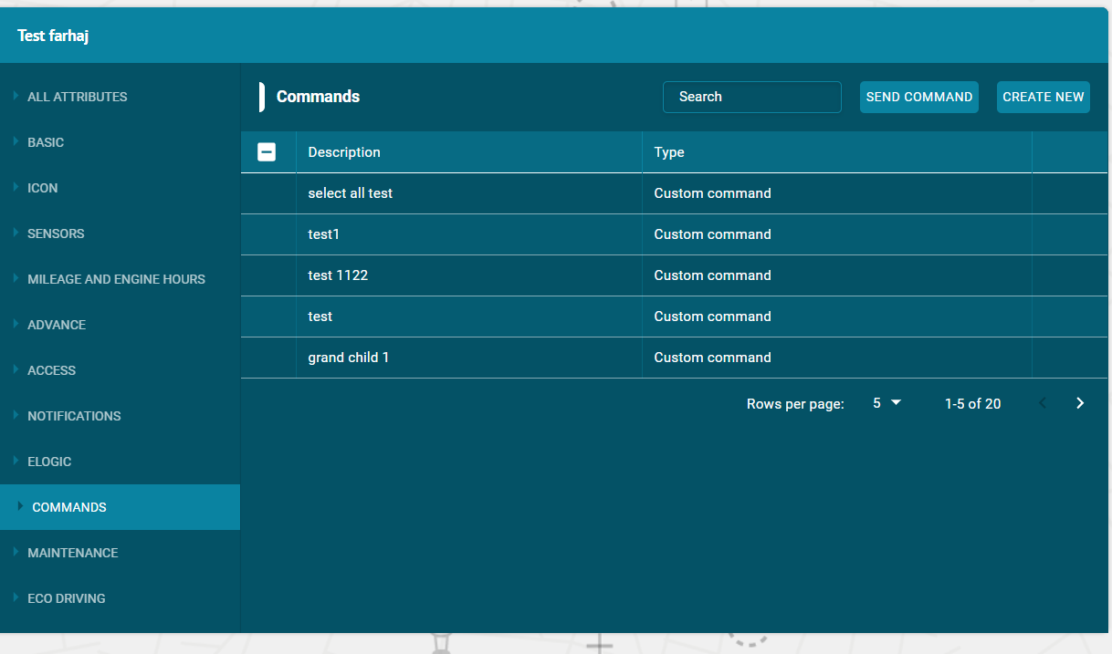

Create Command
To create a command:
- Click on the Create new button
- Enter description of command
- Select send SMS check box (optional)
- Select type of command from dropdown list
- Click on Add button.

Assign Commands
- To assign commands to the units — Click on the unit and then Commands tab.
- Click on the check boxes of the Commands to assigned this unit.
- The commands with the right tick in the check boxes are those who already have some access to this unit.
- The commands with the empty check boxes are those who doesn't have access to this unit.

Search Command
- To find the required command in the commands list, use the search field above commands list.
- Enter the required command name in search field, the result will display.

Delete Command
To delete a command:
- Select the command on the commands list and click on Delete icon next to command name in the command list
- The command will be deleted successfully and will not be displayed in the commands list.

Update Command
To update a command:
- Select the command on the commands list and click on Edit icon next to command name in the commands list
- Update the command information that user wants to update
- Click on UPDATE button.
- The command information will be updated successfully.

Maintenance

In the Maintenance tab of the Unit options, users can create, edit, delete and configure maintenance and assign to the units.
The Maintenance list contains the list of the service works performed during the indicated period and registered by the user for the selected unit. To configure maintenance to the unit, user need to have access right to create, edit and delete maintenance. Otherwise, user can only view existing maintenance.
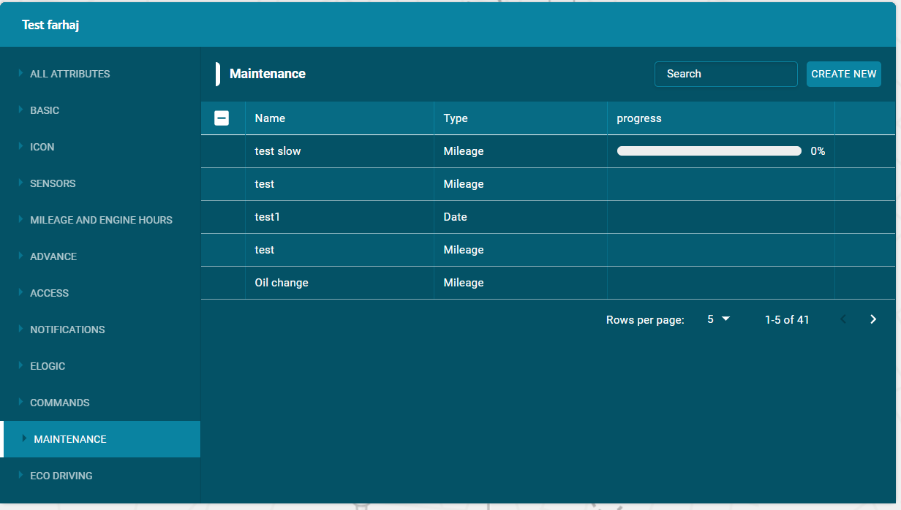

Create Maintenance
To create a maintenance:
- Click on the Create new button
- Enter the name of a maintenance
- Select type of maintenance from dropdown list
- Enter Start and Period time
- Click on Add button.

Assign Maintenance
- To assign maintenance to the units — Click on the unit and then Maintenance tab.
- Click on the check boxes of the Maintenance to assign this unit.

- The maintenances with the right tick in the check boxes are those who already have some access to this unit.
- The maintenances with the empty check boxes are those who doesn't have access to this unit.

Search Maintenance
- To find the required maintenance in the maintenance list, use the search field above maintenance list.
- Enter the required maintenance name in search field, the result will display.

Delete Maintenance
To delete a maintenance:
- Select the maintenance on the maintenance list and click on Delete icon next to maintenance name in the maintenance list
- The maintenance will be deleted successfully.

Update Maintenance
To update a maintenance:
- Select the maintenance on the maintenance list and click on Edit icon next to maintenance name in the maintenance list
- Update the maintenance information that user wants to update
- Click on UPDATE button.
The maintenance information will be updated successfully.

Eco Driving

In the Eco Driving tab on the unit’s options, users can add the eco-driving criteria. Set the templates: use a preset (Bus, truck, Automobile). Eco Driving is a form where user can set the parameters used for accountability of drivers during driving.
Flotilla IOT provides three templates, select one of the three available templates: Bus, truck, Automobile.
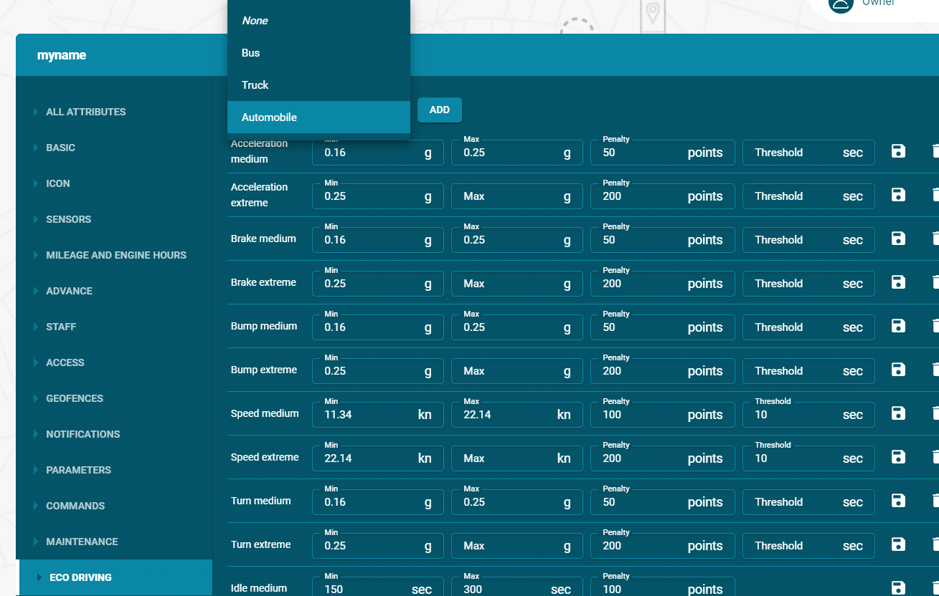
Add Eco Driving
- Select the values against all the parameters like acceleration, brake, bump, speed etc. according to your convenience.
- Click on the ADD button to add new Eco Driving criteria.
Update Eco Driving
- Select the values against all the parameters like acceleration, brake, bump, speed etc. according to your convenience.
- Click on UPDATE button on the right side of the values to save changes
Delete Eco Driving
- Click on the Delete button next to the update option to delete an Eco driving parameter.

Groups

Groups are used in the Flotilla IOT system to add a multiple number of units. A group is a series of monitoring units that are combined together for monitoring and management purposes. Created units are combined to form a group on the basis of some criteria.
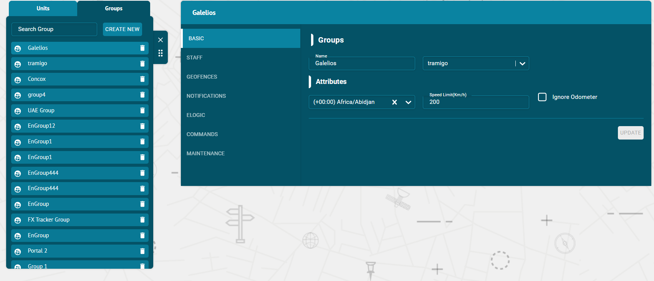

Create group

To create a group:
- Select the groups list and then click on create new button.
- Enter the name of a new group
- Enter the Attributes of a group
- Click on Create new button
- The group will be created successfully and displayed in the groups list.

Search group

- To find the required group in the groups list, use the search field above groups list.
- Enter the required group name in search field, the result will display.

Delete group

To delete a group:
- Select the group and click on Delete icon next to group’s name in the list
- The group will be deleted successfully and will not be displayed in the units list.

Update group

To update a group:
- Click on the group in the groups list
- Select the Basic tab
- Update the group information that user wants to edit and then click on update button
- The group information will be updated successfully.

Groups options

Flotilla IOT provided some options of the group that options can be displayed by clicking on the group in the groups list.
Following are the group options that are the mention in the Flotilla IOT system. The number of options can vary depending on provided access rights.
- BASIC
- STAFF
- GEOFENCES
- NOTIFICATIONS
- ELOGIC
- COMMANDS
- MAINTENANCE
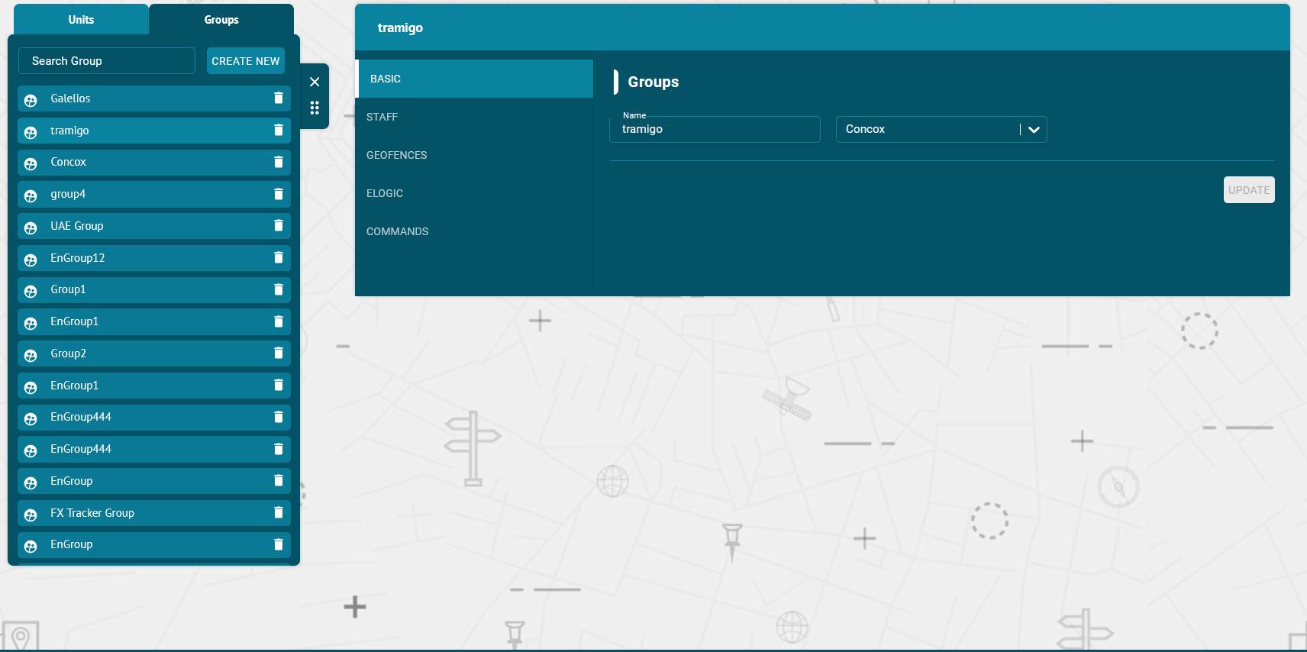

Basic

On the Basic tab of the Group options, user can update or set the information about the groups.
- Set the following parameters
Required information of the unit:
- Name
Set the specific name of the group in the Name option or search group from the drop down list
- Parent Group:
Select the parent group from the list.
Attributes:
- Time Zone
Set the time Zone of the unit i.e. Asia/Dubai etc.
- Speed
Set the speed limit of the unit in km/h.
- Ignore Odometer
Check the ‘Ignore Odometer’ checkbox to ignore odometer for the group.
Staff
In the Staff tab of the Group options, Flotilla IOT provides a possibility to assign and manage the list of staff (drivers). To work with Staff, select the Staff tab in the main menu. User needs to have access right to create, edit, assign and delete staff. Otherwise, user can only view existing staff.

- To give the access — to assign group access rights to the staff (drivers), Click on the group and then Staff tab.
- Click on the check boxes of the drivers to assign this group access.
- The drivers with the right tick in the check boxes are those who already have some access to this group.
- The drivers with the empty check boxes are those who doesn't have access to this group.
Assign Staff
- Check the checkbox before the Staff name to assign staff to the unit.
- Check the checkbox before the Staff option to assign all staff entities to the unit.
- The drivers with the empty check boxes are those who doesn't have access to this group.

Search Staff
- To find the required driver in the staff list, use the search field above staff list.
- Enter the required driver name in search field, the result will display.

Delete Staff
To delete a driver:
- Select the driver on the staff list and click on Delete icon next to driver’s name in the staff list
- The driver will be deleted successfully and will not be displayed in the staff list.

Update Staff
To update a driver:
- Select the driver on the staff list and click on Edit icon next to driver’s name in the staff list
- Update the driver information that user wants to update and then click on update button.
The driver information will be updated successfully.
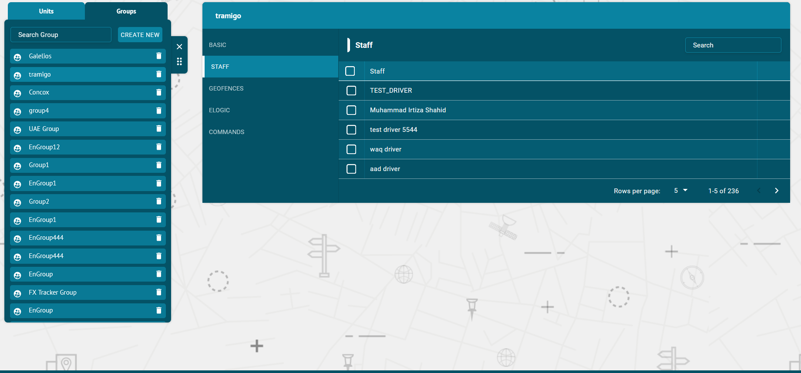

Geofences

In the geofences tab of the Group options, users can view or delete geofences and can assign geofences to the groups.
A geofence can have a shape of a circle, a polygon (2-dimensional shape formed with straight lines), or a polyline (one or more paths, a path is a series of connected segments). Geofences are widely used in Flotilla IOT. Geofences can be used in reports, notifications, etc.
Geofence is an area on the map that is important for tracking purposes. User can choose a name, description and color for a geofence.
To work with geofences, select the Geofences tab in the main menu. User need to have access right to create, edit, assign and delete geofences. Otherwise, user can only view existing geofences.

Assign Geofences
- To assign geofences to the groups — Click on the unit and then Geofences tab.
- Click on the check boxes of the geofences to assign this group.
- The geofences with the right tick in the check boxes are those who already have some access to this group.
- The geofences with the empty check boxes are those who doesn't have access to this group.

Search Geofences
- To find the required geofence in the geofences list, use the search field above geofences list.
- Enter the required geofence name in search field, the result will display.

Delete Geofence
To delete a geofence:
- Select the geofence on the geofences list and click on Delete icon next to the geofence name
- The geofence will be deleted successfully and will not be displayed in the geofences list.
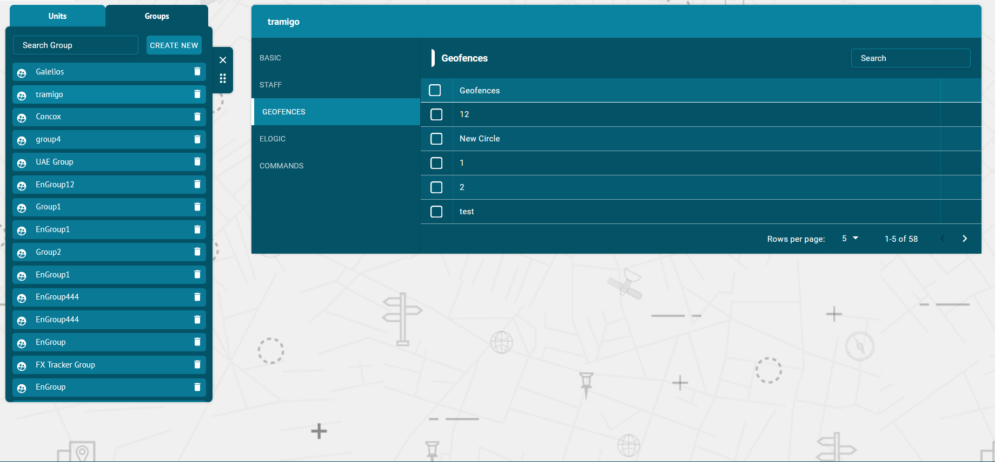

ELOGIC
On the ELOGICs tab of the Group options, users can create, edit, delete or view ELOGICs and can assign ELOGICs to the groups.
In the flotilla IOT, ELOGICs can be of any names. Some names are predefined in the device configuration. ELOGICs is a required sensor property. Most of the sensors are based on the ELOGIC configuration setting of the device. ELOGIC can also be used to create sensors.
To work with the ELOGICs, choose the ELOGICs tab in the Units component. User need to have access right to create, edit, assign and delete ELOGICs. Otherwise, user can only view existing ELOGICs.

Create ELOGIC
To create an ELOGIC:
- Click on the Create new button
- Enter description of the ELOGIC
- Enter attributes of the ELOGIC
- Enter the ELOGIC/input value
- Enter Type (String, Number, Boolean)
- Click on Add button.

Assign ELOGIC
- To assign ELOGICs to the groups — Click on the group and then ELOGICs tab.
- Click on the check boxes of the ELOGICs to assign this group.
- The ELOGICs with the right tick in the check boxes are those who already have some access to this group.
- The ELOGICs with the empty check boxes are those who doesn't have access to this group.

Search ELOGIC
- To find the required ELOGIC in the ELOGICs list, use the search field above ELOGICs list.
- Enter the required ELOGIC name in search field, the result will display.

Delete ELOGIC
- To delete an ELOGIC:
- Select the ELOGIC on the ELOGICs list and click on Delete icon next to ELOGIC name in the ELOGICs list
- The ELOGIC will be deleted successfully and will not be displayed in the ELOGICs list.

Update ELOGIC
To update an ELOGIC:
- Select the ELOGIC on the ELOGICs list and click on Edit icon next to ELOGIC name in the ELOGICs list
- Update the ELOGIC information that user wants to update and then click on update button.
- The ELOGIC information will be updated successfully.
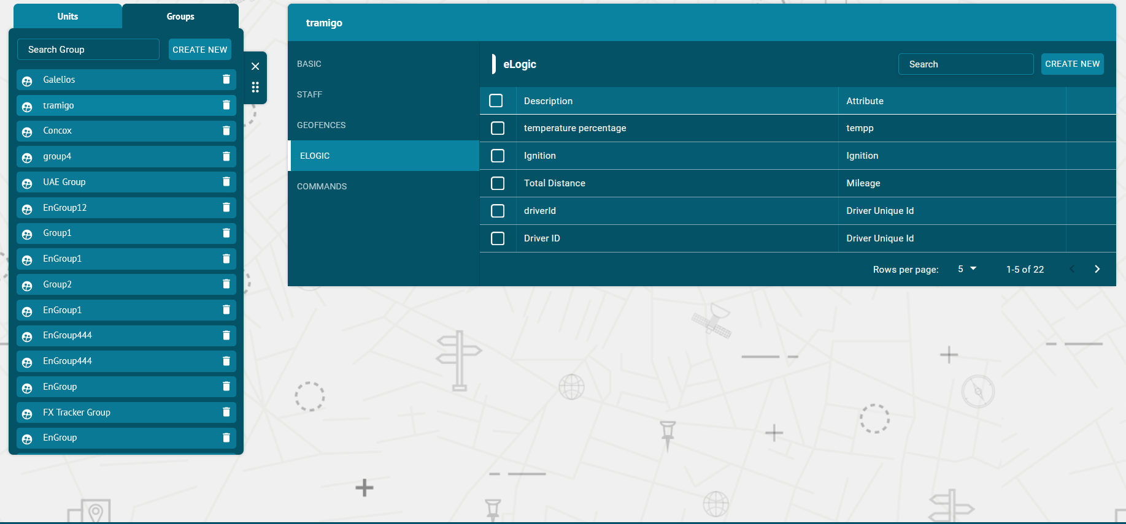
Commands

In the Commands tab of the Group options, users can create, edit, delete and configure commands to be sent to the groups.

To send a command to the group, user need to have access right to create, edit, assign and delete commands. Otherwise, user can only view existing commands.

Create Command
To create a command:
- Click on the Create new button
- Enter description of command
- Select send SMS check box (optional)
- Select type of command from dropdown list
- Click on Add button.

Assign Commands
- To assign commands to the groups — Click on the group and then Commands tab.
- Click on the check boxes of the Commands to assign this group.
- The commands with the right tick in the check boxes are those who already have some access to this group.
- The commands with the empty check boxes are those who doesn't have access to this group.

Search Command
- To find the required command in the commands list, use the search field above commands list.
- Enter the required command name in search field, the result will display.

Delete Command
To delete a command:
- Select the command on the commands list and click on Delete icon next to command name in the command list
- The command will be deleted successfully and will not be displayed in the commands list.

Update Command
To update a command:
- Select the command on the commands list and click on Edit icon next to command name in the commands list
- Update the command information that user wants to update and then click on update button.
- The command information will be updated successfully.
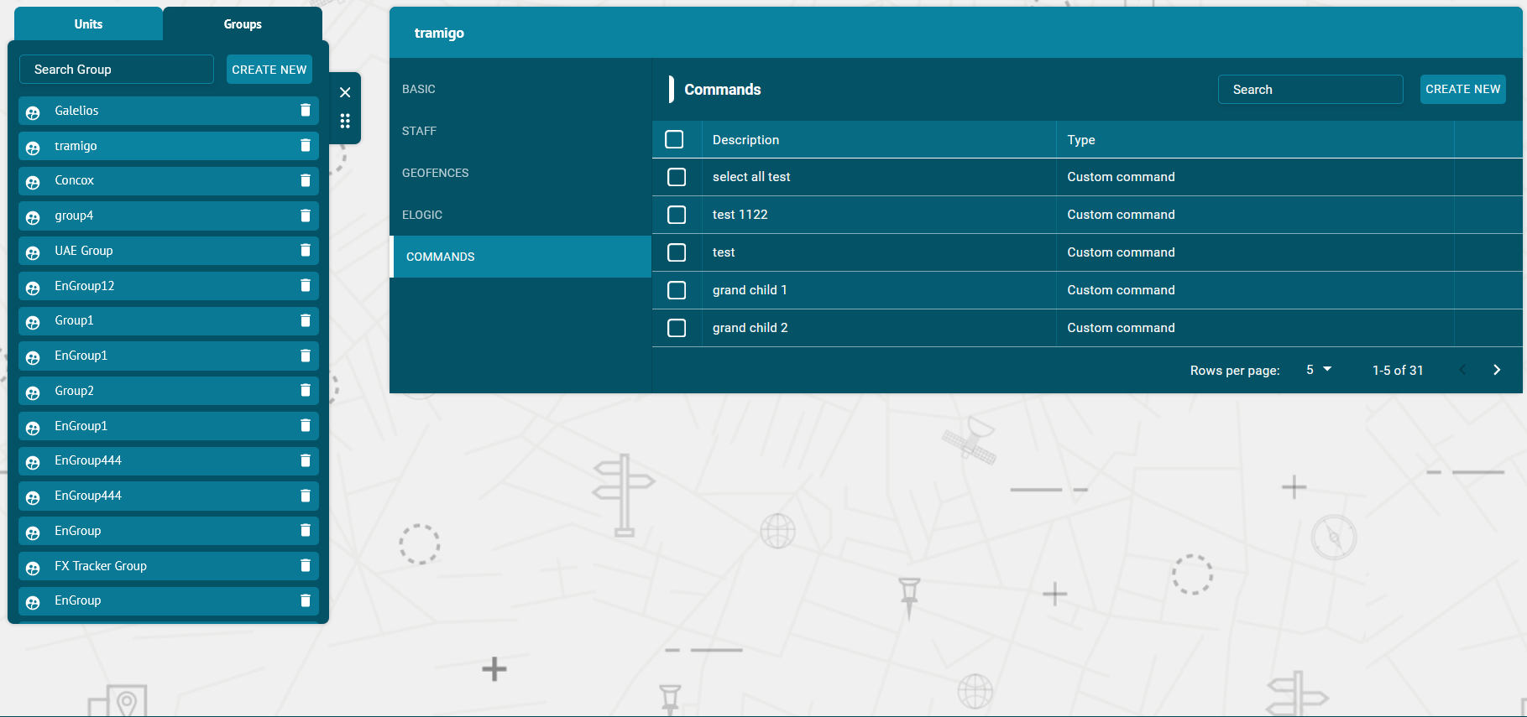
Users

Flotilla IoT provides the user’s module in which users can create, edit, view, or delete other users. It also allows you to assign units, groups, drivers to different users. You need to have access right to create, edit, view, and delete users. Otherwise, users can only view existing users. User can also generate the public login link to login into the flotilla IoT.

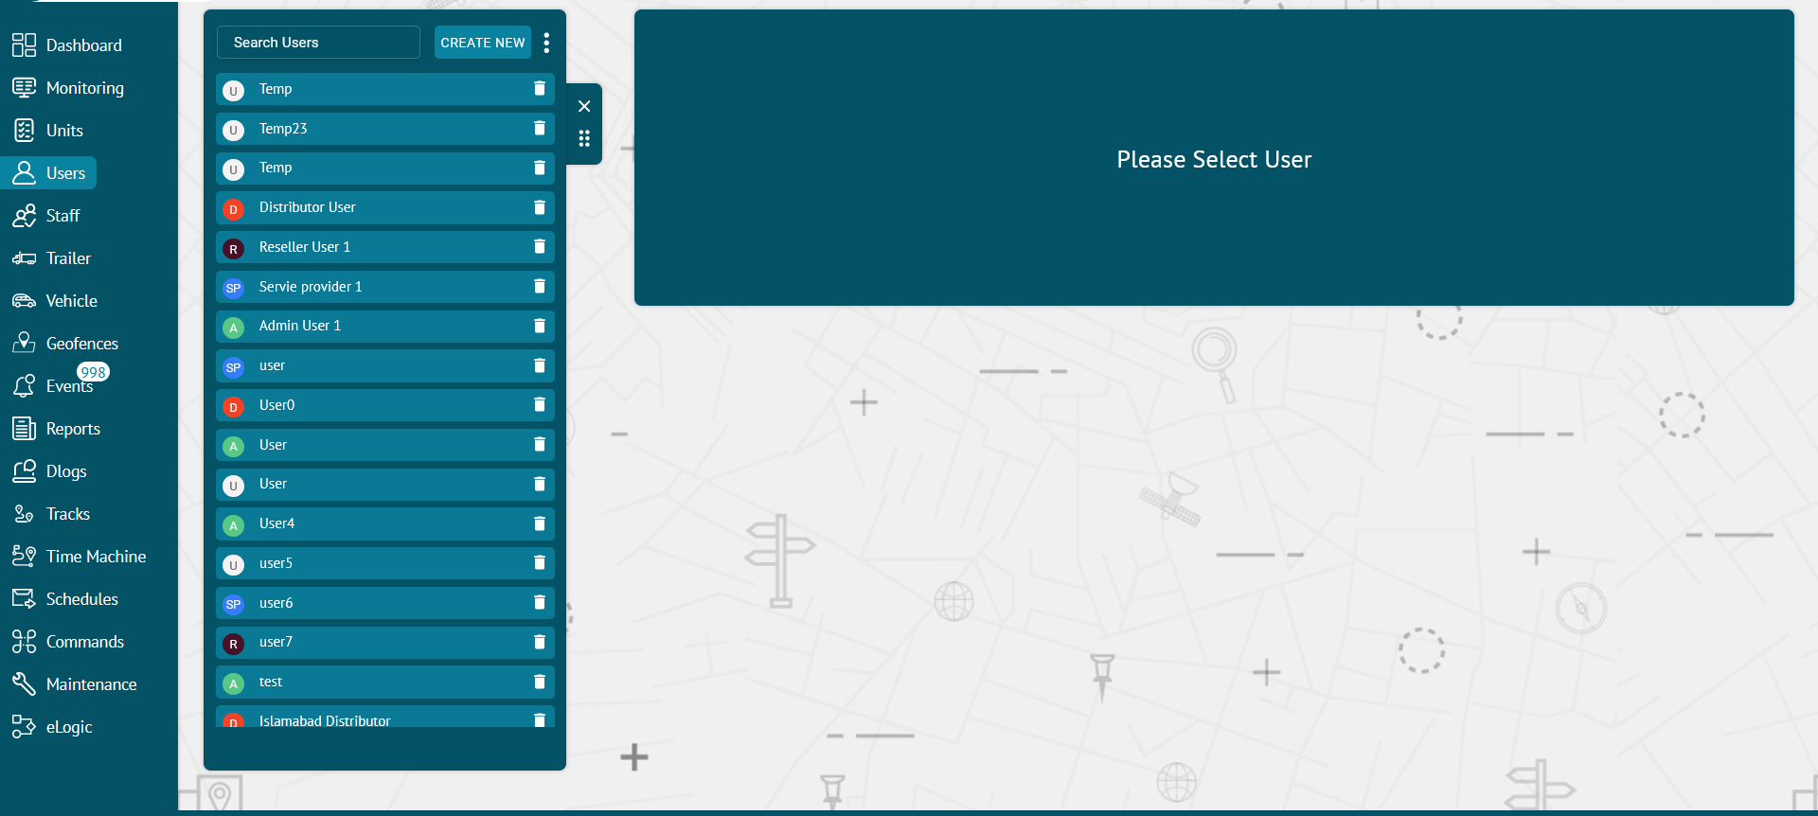

Create User

- Click on the Create new button from the Users tab module

- Enter the following required information of the user:

Name

- Set the specific name of the user

Email

- Set the email of the user

Password

- Set the specific password of the user.
- Add password again in the confirm password option.

User Type

Select the user type from the drop down list.

Preferences

Phone

- Set the phone number of the user. The phone number should be in the international format.

Coordinates Format

- Set the coordinates format from the dropdown

POI Layer

- Set the POI layer

Latitude/ longitude
- Set the latitude, longitude to determine the location of the user.
Zoom Options
- Select the zooming limit of the map.

Attributes

- Set all attributes of the user including maximum zoom, zoom on select, time zone, measurement standard.
- After adding all the information, click on CREATE NEW option.
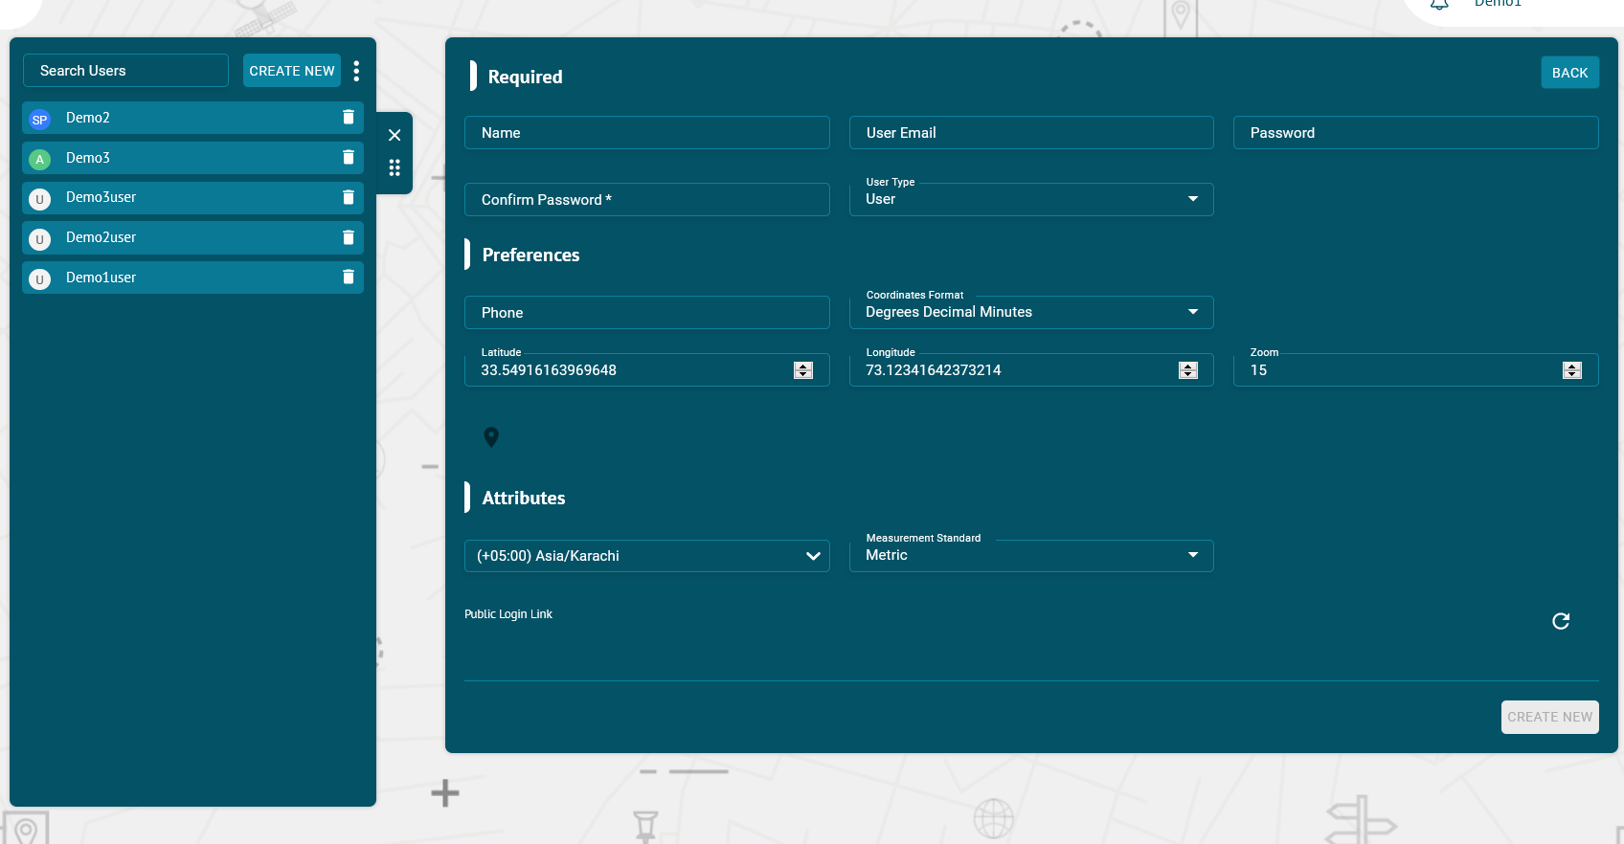

Search and View User

- To find the required user in the user’s list, use the search field above the staff list.
- Enter the required user name in the search field, the result will display.
- Click on the name of the user and following information will show up:
BASIC
- It contains the basic information of a user like name, email, phone etc.
UNITS
- It includes the different units that are either directly created by the user or created by a child of the user. By checking the checkbox, the unit can be assigned to the user.
GROUPS
- It includes all the groups that are either directly created by the user or created by a child of the user. By checking the checkbox, the groups can be assigned to the user.
STAFF
- It includes all the staff that are either directly created by the user or created by a child of the user. By checking the checkbox, the staff can be assigned to the user.
TRAILER:
- It includes the trailers that are either directly created by the user or created by a child of the user. By checking on the checkbox, the trailers can be assigned to the user.
TEMPLATES:
- It includes the reporting templates that are either directly created by the user or created by a child of the user. By checking on the checkbox, the templates can be assigned to the user.
VEHICLE:
- It includes the vehicles that are either directly created by the user or created by a child of the user. By checking on the checkbox, the vehicles can be assigned to the user.
ACCESS
- It includes the different user accounts that are either directly created by the user or created by a child of the user. By checking on the checkbox, access of different users can be assigned to the user.
GEOFENCES
- It includes the geofences that are either directly created by the user or created by a child of the user. By checking the checkbox, the geofences can be assigned to the user.
ELOGIC
- It includes the different ELOGICs that are either directly created by the user or created by a child of the user. By checking the checkbox, the Elogic can be assigned to the user.
- Click on the CREATE NEW button and add description, attribute, expression and return type to create a new eLogic.
COMMANDS
- It includes different commands that are either directly created by the user or created by a child of the user. By checking the checkbox, the commands can be assigned to the user.
- Click on the CREATE NEW button and add description and data attribute to create a new command.
MAINTENANCE
- It includes different types of maintenance that are either directly created by the user or created by a child of the user. By checking the checkbox, the Maintenance can be assigned to the user.
- Click on the CREATE NEW button and add name, maintenance parameter, starting value and period to create a new maintenance.
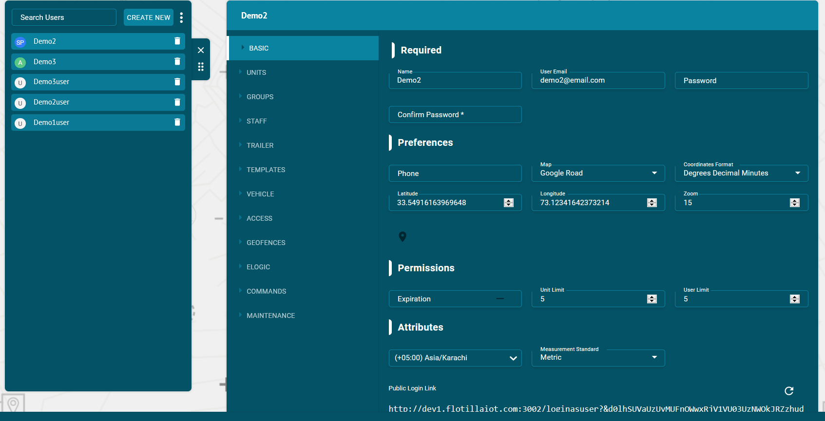
Delete User

- Select the user on the users list and click on Delete icon next to the username

The user will be deleted successfully and will not be displayed in the users list

Update User

- Select the user on the users list.
- Make changes in the information available in Basic tab to update the user information
- Update the user required information.
- Click on UPDATE button.
The user information will be updated successfully.
Staff

Flotilla IoT provides the Staff module functionality in which users can create, edit, view, or delete staff and manage the list of staff (drivers). To work with Staff, select the Staff module on the left from the main menu. Users need to have access right to create, edit, view, and delete staff. Otherwise, users can only view existing staff.
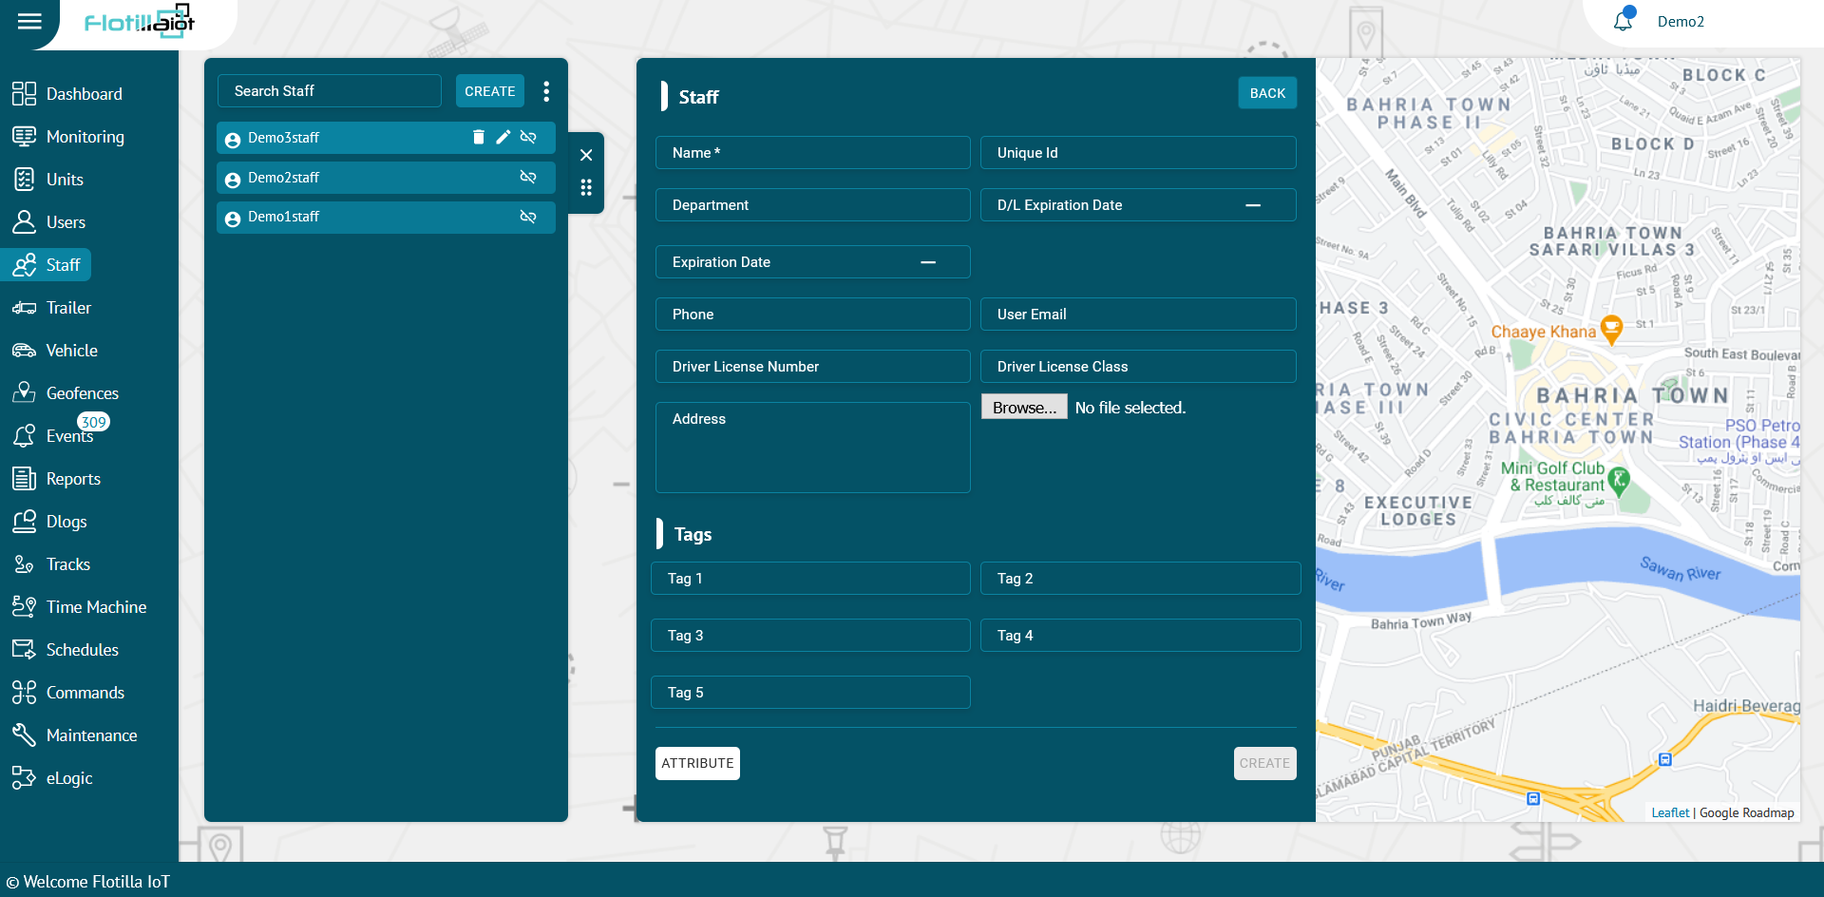

Create Staff

- Click on the Create new button from the Staff module

- Enter the required information of the driver:

Name

Set the specific name of the driver.

Unique ID

Set the unique ID for the driver required to identify it by the system.

Department

Set the department of the driver.

D/L Expiration Time

Set the D/L Expiration Time.

Phone

Set the phone number of the driver. The phone number should be in the international format.

Email

Set the email ID of the driver.

Driver License Number

Set the driver license number.

Driver License Class

Set the driver license class.

Address

Set the driver address.

Profile Image

Set the driver profile image by clicking on CHOOSE FILE option.

Tags
Add different types of tags for staff.

Attributes of the drivers

- To set attributes of the driver – Click on the attribute button
- Search the attributes and click Add button to add attributes.
- After adding all the information, click on CREATE button.
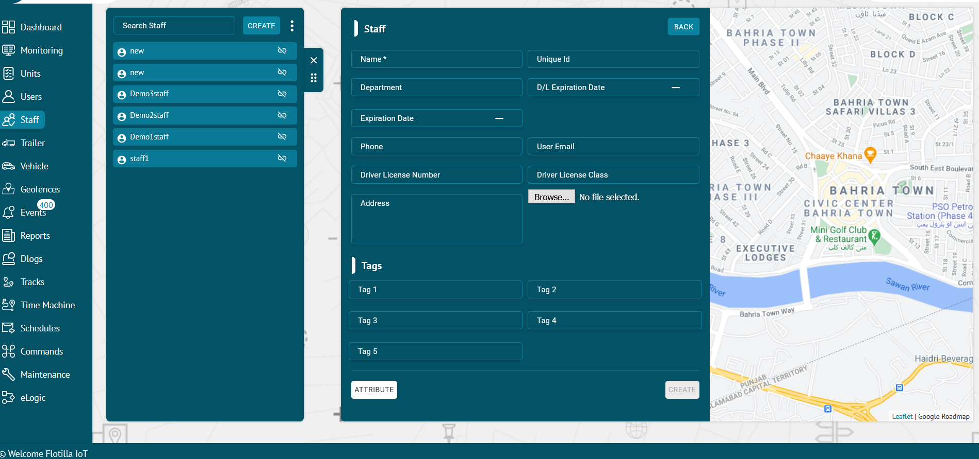

Search Staff

- To find the required driver in the staff list, use the search field above the staff list.
- Enter the required driver name in the search field, the result will display.
View Staff
- Click on the name of the Staff to view its complete information including Name, ID, Driver License Number, Driver License Class, Department etc.
Delete Staff

- Select the driver on the staff list and click on Delete icon next to the driver name
- The driver will be deleted successfully and will not be displayed on the staff list.

Update Staff

- Select the driver on the staff list and click on Edit icon next to the driver name
- Update the driver information that user wants to update and then click on update button.
The driver information will be updated successfully.
Download Staff
Click on the three vertical dots to download any staff's information in Excel and PDF.
Upload Staff
Click on the three vertical dots and select ‘Upload Excel’ option to import any staff information.
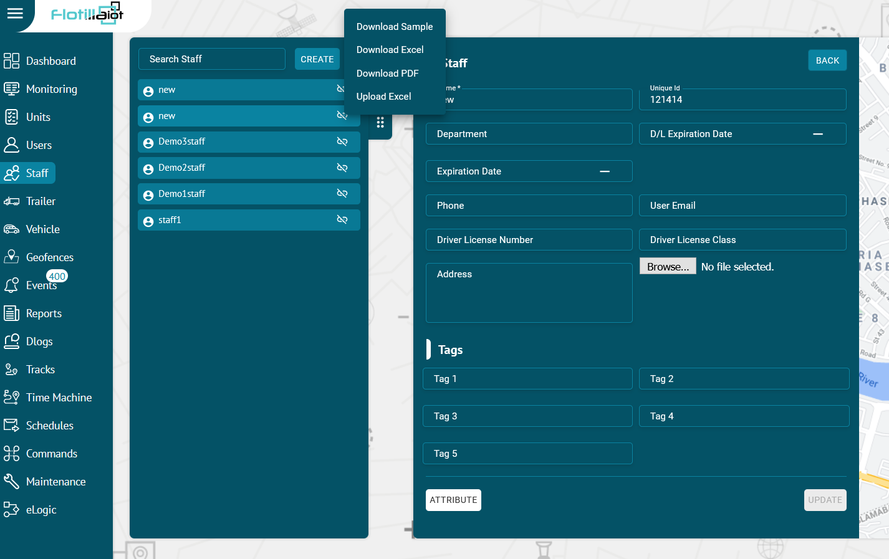

Trailer
Create Trailer

- Click on the Create new button on the top of Trailer module.
- Enter the required information related to trailer.
Trailer Plate
Enter the trailer plate number in this option.

Trailer UUID
Enter the unique trailer UUID number in this option.

Description
Enter the description of the trailer in this option.

Browse
You can add an image related to the trailer by clicking on this option.

Search Trailer

- To find the required trailer in the staff list, use the search field above the staff list.
- Enter the required trailer name in the search field, the result will display.
View Trailer
- Click on the name of the trailer to view its complete information.
Delete Trailer

- Select the trailer from the list and click on Delete icon next to its name.
- The trailer will be deleted successfully and will not be displayed on the trailer list anymore.
Update Trailer

- Select the trailer from the list and click on Edit icon next to its name.
- Update the trailer information that you want to update and then click on the update button.
The trailer information will be updated successfully.
Download Trailer
Click on the three vertical dots to download any trailer's information in Excel and PDF.
Upload Trailer
Click on the three vertical dots and select ‘Upload Excel’ option to import any trailer information.
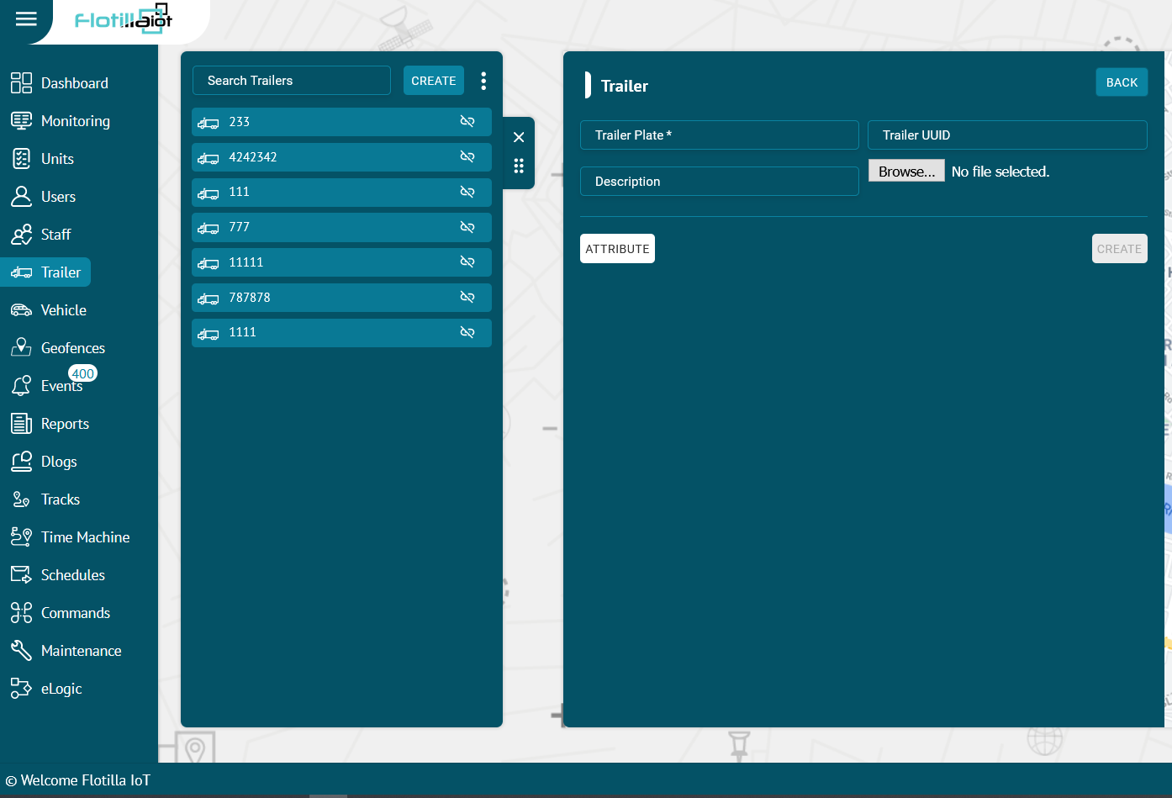
Vehicle

Flotilla IoT provides the Vehicle module functionality in which users can create, edit, view, or delete vehicles. To work with Vehicle, select the Vehicle module on the left from the main menu. Users need to have access right to create, edit, assign, and delete Vehicles. Otherwise, the user can only view the existing Vehicle.
Create Vehicle

- Click on the Create new button from the Vehicle module
- Enter the required information of the vehicle like Label, Model, Color, Garage, Tags etc.
- Click on CREATE button.

Search Vehicle

- To find the required vehicle in the vehicles list, use the search field above the vehicles list.
- Enter the required vehicle name in the search field, the result will display.

Delete Vehicle

- Hover over the vehicle on the vehicles list and click on Delete icon next to vehicle name.
- The vehicle will be deleted successfully and will not be displayed in the vehicles list.

Update Vehicle

- Hover over the vehicle' name on the list and click on Edit icon next to Delete option.
- Update the vehicle information that user wants to update.
- Click on UPDATE button.
- The vehicle information will be updated successfully
Download Vehicle Data:
A user can download vehicles data by clicking on the 'Download Excel' button next to search option.
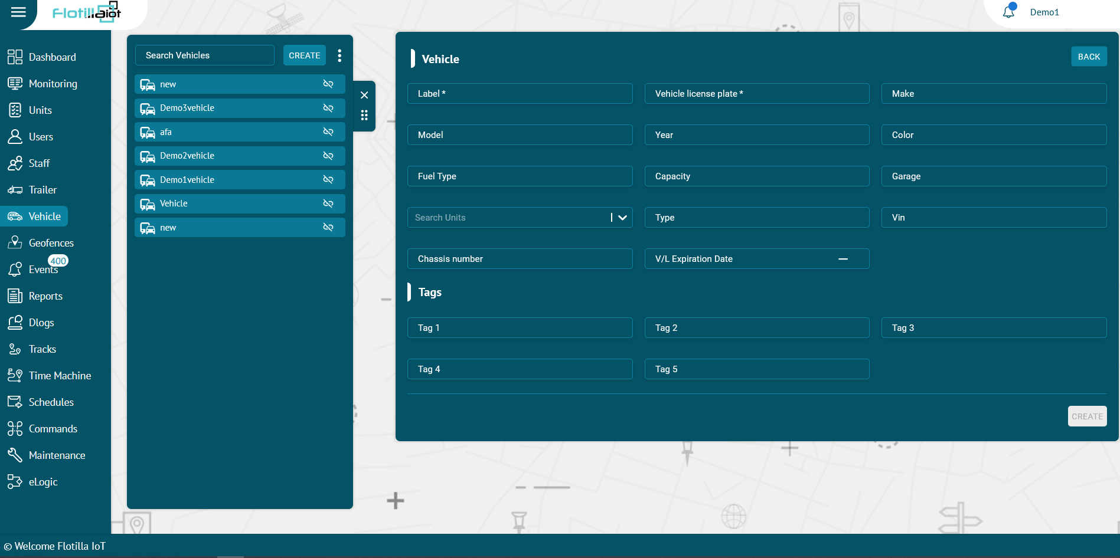
Geofences

In the geofence module, users can create, edit, view or delete geofences. A geofence can have a shape of a circle, a polygon (2-dimensional shape formed with straight lines), or a polyline (one or more paths, a path is a series of connected segments). Geofences can be used in reports, notifications, etc.
Geofence is an area on the map that is important for used route planning track monitoring purpose. User can choose a name, description and color for a geofence to differentiate them. User need to have access right to create, edit, view and delete geofences. Otherwise, user can only view existing geofences.

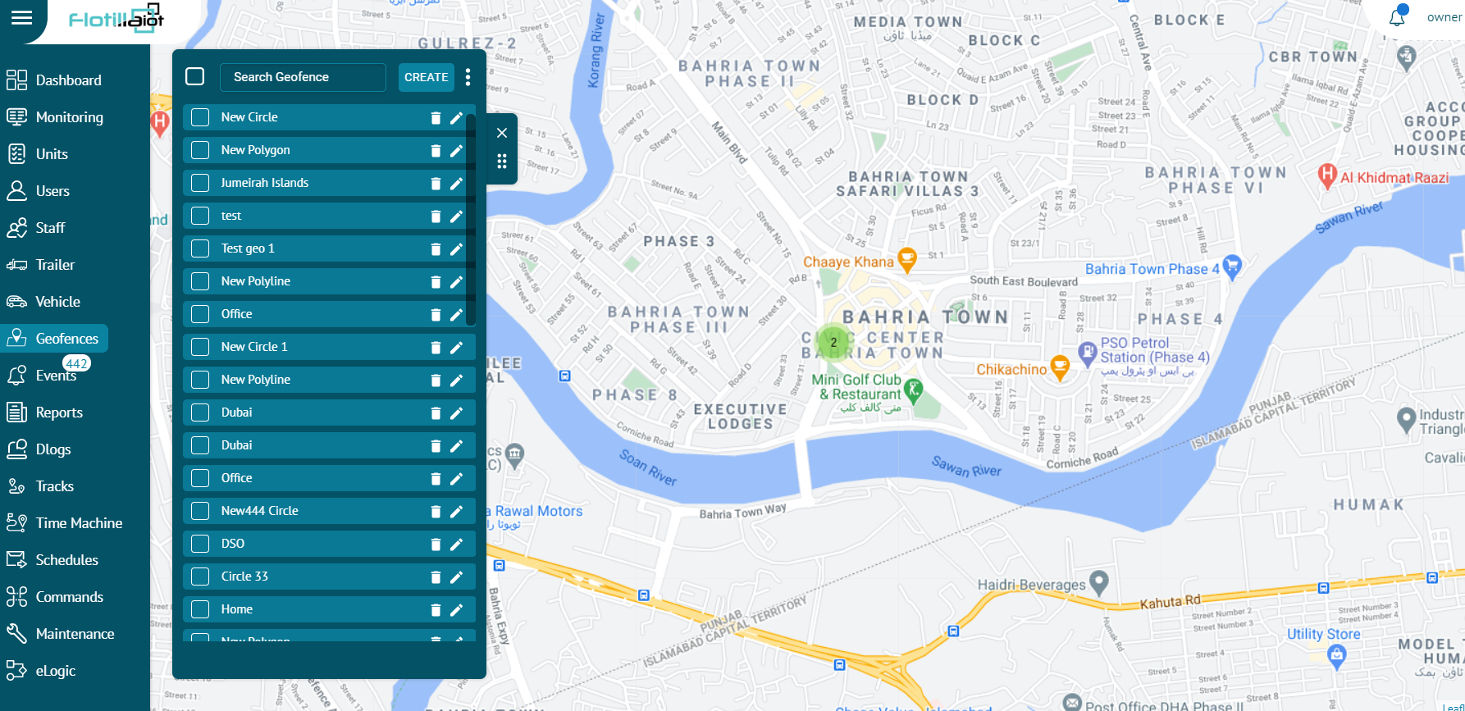

Creating Geofence
To create a geofence:
- Select the Geofences module on the left from the main menu.
- Click on the CREATE NEW button.
- Choose one of these shapes circle, polygon, polyline to draw them on the map.
- Add name and description of the geofence.
- Select the color of the geofence.
- Click on CREATE button to add a new geofence or click CANCEL to dismiss it.
The geofence will be created successfully and display in the geofences list.
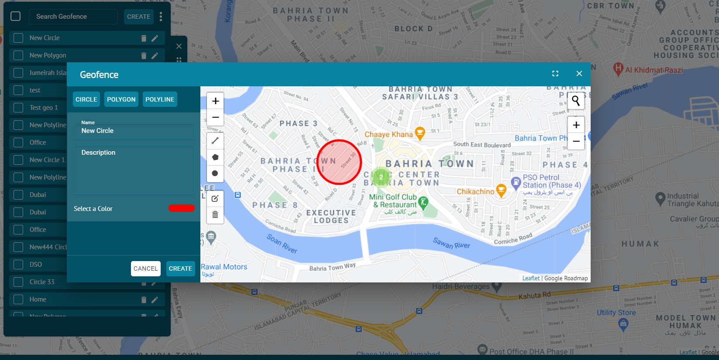
Search Geofences

- To find the required geofence in the list, use the search field above geofences list.
- Enter the required geofence name in search field, the result will display.
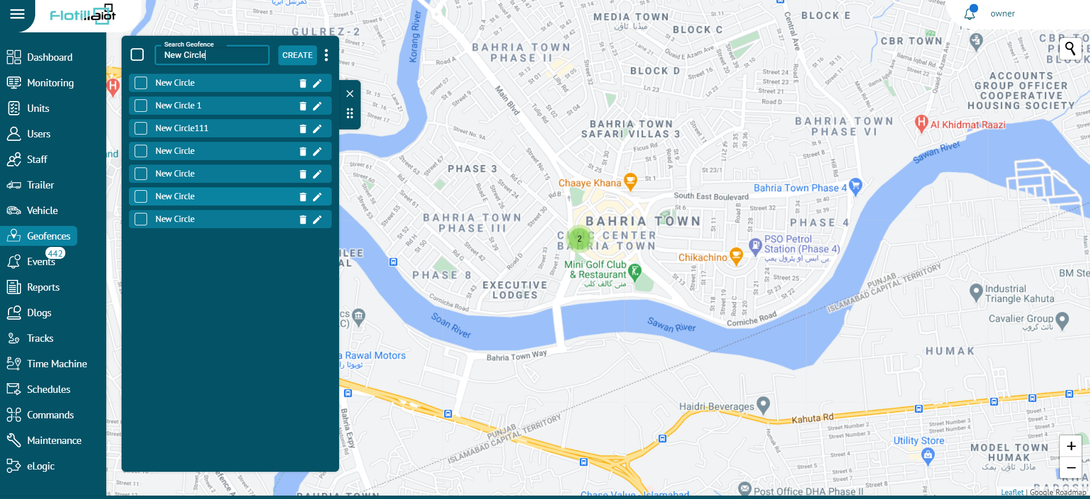
Delete Geofence

To delete a geofence:
- Select the geofence on the geofences list and click on Delete icon right next to its name
The geofence will be deleted successfully and will not be displayed in the geofences list.
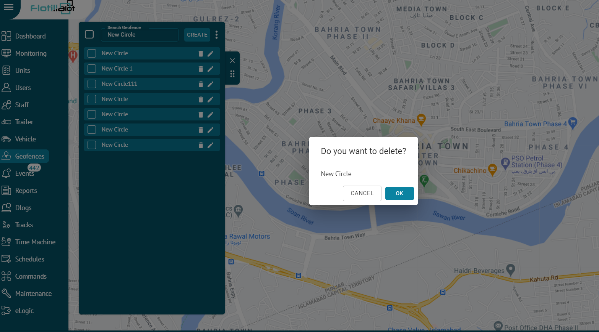
Update Geofence

To update a geofence:
- Select the geofence from the list and click on the Edit icon next to its name.
- Update the geofence information according to your requirement and then click on UPDATE button.
The geofence information will be updated successfully.
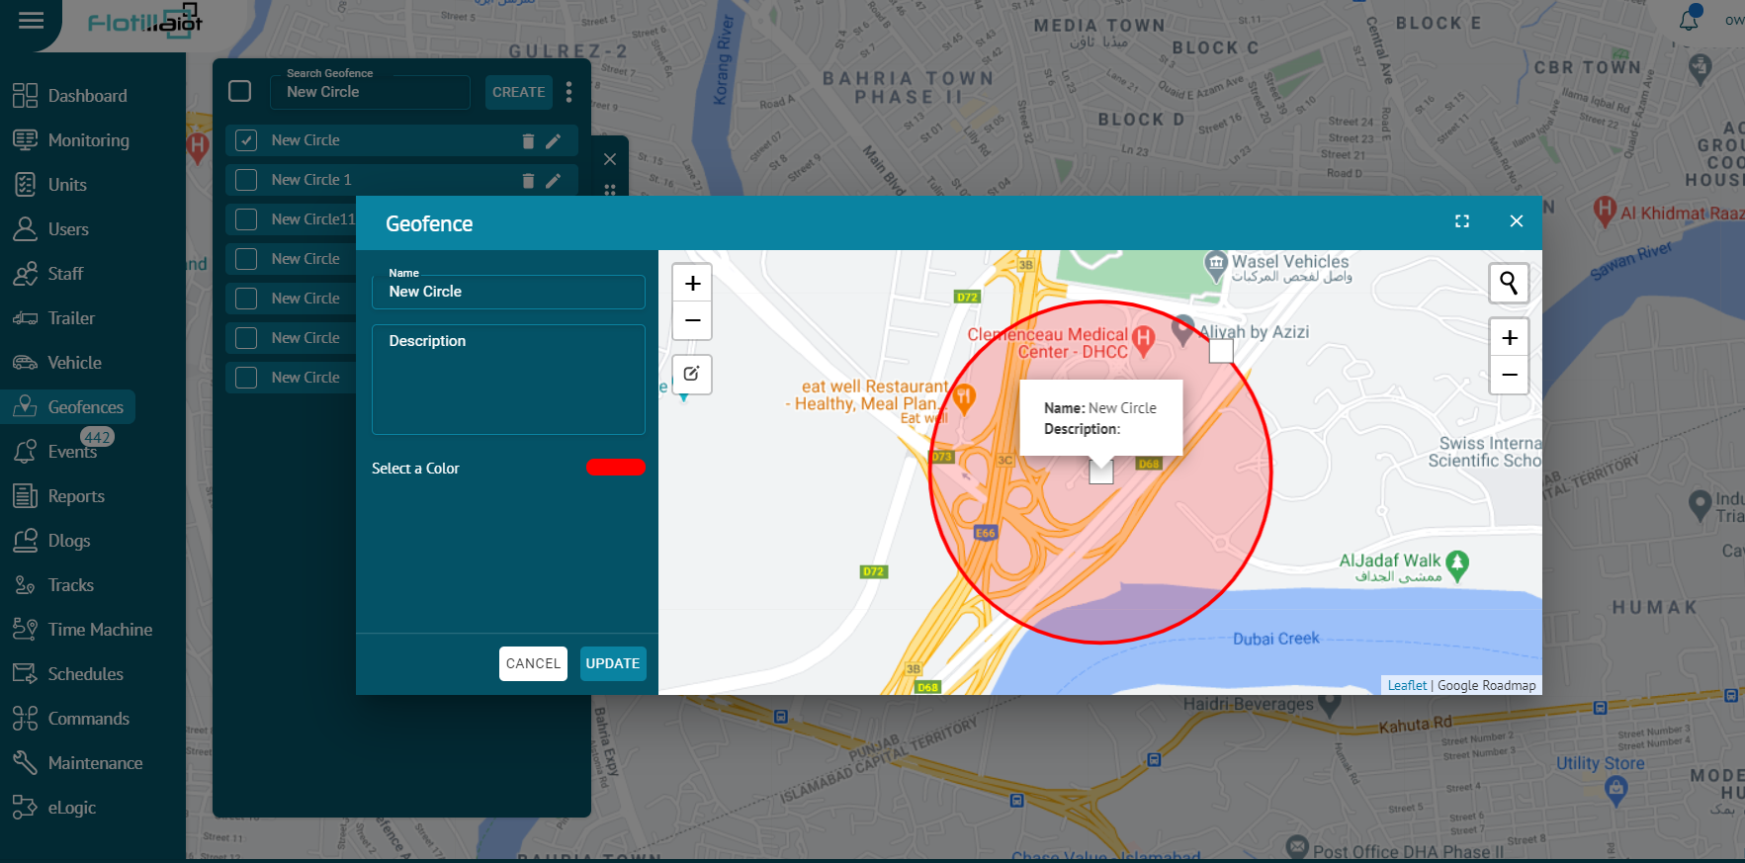

Events

- Events module allows user to manage different notification for units. In the flotilla IoT, users can be notified about any unit’s activity or change. It can be sensors values, change of location, speeding, and others. A notification can be displayed online in a popup window on the system. In this module, users can view the status of the notification of the units for any picked date. Notifications can be set for individual units or groups.

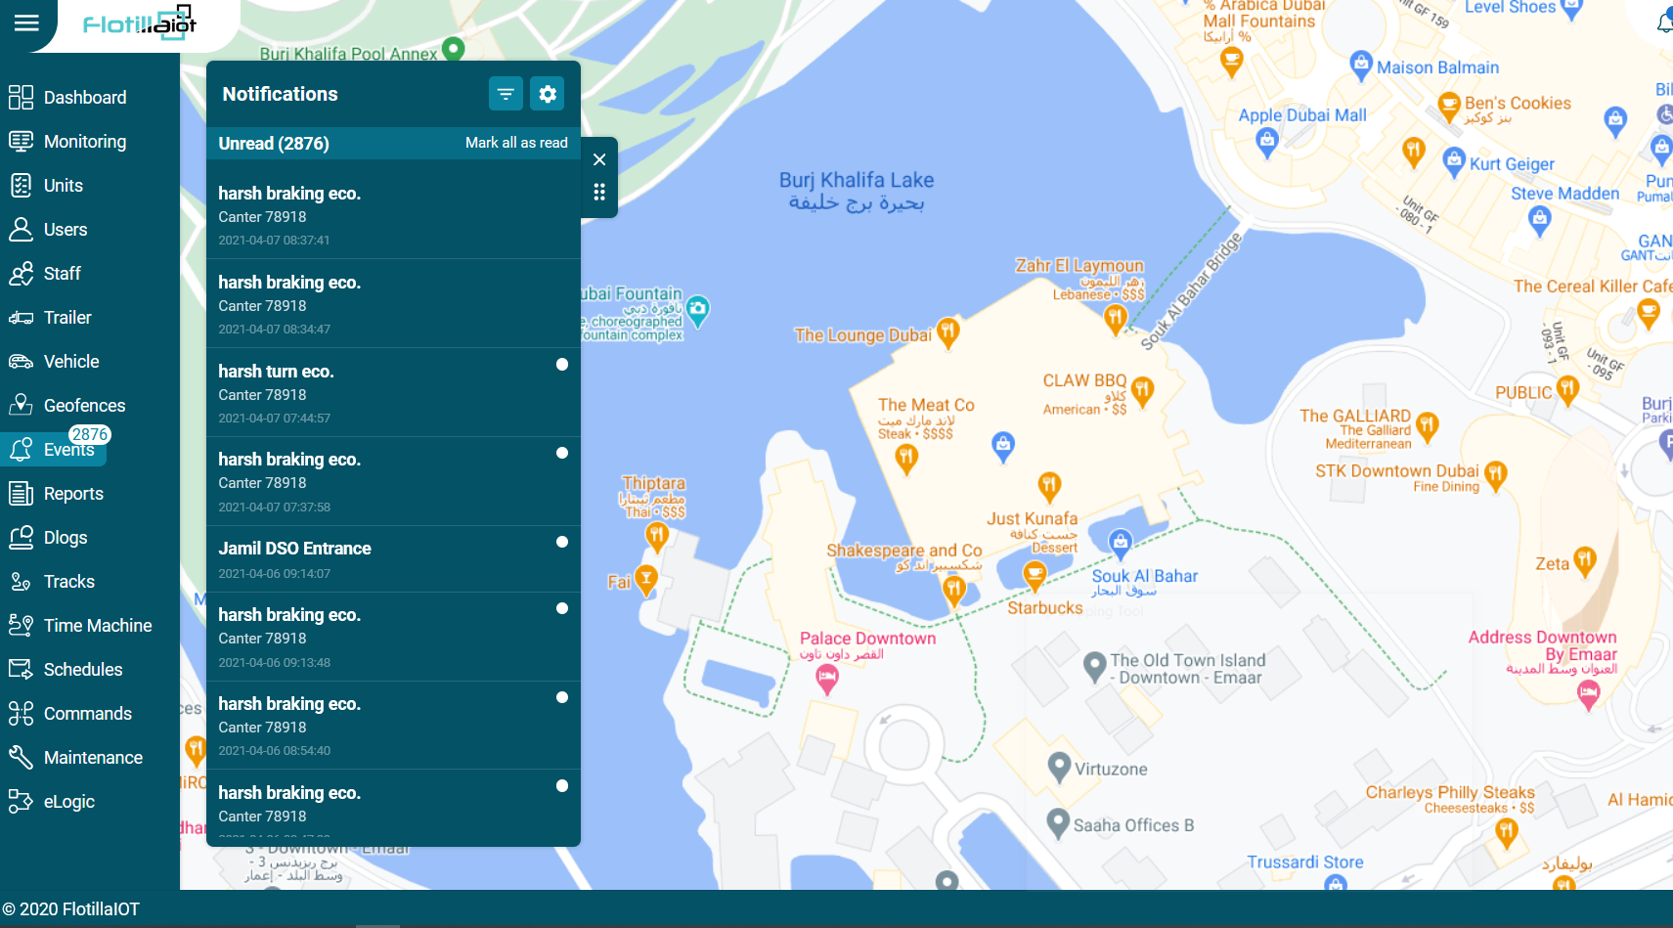

Create New

To generate a new event:
- Click the MANAGE option in the right next to notification filter.
- Click on the CREATE NEW button.
You can create notifications for following events:
Movement
- You can set the notification for individual units or groups.
- You can select the movement notification of various events like geofence entrance, exit, unit movement, unit stop, towing, idling etc.
- Geofence Entrance/Exit:
- Search Geofence: Search the geofence on which you want to apply the event by entering its name in the search field.
- Check the checkbox to select the geofence.
- Search Units: Search the unit on which you want to apply the event by entering its name in the search field.
- Check the checkbox to select the unit.
- Speed Limit Exceeded:
- Tolerance: Enter the speed value as a cushion to extend the max. limit.
- Min. Limit: Enter the min. speed value after which the notification will be triggered.
- Max. Limit: Enter the max. speed value till which the notification will be triggered.
- Check the checkbox to select the unit.
- Unit Stopped:
- Threshold: Enter the threshold time value after which the stop condition will be considered.
- Use Ignition: Check this checkbox to fetch the data from ignition.
- Check the checkbox to select the unit.
- Unit Moving:
- Select this notification type to get the alerts whenever unit starts moving.
- Check the checkbox to select the unit.
- Towing:
- Select this notification type to get the alerts whenever the unit starts towing.
- Check the checkbox to select the unit.
- Idling:
- Select this notification type to get the alerts whenever the unit starts idling.
- Select the threshold time value after which the idling condition will be considered.
- Check the checkbox to select the unit.
- Parking:
- Select this notification type to get the alerts whenever the unit starts parking.
- Select the threshold time value after which the parking condition will be considered.
- Check the checkbox to select the unit.
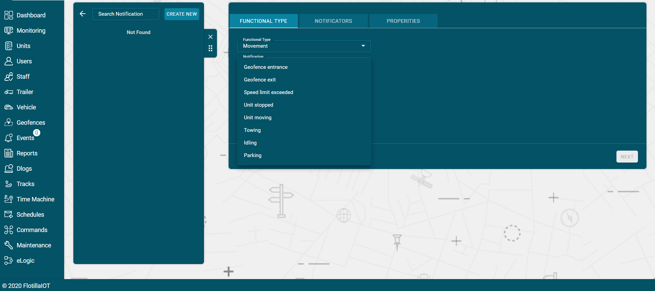
Maintenance Reminder:
- Search the maintenance type for which you want to set the notification.
- Set the value at which you want to receive the notification in ‘Notify me on due’ option.
- Set the value at which you want a heads-up before the actual notification in ‘Remind Me Before’ option.
Digital:
- Digital notifications can be set for various events like ignition, panic button, external power etc.
- Select the state (ON, OFF or both) for which you want to receive notification from the ‘State’ drop down list.
- Select the unit or group for which you want to assign notification.
- Click on Next button.
- Select NOTIFICATORS out of email, web popup, mobile notification and SMS by enabling the respective options.
- Click on Next button.
  - Set the properties of the Notification including name, geofence, duration, timings etc.
  - Click on the SAVE button.
Analog:
- Analog notifications can be set for various events like fuel, temperature, RPM etc.
- Select the index which refers to the number of a particular notification. For example, if you are creating second fuel notification, the index will be 2.
- Select the maximum and minimum limit for which you want to receive notification from the drop down list.
- Check the ‘Trigger when’ option by checking In range or Out range option.
- Select the unit or group for which you want to assign notification.
- Click on Next button.
- Select NOTIFICATORS out of email, web popup, mobile notification and SMS by enabling the respective options.
- Click on Next button.
  - Set the properties of the Notification including name, geofence, calendar (duration, timings) etc.
  - Click on the SAVE button.

Detect:
- Detect notifications can be set for various events like driver changed, passenger changed, trailer changed.
- Check the ‘Consider Null Value’ checkbox if you also want to accept null values.
- Select the unit or group for which you want to assign notification.
- Click on Next button.
- Select NOTIFICATORS out of email, web popup, mobile notification and SMS by enabling the respective options.
- Click on Next button.
  - Set the properties of the Notification including name, geofence, calendar (duration, timings) etc.
  - Click on the SAVE button.

Unit Status:
- Unit status notifications can be set for various events like Connection restore, Status unknown, Connection loss.
- Select the unit or group for which you want to assign notification.
- Click on Next button.
- Select NOTIFICATORS out of email, web popup, mobile notification and SMS by enabling the respective options.
- Click on Next button.
  - Set the properties of the Notification including name, geofence, calendar (duration, timings) etc.
  - Click on the SAVE button.

Eco Driving:
- Eco driving notifications can be set for various events like Harsh Brake, Harsh Turn, Harsh Acceleration, Harsh Bump.
- Select the tolerance value after which the notification will be triggered.
- Set the maximum and minimum limit between which you want to receive notification.
- Select the unit or group for which you want to assign notification.
- Click on Next button.
- Select NOTIFICATORS out of email, web popup, mobile notification and SMS by enabling the respective options.
- Click on Next button.
  - Set the properties of the Notification including name, geofence, calendar (duration, timings) etc.
  - Click on the SAVE button.

Fuel:
- Eco driving notifications can be set for various events like Filling and Drain.
- In filling notification type, you will receive a notification whenever the fuel filling starts.
- In drain notification type, you will receive a notification whenever the fuel drainage starts.
- Select the unit or group for which you want to assign notification.
- Click on Next button.
- Select NOTIFICATORS out of email, web popup, mobile notification and SMS by enabling the respective options.
- Click on Next button.
  - Set the properties of the Notification including name, geofence, calendar (duration, timings) etc.
  - Click on the SAVE button.
Notificators:

- Select ‘NOTIFICATORS’ for setting notification medium from email, web popup, and mobile notifications.
- Click on Next button.
Properties:
Basic:
- Name:
Enter the name of the event in this option.
- Description:
Enter any description that you want to add for the notification.
- Alarm State/sec:
Enter the alarm state (in seconds) which is the duration for which you want to trigger the notification.
- Interval/min:
Enter the time interval (in minutes) which is the time duration between subsequent notifications.

Time Control:
You can apply time control on the notification according to your requirement.
Weekly:
Select the days on which you want to receive notification.
Custom:
- Select the time span, dates and months at which you want to receive the notification.
- You can also select multiple time slots by clicking on the ‘ADD ANOTHER SLOT’ button.
- You can check the days on which you want to receive the notification.
- Check the month in which you want to receive the notification.
- Click on the SAVE button.

Reports

Flotilla IoT provides a unique report form module, which acquired all-around statistics and analytics. The summary data can be displayed from various perspectives i.e. in tables and graphs. Various types of customized reporting options are available according to user's requirements.

Report Templates

To generate a report template, users should have access right to generate report templates. Flotilla IOT provided the following report templates and that is available to the users:

Trip Report: Trip report template gives detailed information on trips history or the intervals of movement, including trips total length, travel time, average and maximum speed.

Stops Report: Stops report gives a breakdown of stops, addresses, and duration. This report template also gives you an ability to check the ignition time.

Engine Hours Report: Engine hours report template gives an overall activity diagram for the period in the form of a pie chart. This report template provides detailed information to display engine hour’s details in movement and idling and shows the how much time was in motion.

Fuel Report: Fuel report template gives an overall fuel consumption for the period in the form graph. This report template provides detailed information about fuel consumption with fuel counts and drains counts at a certain time and place.

Geofence Report: Geofence report template displays the number of visits to geofences during a specific duration including the distance in km.

Eco-Driving: Eco-Driving report templates give detailed information on how a driver handles the vehicle and analysis of the driving behavior. Event Report: Event report template gives detailed information on all types of events i.e. ignition on, ignition off, status online, status offline, etc.

Report Creation

- Select the report template from the dropdown list.
- Select the date and time range for which you need report.
- Select units, groups or staff whose report is required.
- Click on UNITS button to select a unit or multiple units from the units list (Select all units by checking 'Select all' checbox) whose report is required.
- Click on GROUPS button to select a group or multiple groups (Select all groups by checking 'Select all' checbox) whose report is required.
- Click on STAFF button to select a staff member or multiple staff members (Select all staff members by checking 'Select all' checbox) whose report is required.
- Click on the Submit button to view report.

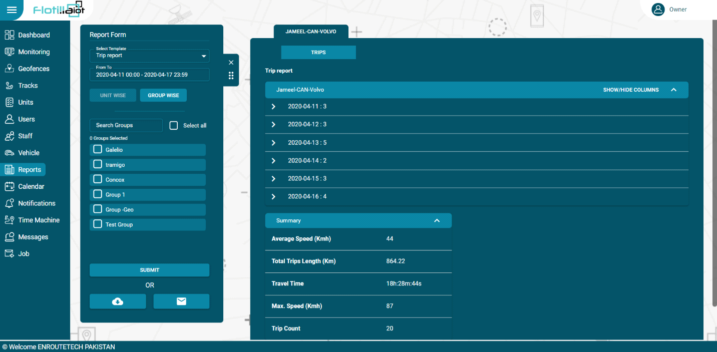

Flotilla IoT provides the two options in which users can download or mail the generated report template:

Save as Excel or PDF File:

- Select the date and time range

- Chose the template of report

- Select the unit whose report is required

- Click on the EXCEL download or PDF download button at the bottom.

Email:
- Select the date and time range
- Chose the template of report
- Select the unit whose report is required
- Click on the email button at the bottom.

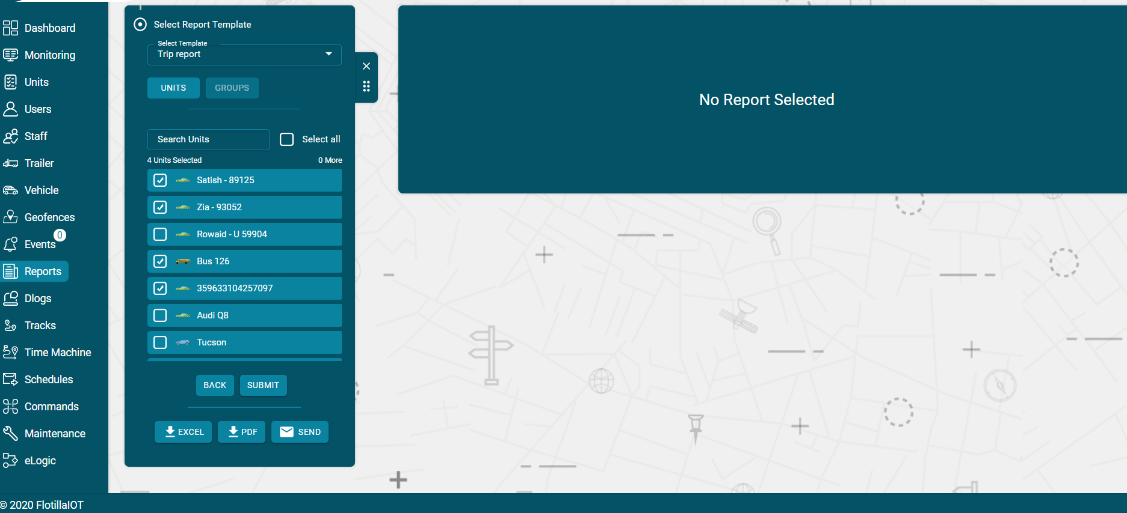

Dlogs

- Dlogs contains the complete database of the devices attached to the units. From location coordinates to speed, everything is available in Dlogs. In this module, users can view the Dlogs status form of the units for any picked date. Dlogs provides a data storage platform that ensures the security of the records.
All the information is available at one place to be retrieved quickly and conveniently.
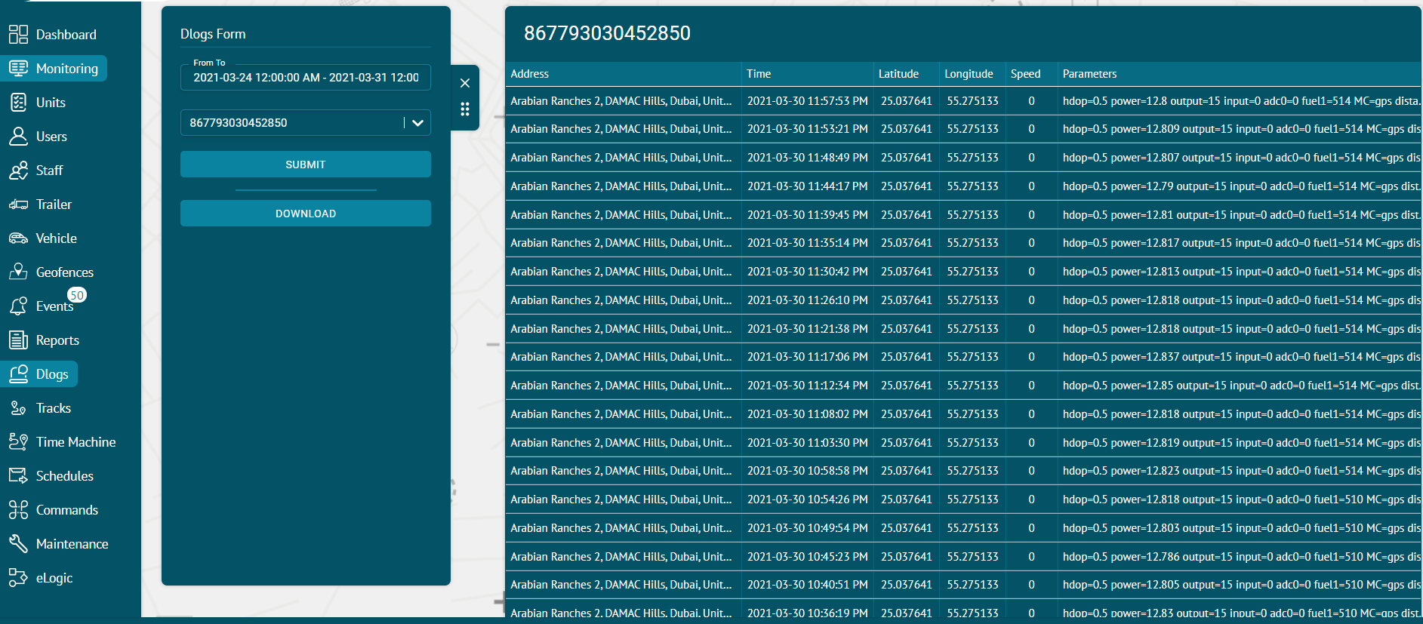

Dlogs Form

To generate a Dlog form:
- Select the date and time range
- Select the unit from the dropdown
- Click on Submit button
The positions of the selected unit within the selected time period will be displayed in the Dlog form.
Download
- Click on the DOWNLOAD button to download the dlogs in excel format.

Tracks
This module contains the detailed information regarding all the trips made by the units. The user can view complete track details and history of units for the chosen date and time range.
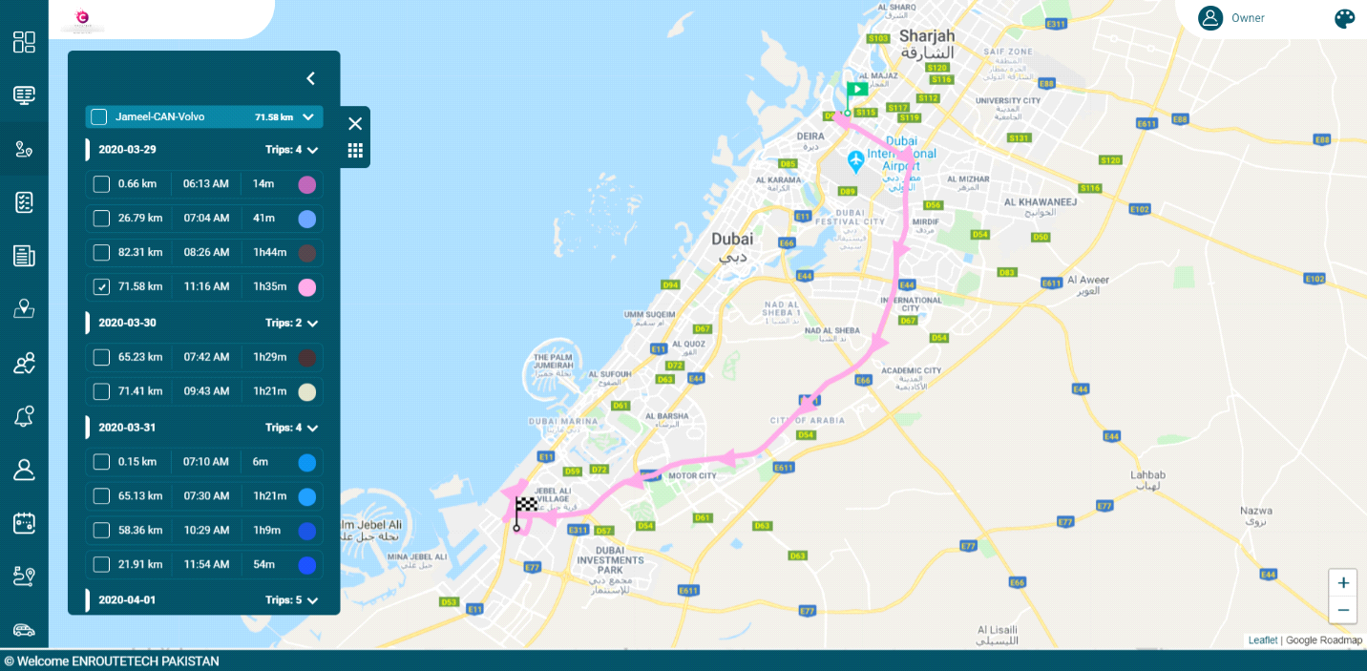

View tracks
- A track form view is used to see the location history of units from starting position in green flag icon to ending position in black & white flag icon.
- Add the duration for which tracking history is required in the ‘From To’ option.
- Search the unit by its name for which you want to view the search history or select it from the list.
- Click on the SUBMIT button to view the track history of the selected unit.
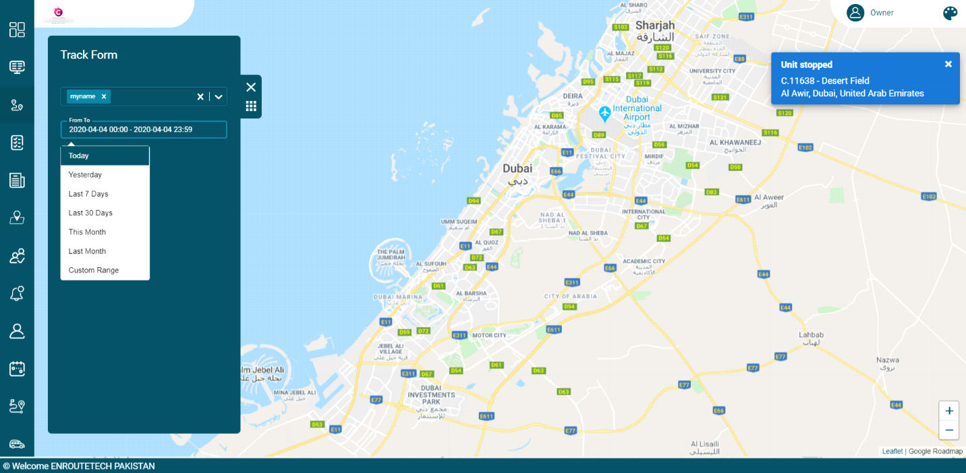
- Tracks list will display on the right top menu screen.
- To view the trips, user can select check boxes of trips.
- Trips will display on the map with starting position in green flag icon to ending position in black & white flag icon.

Trips color

- Each trip will be displayed with particular color to differentiate it from others.
- User can also change the color of trips by clicking on color icon next to each trip.
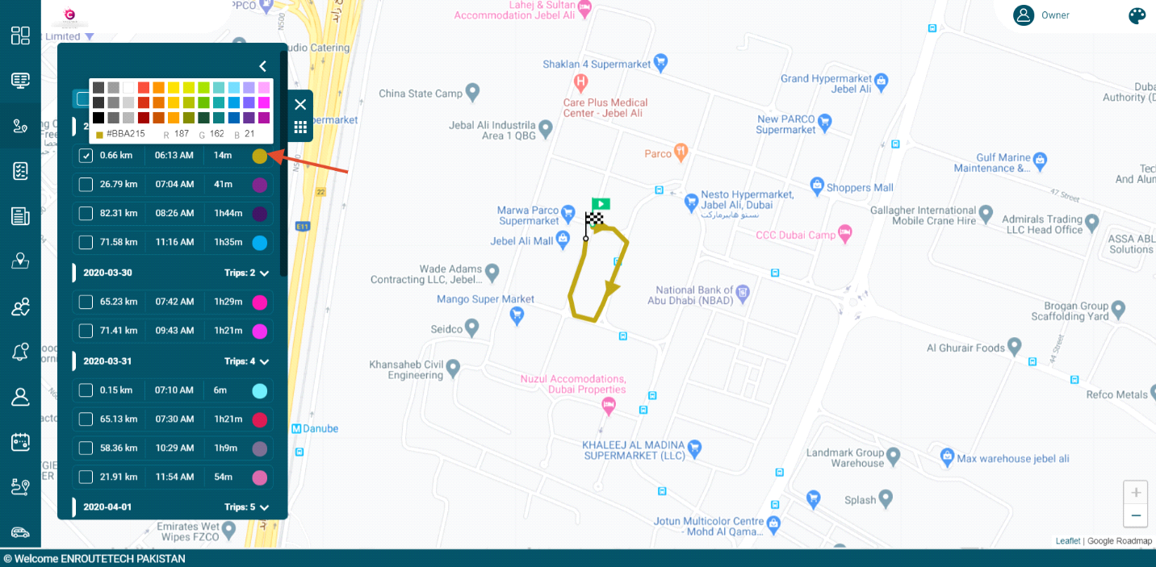
Upload and Download Track Files:
- The user can upload a KML file of any track by clicking on the small icon next to Track Form.
- The uploaded track will be displayed on the map.
- The track details of any unit can be downloaded by clicking on the download option next to its name.

Time Machine

Flotilla IoT provides a unique Time Machine module. Time Machine is a device that permits you to playback the previous travel history of the units for any picked date. You can see every instant of a trip including movements, stops, speed by replaying it.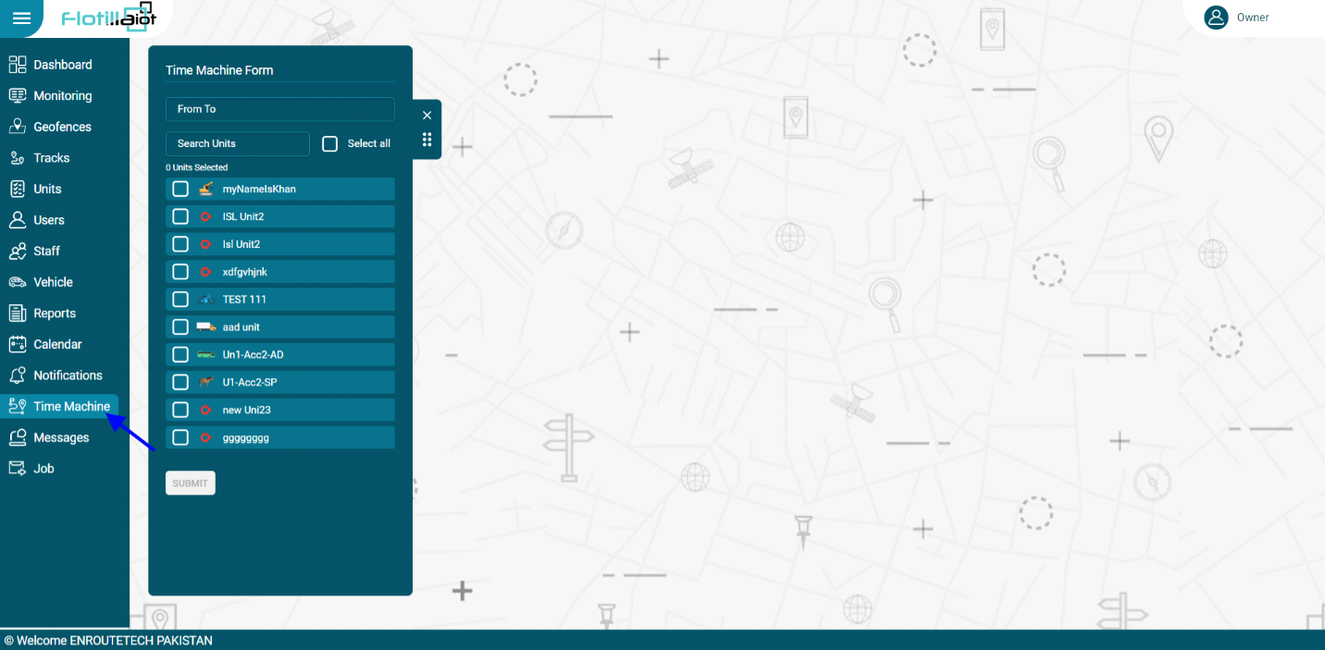

Time Machine Form

To generate a time machine form:
- Select the date and time range
- Select the unit or multiple units from the units list (User can select multiple units or Select All unit’s option)
- Click on the Submit button.
- At the bottom of the screen, the user will see the time machine settings.
- Users can set various options like playback speed, show tracks, and points on the map, etc. Click on the Play button.
- Users will see unit movement or previous travel history.
- Users can set speed control of unit travel history on the map.
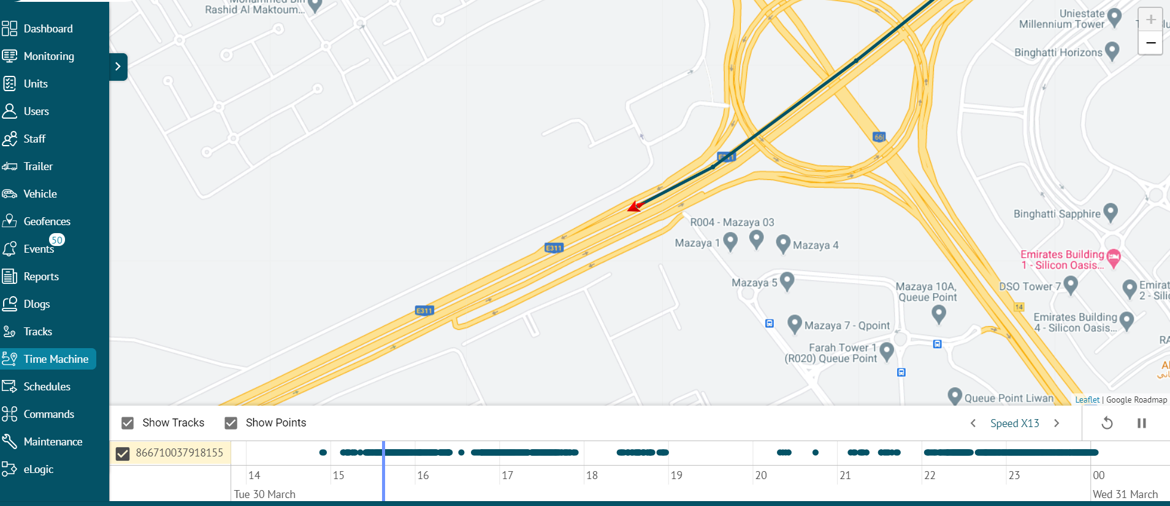

Schedules
This module allows different reports to be scheduled for future to ensure efficient monitoring. The user can set an important event’s notification beforehand to ensure convenience. Any type of notification can be scheduled for staff, units and groups with customized triggering settings. All the previously created schedules are shown in the list.
Creation of New Schedules
- Click on CREATE NEW button.
- Select the duration of report in 'Report From' option.
- Select the 'Report Template' from the dropdown list.
- Set the 'Report Interval' from the given options or you can select custom as well.
- Select the option from Staff, Units, Group for which report is required.
- Check the specific unit, group or staff or choose all by checking the 'Select all' checkbox.
- Click on the NEXT button.
Execution Schedule
- Select the Execution schedule.
- Choose Trigger Time at which the report will be received.
- Set repetition for the report from Once, Daily, Weekly and Monthly.
- Set User email or custom emails by checking the respective options for receiving the report.
- Check the Enable checkbox to enable the status of the report.
- Click on SUBMIT button to schedule report.
Delete Schedule
- Click on the delete option next to the schedule's name.
- Click OK button to delete and CANCEL to dismiss deletion.
The report will be successfully deleted and removed from the list.
Edit Schedule
- Click on the Edit option next to the delete option.
- After adding all the information, click UPDATE button to save changes.
Click OK button to delete and CANCEL to dismiss deletion.

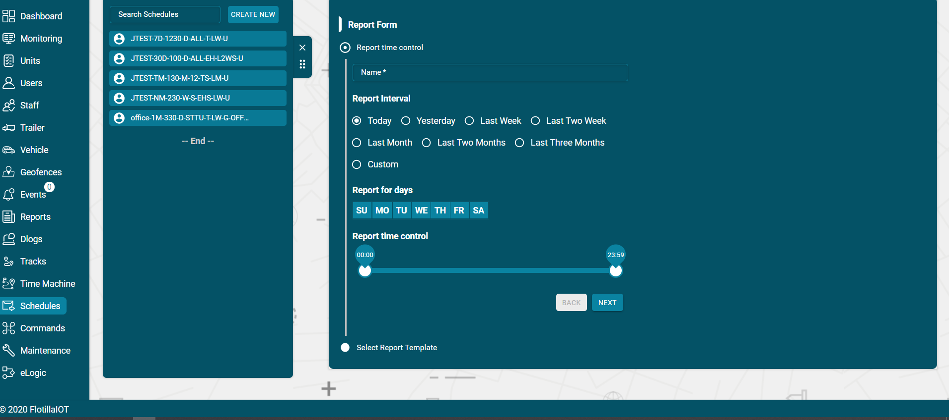
Commands
Commands can be assigned according to the operational needs of the fleet. They can be set for the future to keep a smooth operational flow. A user can create, edit, view, or delete commands. Users need to have access right to create, edit, assign, and delete commands, otherwise, users can only view the existing commands.
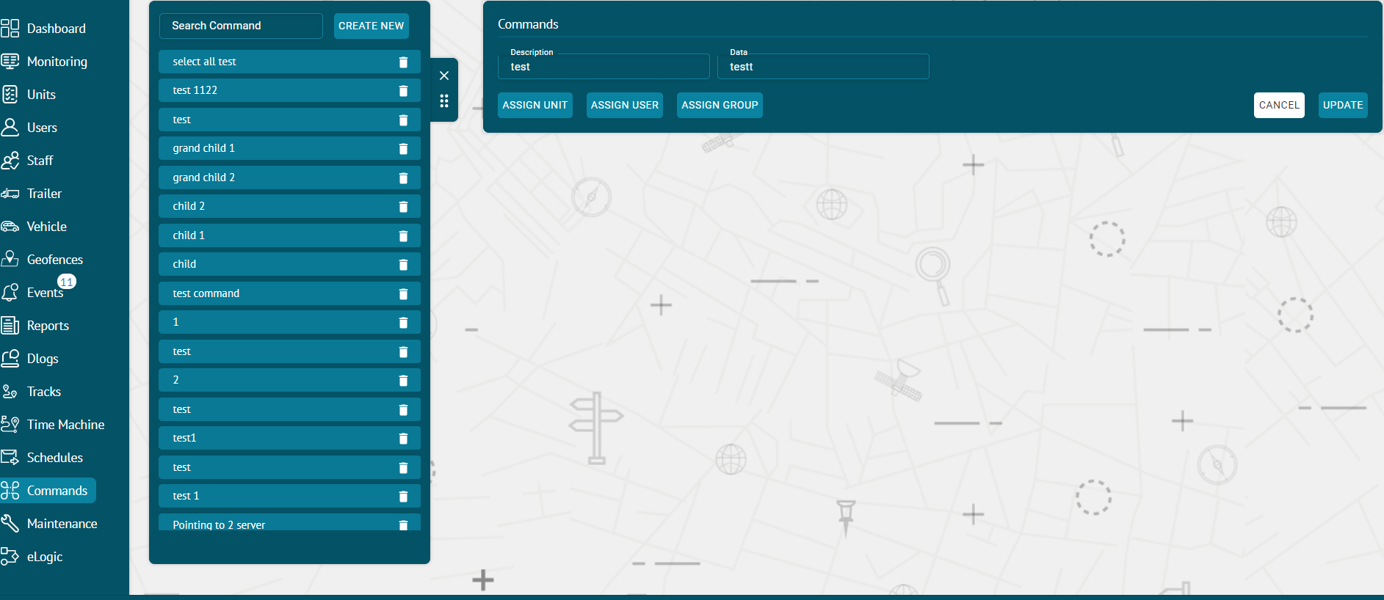
Creating Commands
- Click on the CREAT NEW button in commands section.
- Add description and data type of command.
- Check the 'Send SMS' checkbox to send SMS alerts for the command.
- Click on CREATE button to create a command.
- Click on CANCEL button to dismiss command.
Assigning Commands
- Assign Unit:
- After creating the command, click on the assign unit button.
- Check the checkbox of the unit to whom you want to assign command.
- By checking the topmost checkbox, you can assign commands to all the units at once.

- Assign User:
- After creating the command, click on the ‘ASSIGN USER’ button.
- Check the checkbox of the user to whom you want to assign command.
- By checking the topmost checkbox, you can assign commands to all the users at once.

- Assign Group:
- After creating the command, click on the ‘ASSIGN GROUP’ button.
- Check the checkbox of the group to whom you want to assign command.
- By checking the topmost checkbox, you can assign commands to all the groups at once.

Delete Command

- To delete a command, click on the bin icon next to the command's name in the list.

Maintenance:
The maintenance of the units is managed and monitored through this module to ensure a fully functioning fleet. The maintenance deadline of any unit can be set based on different ELOGICs like date, mileage, engine hours etc. A user gets informed about the required maintenance of the unit through alerts.
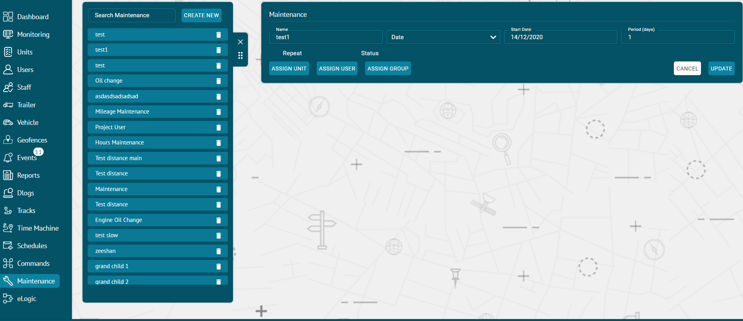
Create Maintenance
- Go on 'Maintenance' tab and click on CREATE NEW button.
- Add Name of the Maintenance.
- Select the type of the maintenance from the dropdown list.
- Set the starting value in the 'Start' option.
- Set the period in KMs.
- Check the 'Repeat' checkbox for repetition of the maintenance.
- Click CREATE button to update the new maintenance.
- After creating the maintenance, check the ‘Status’ checkbox to activate the maintenance.
Assign Unit:
- Click on the ‘ASSIGN UNIT’ button.
- Check the checkbox of the unit to whom you want to assign maintenance.
- By checking the topmost checkbox, you can assign maintenance to all the units at once.
Assign User:
- Click on the ‘ASSIGN USER’ button.
- Check the checkbox of the user to whom you want to assign maintenance.
- By checking the topmost checkbox, you can assign maintenance to all the users at once.

eLogic:
eLogic contains the mathematical and logical operations applied for converting data received from the sensors. The data inputs of different ELOGICs like odometer reading, acceleration, speed etc. can be set according to convenience.
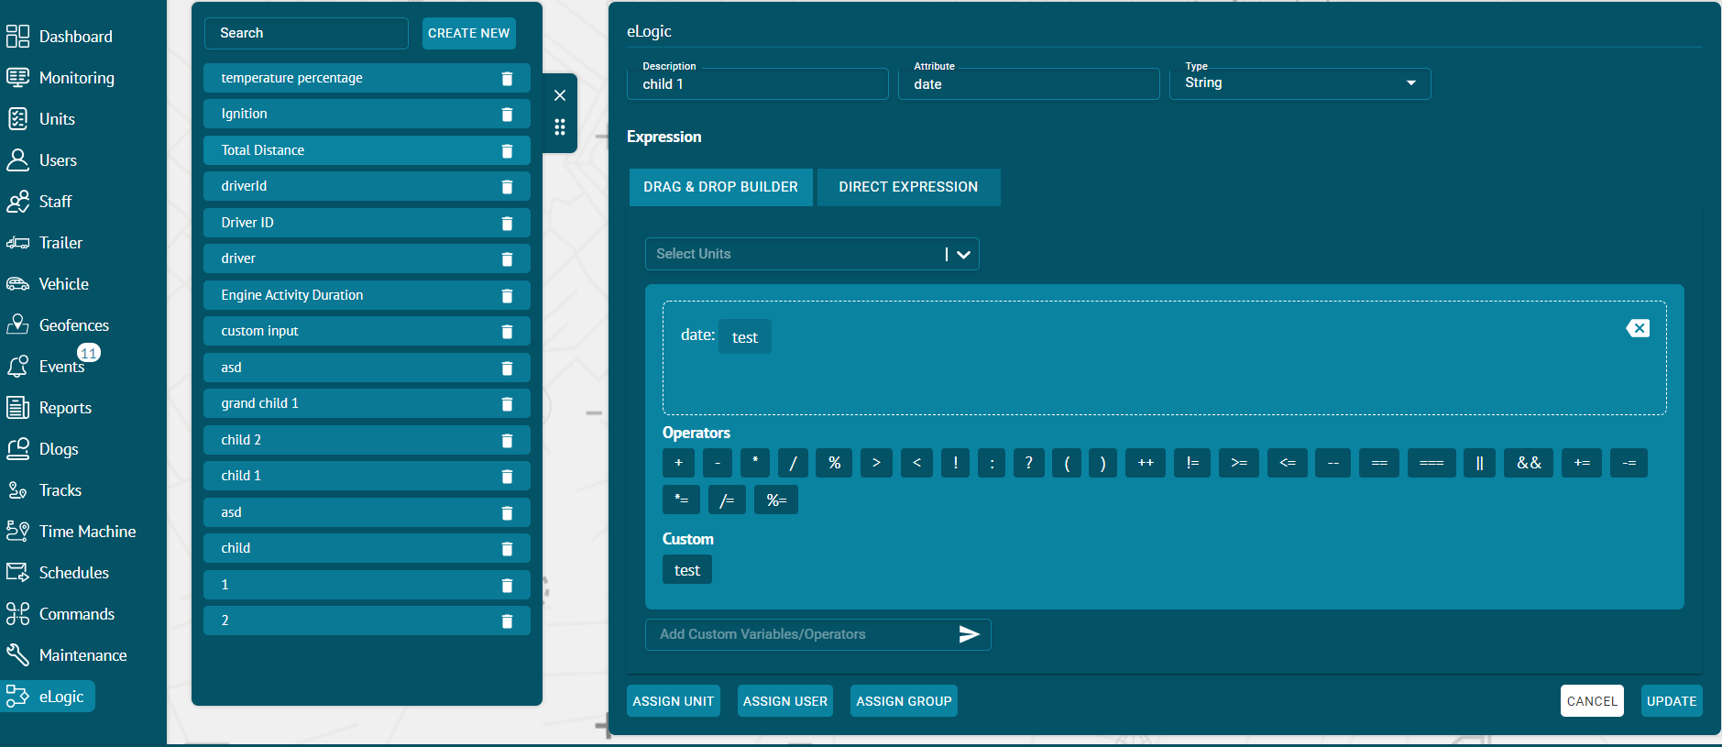
Create ELOGIC

- To create new eLogic, click on the 'CREATE NEW' button.
- Fill all the required fields to create a new eLogic.
- Enter the description for the eLogic.
- Enter the data attribute at which the particular type of data would be sent.
- Select the return data type from string number Boolean.
- Expression: There are two choice for adding expressions:
- DRAG & DROP BUILDER:
- Select Units: Select the unit on which you want to apply eLogic.
- Variables: Drag and drop the data attributes of the
- Operators: Drag and drop the operators you want to apply on the attributes.
- Add Custom Variables/Operators: Create a custom variables to apply operations on them.
- Click on the create button.

- DIRECT EXPRESSION:
- Write the direction expression to apply the eLogic. For example, ignition==1?true:false or distance=speed*time etc.
- Click on the create button.

Search ELOGIC

- You can search for any previously created eLogic by typing its name.
- By clicking on the name of any eLogic, its details will show up.
Delete ELOGIC
- An eLogic can be deleted from the list by clicking on the delete option.

Update ELOGIC

- The name and the attribute of an eLogic can be set according to requirement.
- The required input value and the data type of an eLogic can be set.
- By clicking the 'CANCEL' button, the eLogic will not be updated.
- By clicking on the 'UPDATE' button, the eLogic will be updated
- After updating the eLogic, it can be assigned according to the requirement.
Assign ELOGIC

- Click on the 'ASSIGN UNIT' button to assign eLogic to the selected unit.
- Select the unit from the list and and click on the ‘ASSIGN ELOGIC’ button
- For assigning eLogic to the user, click on the 'ASSIGN USER' button,
- Select the user's name from the list and and click on the ‘ASSIGN ELOGIC’ button.
- The eLogic can be assigned to a group of users by clicking on 'ASSIGN GROUP' button.
- Select the group’s name from the options and click on the ‘ASSIGN ELOGIC’ button.

